

SOLICITOR USER GUIDE

Civil Online Portal

V2.2 Feb 2024

|  |  |
| --- | --- |
|  |  |
| Accessing the portal and adding new users |  |
| Accessing the portal | 2 |
| Sign up | 3 |
| Sign in | 4 |
| Welcome page | 5 |
| User admin | 6 |
| Caveats |  |
| Creating a new caveat | 7-13 |
| Tracking & renewing caveats | 14-15 |
| Submitting a New Simple Procedure Claim |  |
| Court details | 16 |
| Claimant details | 17 |
| Claimant representation | 18 |
| Respondent details | 19 |
| Claim details – About the claim | 20 |
| Claim details – Court order(s) | 21 |
| Upload supporting documents | 22 |
| Summary page | 23 |
| Pay for your document | 24 |
| Submission receipt | 25 |
| Responding to a Simple Procedure Claim |  |
| Initiating a Simple Procedure response | 26 |
| How does your client wish to respond to the claim? | 27 |
| Admit and settle – Respondent details | 28 |
| Additional respondents | 29 |
| Respondent representation | 30 |
| Upload supporting documentation | 31 |
| Summary page | 32 |
| Submission receipt | 33 |
| Admit and seek time to pay the money | 34 |
| Dispute the claim or part of the claim | 35 |
| Drafts |  |
| Submission drafts | 36 |
| My Cases |  |
| My cases | 37 |
| Submit documents | 38-39 |
| Case tracking – Simple Procedure | 40 |
| Notifications | 41 |
| Rejected Simple Procedure claims | 42 |
| Case tracking – Ordinary actions | 43-45 |
| Court of Session Case Tracking | 46-48 |
| FAQs |  |
| Frequently Asked Questions - FAQs | 49-52 |

**CONTENTS**



# **ACCESSING THE PORTAL**

# 

The Civil Online portal can be accessed by selecting “Access Civil Online” on the homepage of the SCTS website ([www.scotcourts.gov.uk](http://www.scotcourts.gov.uk)) and then selecting the “Start Now” button.

Alternatively, users can access the portal directly by clicking the following link:

[Civil Online (scotcourts.gov.uk)](https://civilonline.scotcourts.gov.uk/)



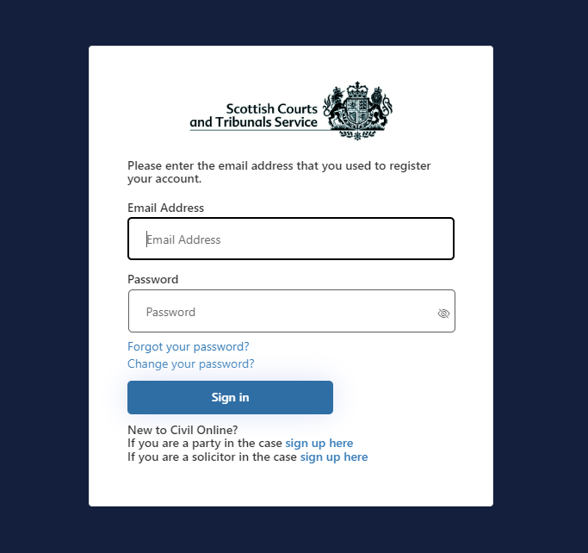**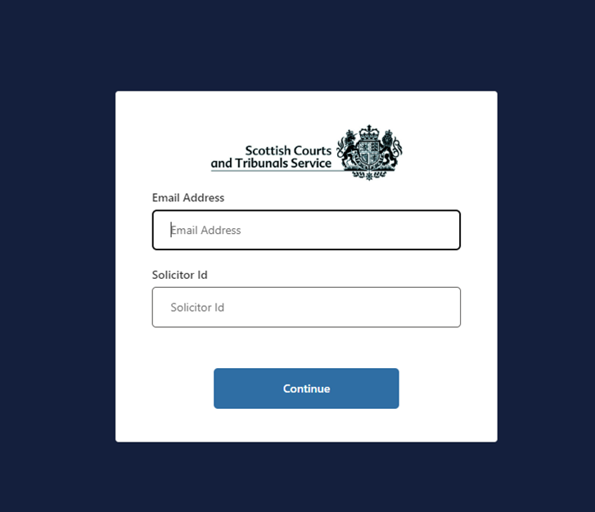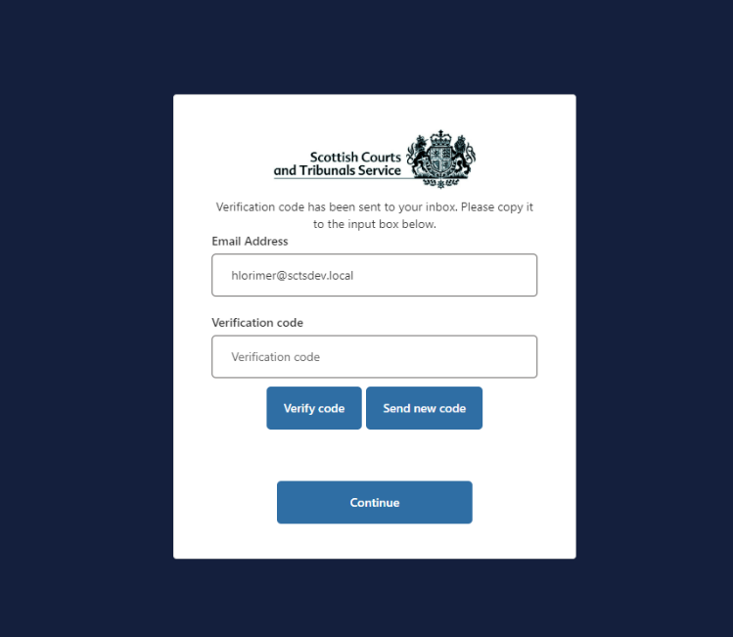SIGN-UP PROCESS**

# When accessing the portal for the first time, users are required to follow the sign up process. Users who previously used the old Civil Online (pre 31 May 2023) but are accessing the new version for the first time, will also be required to follow this process.

1. Click on the hyperlink to sign-up as a solicitor
2. Enter your email address
3. Enter the solicitor ID (formerly known as the Company ID). - If you have access to more than one office, simply use one of the solicitor IDs for the purpose of signing-up.
4. Click send verification code
5. Check your email for the verification code
6. Enter the verification code received by email into the appropriate field
7. Click Verify Code
8. Users will then be required to create a password which must be between 9 and 64 characters and it must have at least 3 of the following character types:

* Lower case
* Upper case
* Numeric
* Symbol



**2**

**1**

**3**

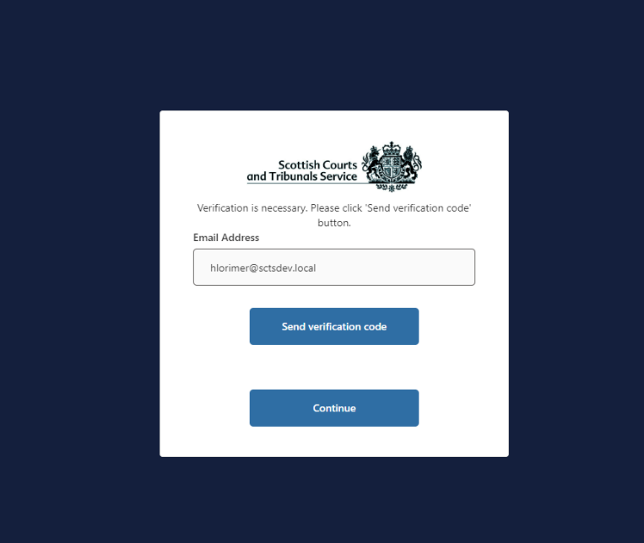

**4**

**6**

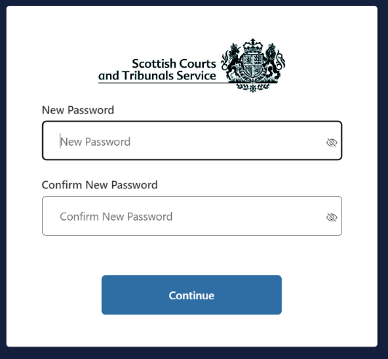

**NOTE**: In order to be able to follow the sign-up process your company/organisation/office must be registered for access to Civil Online and your email address must be granted access as either an **admin user** or a **non-admin user**. If you try to sign-up to the portal before being granted access you will receive an error message.

If your company/organisation/office is not registered for access to Civil Online please contact [civilonlinelab@scotcourts.gov.uk](mailto:civilonlinelab@scotcourts.gov.uk) to register.   
  
If your company/organisation/office has been registered and you require to be added as a user, please speak to an admin user for your company/organisation as they can grant colleagues access to non-admin users. (See page 6)

**7**

**8**

# **SIGN IN PROCESS**

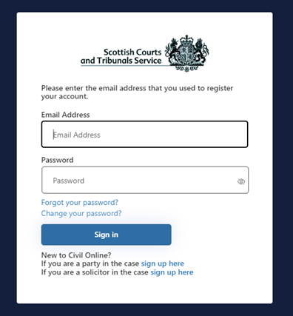

Once successfully registered and signed-up, users can sign in to the portal using their registered email address and password.

Users will also be required to pass multifactor authentication (MFA) the first time they access the portal each day. Users will not be able to access the portal without successfully completing this step.

If a user has forgotten or requires to change their password, they can reset this using the appropriate links on the “Sign In” page.

# **HOME PAGE**

1

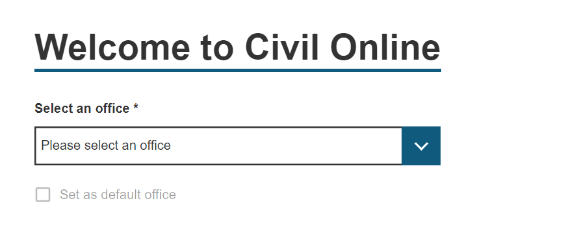

When users log into the portal they will be brought to the home page.

The features shown on the home page will vary slightly for users depending on their permissions.

**User Admin**

This button is only visible for admin users. Admin users can use this functionality to manage the list of non-admin users for an office. This puts an office in control of their list of users without the necessity to contact the SCTS.

**Caveats**

The “My caveats” and “New caveats” tiles will only show for users of an office that currently holds an active SCTS credit account.

**Select an office**

If a user has access to more than one office, they will also see a component where they are prompted to select an office they wish to work from (See image with gold border). Users can opt to set a default office, which means that they do not need to select an office each time they log-in. The office can be easily changed from the home page at any time.

# **USER ADMIN**

On this page admin users can:

1. See a list of current non-admin users for the office selected. Admin users are not included within this list.
2. Grant access to a new user. Any users added in this way can log-into civil online and access all cases for the office selected. The only thing they are unable to do is access this user admin functionality to add/remove users.
3. Remove a user’s access

Once you have granted a non-admin user access, if that user hasn’t used the new Civil Online before or the email address that has been granted access is different from one they already have registered, then they will be required to follow the solicitor sign-up process. Please provide the user with the corresponding Solicitor ID for the office order for them to complete this step. This number will have been provided by the Civil Lab at SCTS when the admin user was set-up.

**NOTE:** Should you require any modifications to the list of admin users please contact [civilonlinelab@scotcourts.gov.uk](mailto:civilonlinelab@scotcourts.gov.uk).  
  
We encourage organisations to utilise the user admin functionality to enable them to manage their list of users without the necessity of contacting SCTS. Users should not be routinely set up as admin users as a replacement for this functionality.

# **CREATE A CAVEAT**



**NOTE:** The “**My caveats**” and “**New caveat”** options will only be visible to users of firms/organisations that hold an SCTS credit account.

For more information on SCTS credit accounts please refer to the website [Credit Accounts (scotcourts.gov.uk)](https://www.scotcourts.gov.uk/finance/credit-accounts)

# 

Log in to Civil Online and click “New caveat” from the options available on the home page. The user will then be directed to the “create a caveat” screen.

Click anywhere on the bar that says “Party the caveat applies to”, this will expand the first drop-down section that requires to be completed. Alternatively, users can select “Open all” to expand all sections at once.



# 

If a user selects “I want to check case details or submit supporting documents in an existing case” they are brought to this screen. Here the user can view all of the current live cases for the selected office.

There is search functionality and a status filter available to assist with locating a case quickly.

Case references which are highlighted in blue are hyperlinked, meaning that case tracker functionality is available. Case tracker is only available for simple procedure actions at present. Any case reference numbers that appear in black mean the case cannot be tracked, and these cases are available on the portal for document submission only.

If a claim has been rejected by a court, then the case will be listed here, displaying a status of rejected. Users can click on the blue hyperlink reference and they will see the rejection reason(s) within the case tracker and there will be an option to begin reviewing the rejected claim.

Users can also submit documentation for cases, including ordinary actions with the exception of initiating documents such as Initial Writs and Notices of Intention to Defend (NIDs).

# **CREATE A CAVEAT – Party the caveat applies to**

# 

Use the radio button to select whether the party the caveat applies to is a natural person or a business. The fields that displayed below this button change based upon the selected radio button.

If the party is acting in a representative capacity or “trading as” select the tick box, this will populate a textbox field to enable further information to be entered.

Users are required to enter details about the party’s address. The postcode field has an address finder functionality. Meaning that when users start typing a postcode, the system will provide a list of suggested addresses to choose from. This is to save users from having to type the full address manually. Users can select an address and amend or add details as required.

At the bottom of this section the tick box “This party is the lodger” is selected by default. If the party the caveat applies to is not the lodger of the caveat, then this box should be unchecked. This will expand the next section called “Party lodging the caveat (if not the above)” so that the user can enter details about the party lodging the caveat.   
  
If the party is the lodger, the next section can be ignored and users can move onto the “Submission Court(s)” section.

**NOTE:** The business name field has a 6000 character limit.

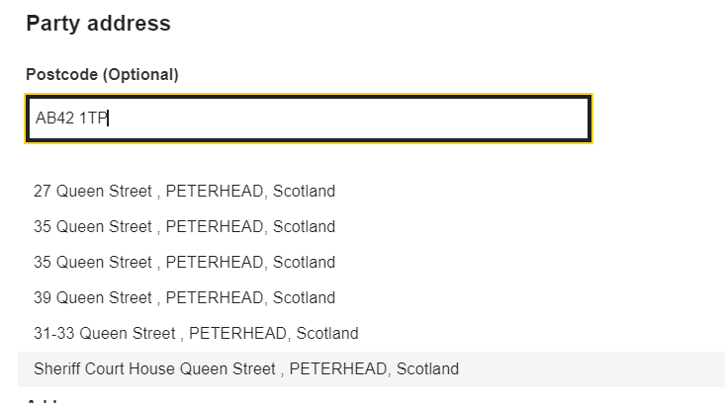

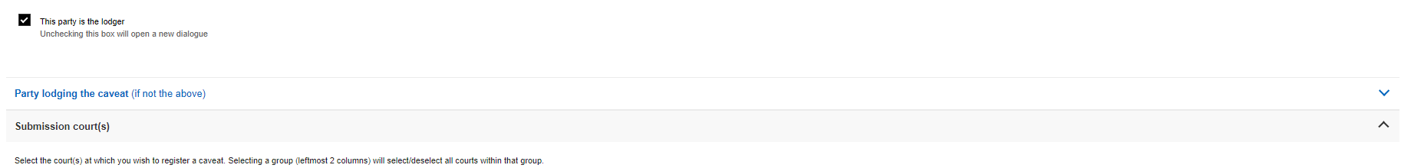

# **CREATE A CAVEAT – Party lodging the caveat (if not the above)**

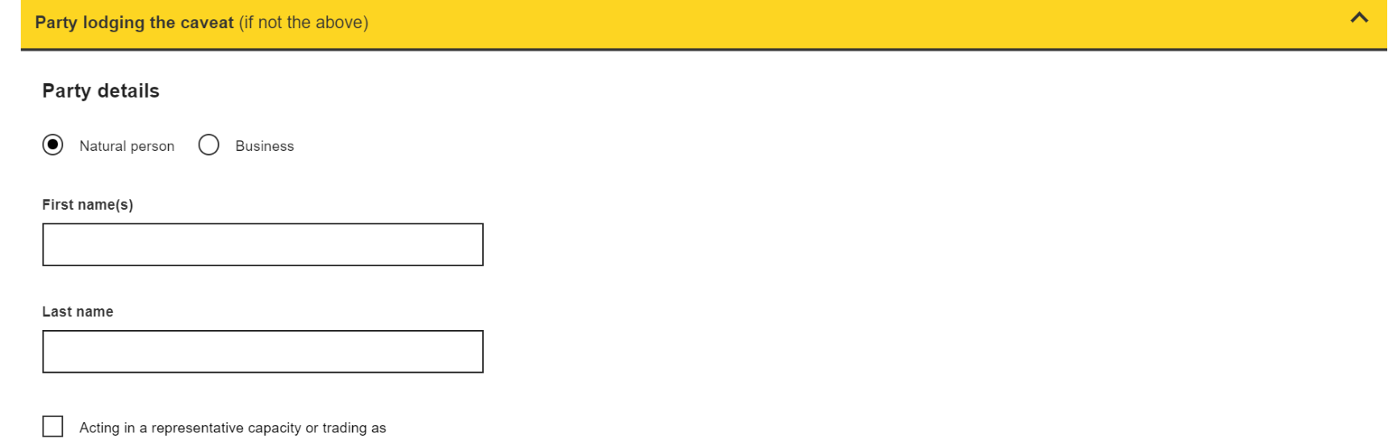

**NOTE:** This section is only for use in situations where the party the caveat applies to, is not the party instructing the lodging of same. For example, a power of attorney has instructed the lodging of the caveat on behalf of an individual.

If in the previous section, the tick box that says “The party is the lodger” is selected, then the fields within this section will be pre-populated with the same details that was entered in the previous section.

If, the tick box is unselected, then these fields will be empty for users to enter the details as appropriate.

# **CREATE A CAVEAT – Submission court(s)**

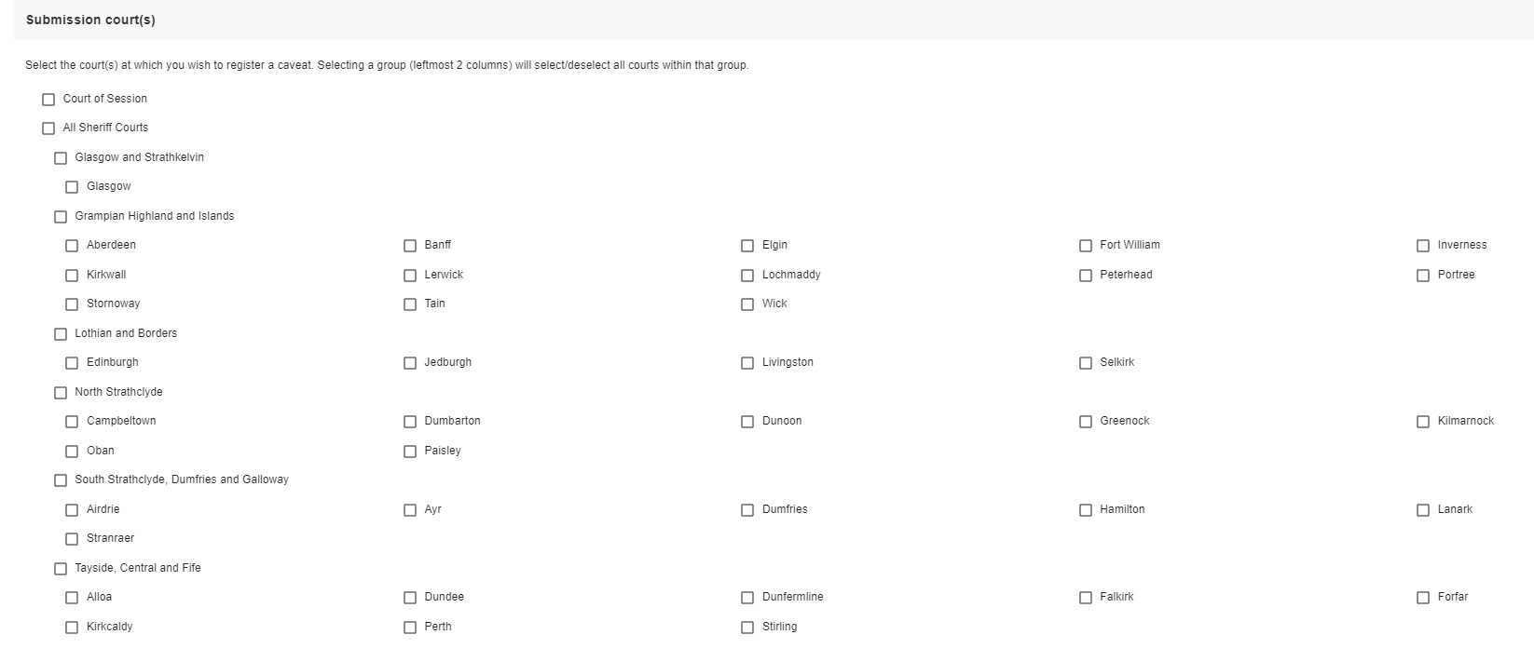

Users are required to select which courts they wish to submit the caveat to.

Courts are listed in alphabetical order from left to right under their respective Sheriffdom.

Groups have been created such as “All Sheriff Courts” to allow the user to select numerous courts as quickly as possible. Selecting a group (leftmost 2 columns) will select all the courts within that group. If one of the subgroups or courts is unchecked the overarching selection will be removed but all other courts will stay checked.

 **CREATE A CAVEAT – Action types and contacts**

The first part of this section asks users to confirm if they are the solicitor signing the caveat. “Yes” is selected by default. If the user logged into the portal is the solicitor that will be signing the caveat then they do not need to change the selection, as the system will automatically populate their name into the caveat accordingly (See note).

If users select “No, I am creating this caveat on behalf of that solicitor”, then a new field will appear to allow the user to enter the name of the appropriate solicitor (see no.1).

If the primary contact details are the same as the out-of-hours, users can select the “copy out-of-hours” button to save them having to re-type details (see no.2).

At the bottom of this section users can select/de-select the action types they would like covered. There are separate lists for Sheriff Court and Court of Session. The list(s) that displays on-screen depends upon the courts that have been selected for submission. All covered action types are selected by default (see no.3).

Once all information has been populated users should click “Submit caveat”. If the button is grey in colour instead of blue, this indicates required information is missing from one of the sections (see no.4).

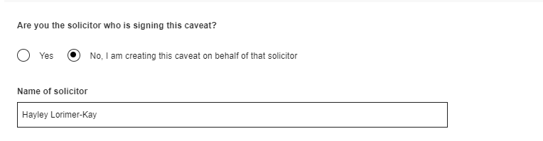

**1**

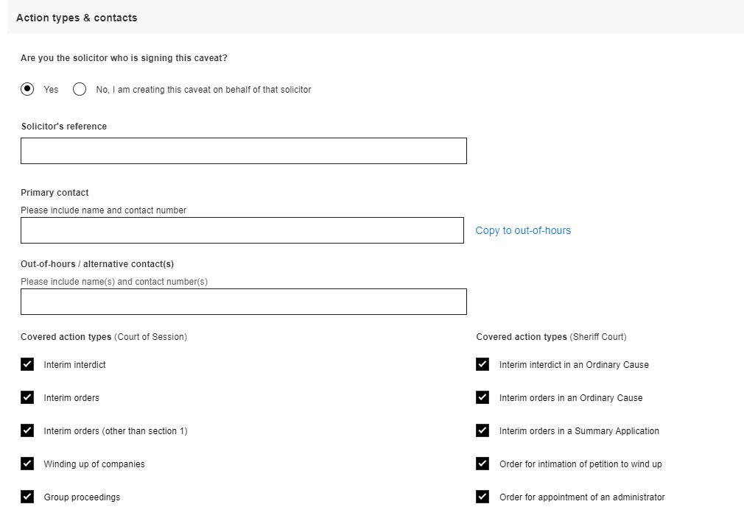

**2**

**3**



**4**

**NOTE:** The signee’s name is pre-populated using the name entered when you were set-up as a user. If you are a non-admin user please ask an admin user to check how your name shows on the list of current users on the “User Admin” tab as it may require to be amended. If you are an admin user please contact [civilonlinelab@scotcourts.gov.uk](mailto:civilonlinelab@scotcourts.gov.uk). Selecting “No” will allow users to enter their name manually as a workaround.

#

# **CREATE A CAVEAT – Please pay for your caveat(s)**

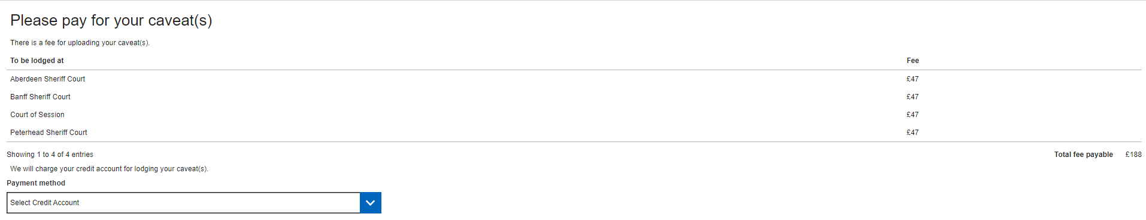

If a user has access to more than one firm/office that holds an SCTS credit account, they will be required to select the office/credit account they wish to charge the caveat(s) to. It is worth noting that the caveat, once accepted by the court, will appear on the tracker list for the office of the credit account that was selected. Once an account has been selected the caveat preview pane will be displayed.

If the user only has access to one firm that holds an SCTS credit account then they will not be required to select a credit account. This component won’t be visible and users will automatically see the caveat preview pane.

Users can utilise the preview pane to review the caveat(s) information. There will be 1 caveat for each court that has been selected. If users wish to make amendments they can use the “Back” button at the bottom of the page to navigate to the previous screen. There is also an option to save and print the caveat(s) (see no.1).

Once content with all the details, users can press “confirm” which will submit the caveat to the court(s).

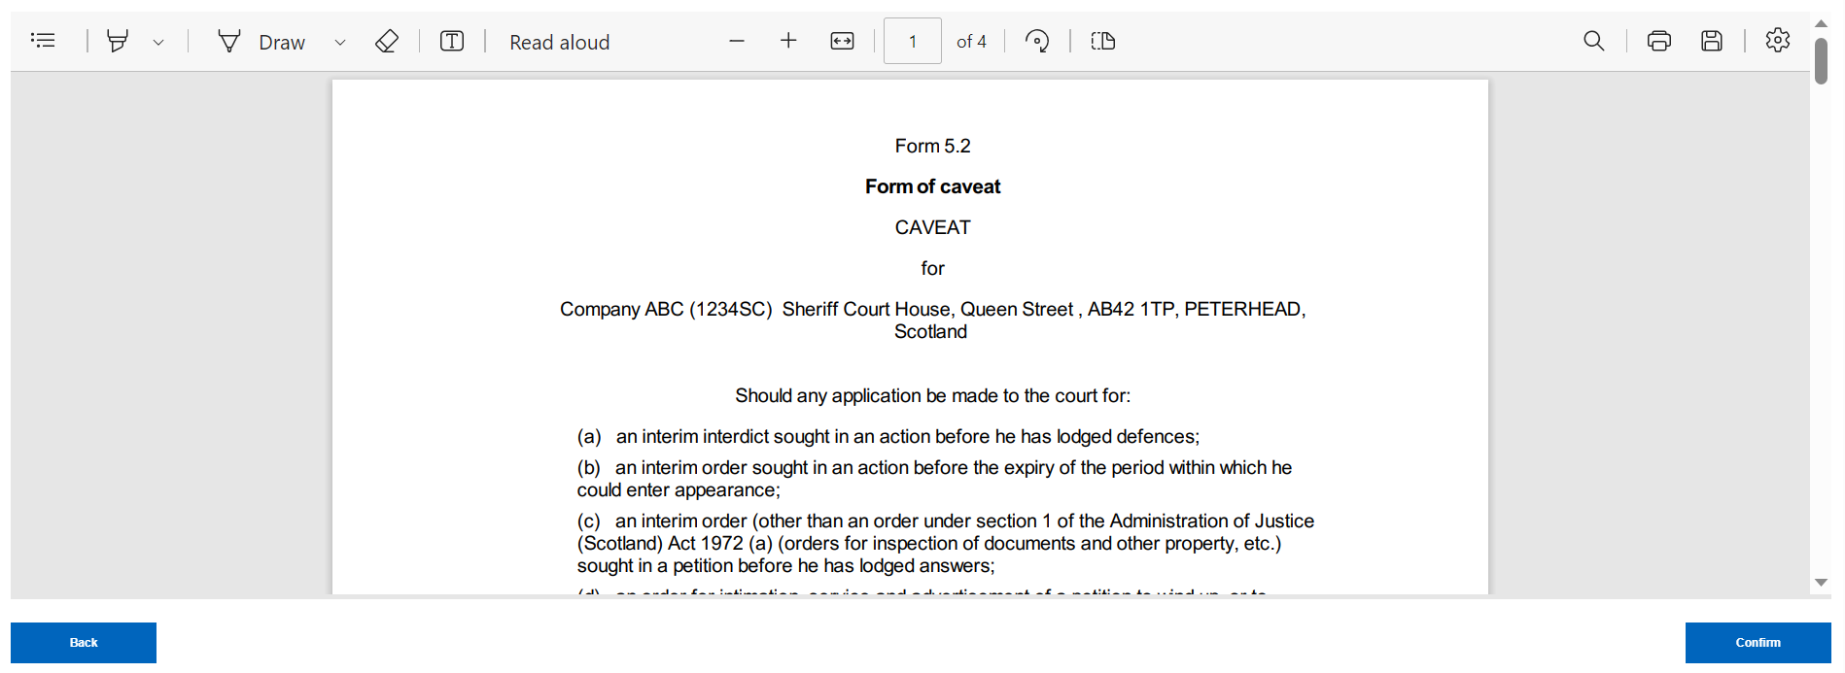

**1**

# **CREATE A CAVEAT – Submission receipt**

Users will be presented with the submission receipt screen which confirms that the caveat(s) have been submitted to the selected court(s). Users also have the option to print or download their receipt.

Users can also opt to create a new caveat for a different party or return to the home page by clicking on the hyperlinks indicated in the image below.

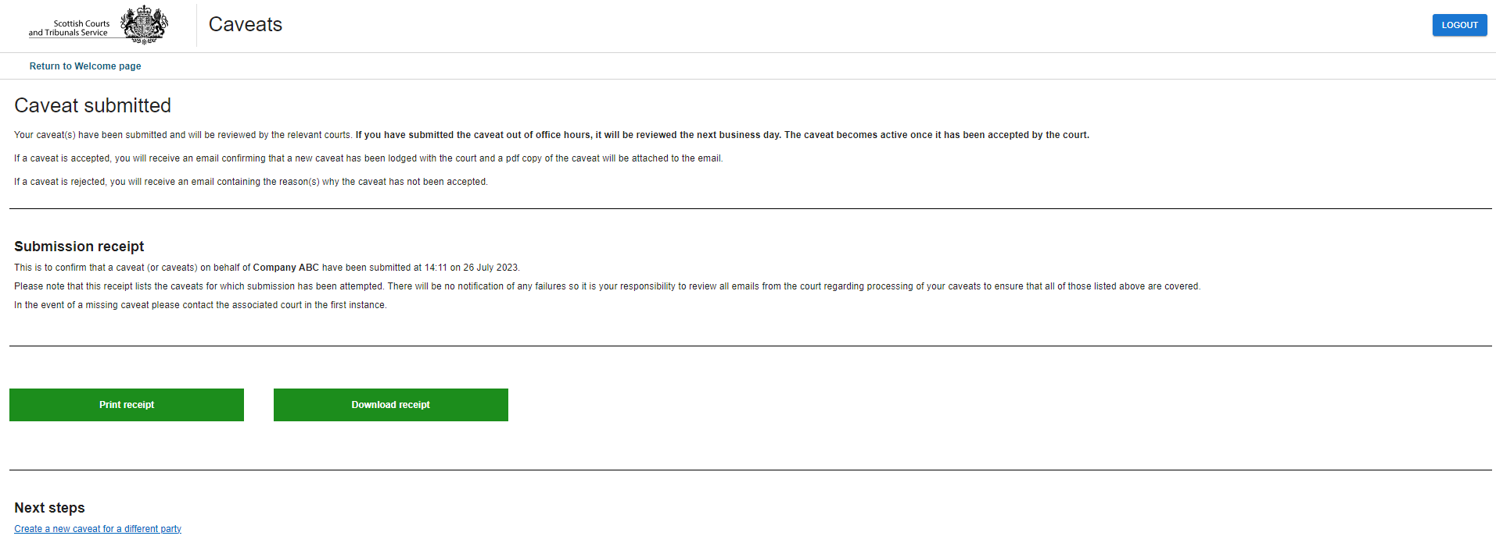

**NOTE:** The caveat is not active until it has been accepted by the court. The user will receive an email from each court confirming if the caveat has been accepted or rejected.   
  
In the event of a missing caveat please contact the relevant court(s) in the first instance.

# **MY CAVEATS –** **Track or Renew Caveat(s)**

# 

From the home page select “My caveats”.   
  
Users will then be presented with the “My caveats” screen, otherwise known as the caveats tracker, where the user can see all the active caveats for the office/firm they are a member of.

Caveats are organised by renewal date with the closest renewal date being listed first.

Users can select the tick boxes of the caveats they wish to renew or select “Toggle Renewals” at the bottom of the page to select all caveats.

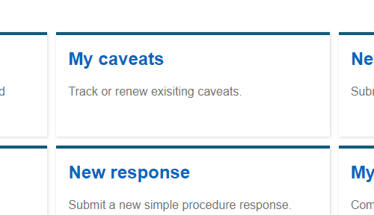

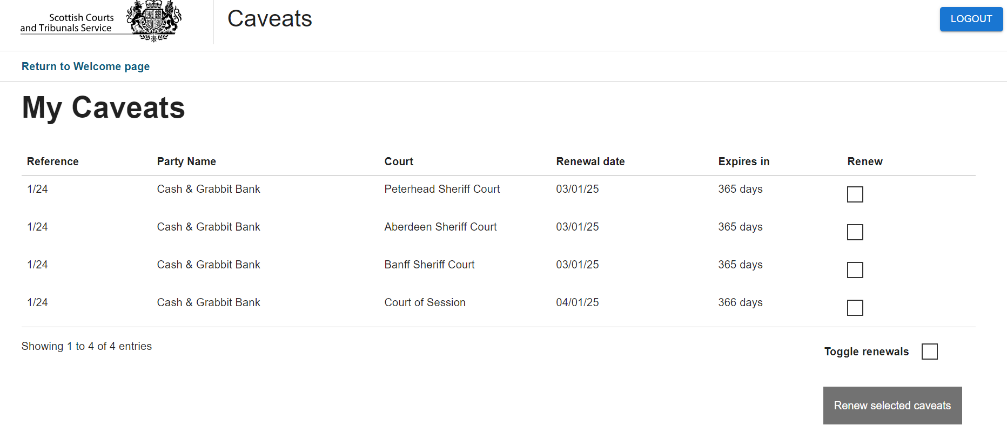

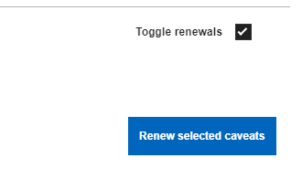

**NOTE:** Caveats that have been submitted to a court will not appear on this list until they have been accepted by the court.

# **CAVEAT RENEWAL(S) – Update contact details**

The contact details fields will be populated with details from the existing caveat. Users should review and amend the information as required. Users will not be able to proceed unless there is information contained within both the primary contact and out-of-hours/alternative contact fields.   
  
Users are asked “Are you the solicitor who is signing this caveat?" and the “yes” radio button is selected by default. If the user selects “No” a textbox field will populate to allow the user to enter the name accordingly.

If more than one caveat has been selected for renewal, the page will be populated with “previous” and “next” buttons to allow the user to navigate between each caveat.

Once the required information has been reviewed for all caveats that have been selected for renewal, users can select “Confirm” and they will be directed to the “pay for your caveat(s)” screen, followed by the submission receipt page. The functionality on those pages is the same as outlined on pages 12 & 13 of this guide.

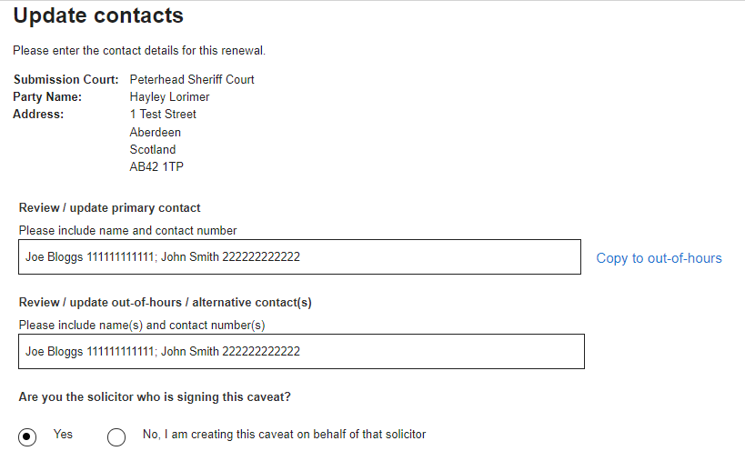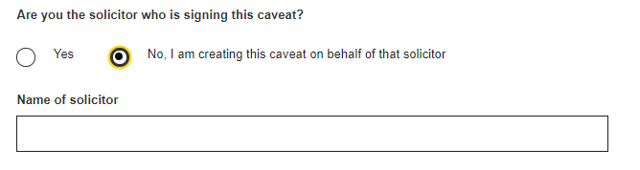

# **SUBMITTING A NEW SIMPLE PROCEDURE CLAIM**

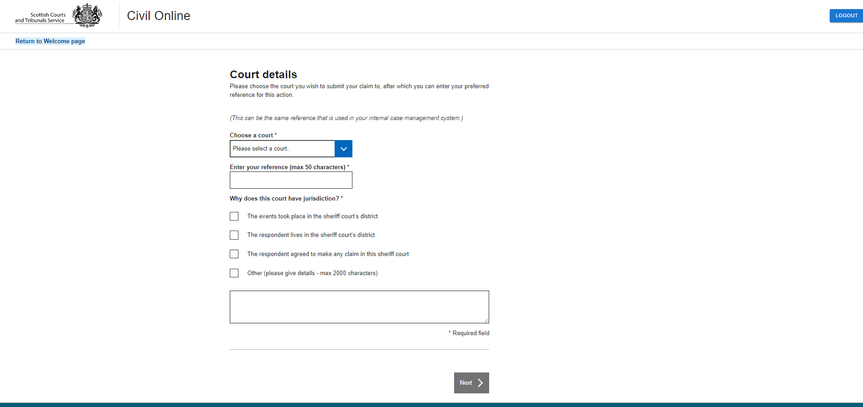

## Court details

When “New claim” tile is selected on the home page, users will be taken to the start of the claim journey.

Users are required to choose a court to submit the claim to.

A reference number must be entered. This is your own office reference number that will assist you in identifying the claim in the future.

The basis for jurisdiction has to be selected, more than one option can be selected. If selecting “Other” please complete the appropriate text-box.

# **SUBMITTING A NEW SIMPLE PROCEDURE CLAIM**

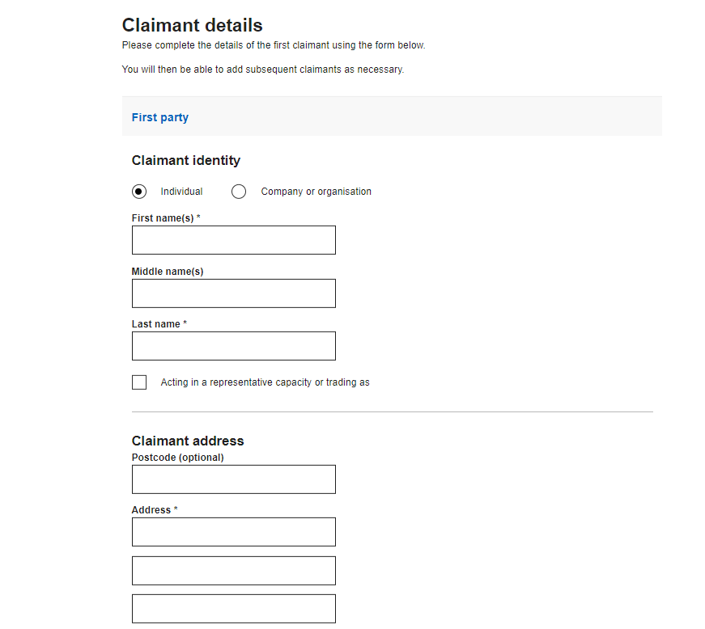

## Claimant details

Users are required to enter the details of the claimant including name, postal address and email address.

If the user types in the postcode then suggested addresses will be listed for the user to choose from, to make inputting the information quicker.

The claimant’s preferred method of contact can be selected. “Civil Online” is selected by default. Where a solicitor is representing the claimant it is presumed the claimant would wish to be contacted through their solicitor.  
  
The solicitor can select their preferred method of contact on the following screen.

If there is more than one claimant, further claimants can be added by clicking this button. The system allows a total of 20 claimants to be added

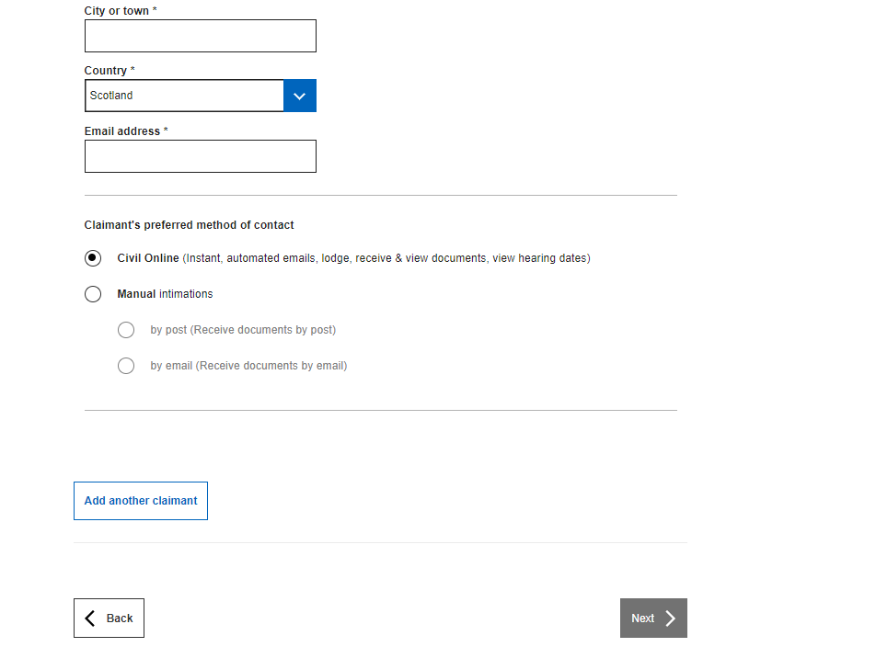

**NOTE:** Users should take care when entering the email address to ensure that it is correct.   
  
Once registered, the case can be visible on Civil Online for the email address that has been entered in this field.

# **SUBMITTING A NEW SIMPLE PROCEDURE CLAIM**

## Claimant representation

Information on this screen is pre-populated into the appropriate fields. It is designed to save users time by not having to enter their details each time they raise a claim.

1. When “yes” is selected, the first name, last name and email address fields cannot be amended.
2. If the user submitting the claim is not a solicitor (e.g. the claim is being submitted by a legal secretary on behalf of a solicitor) they can select the “No” radio button. The first name, last name and email address fields become editable and the user can enter the details of the appropriate solicitor.
3. Users can amend the preferred method of contact. Civil Online is selected by default.

Users are encouraged to keep the method of contact set to “Civil Online” as users will receive instant automatic case updates known as portal notifications.  
  
Manual intimations can be selected however, this may require court staff to manually issue case documents by either post or email and therefore is not instantaneous

2

1

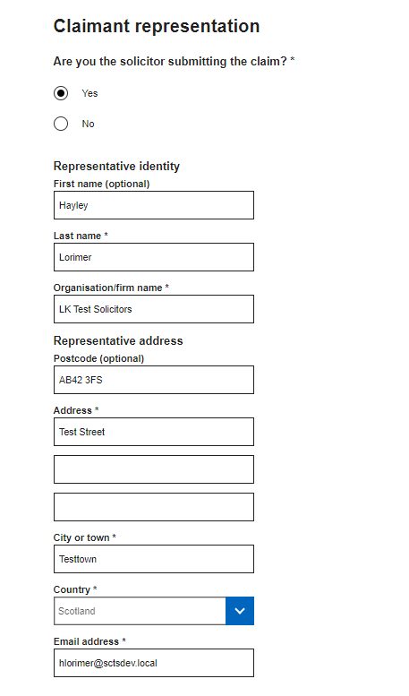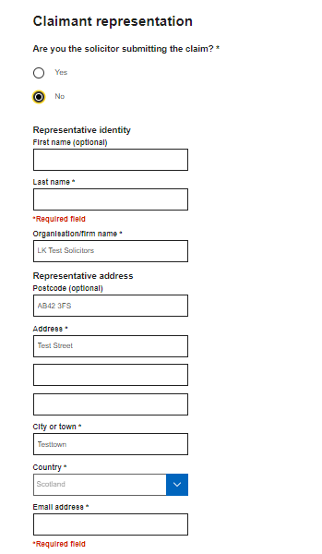

**NOTE:**  The organisation/firm name and address fields are not editable. If these details are incorrect and require to be updated please contact [civilonlinelab@scotcourts.gov.uk](mailto:civilonlinelab@scotcourts.gov.uk)

3

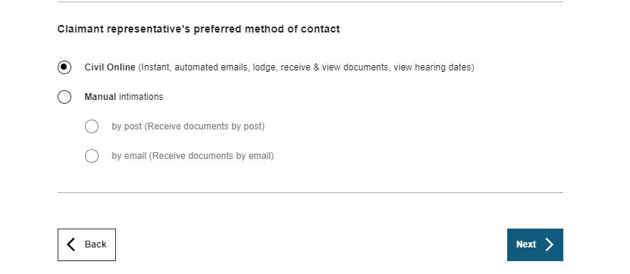

# **SUBMITTING A NEW SIMPLE PROCEDURE CLAIM**

## Respondent details

Users are then required to enter details about the first respondent including name and postal address.

If the email address of the respondent is known this can be entered too.

If there are multiple respondents, users can add additional respondents by clicking on “Add another respondent”. Users can add up to 20 respondents using this functionality.

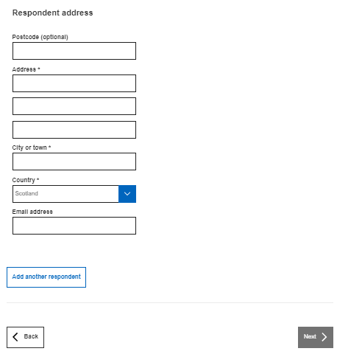

# **SUBMITTING A NEW SIMPLE PROCEDURE CLAIM**

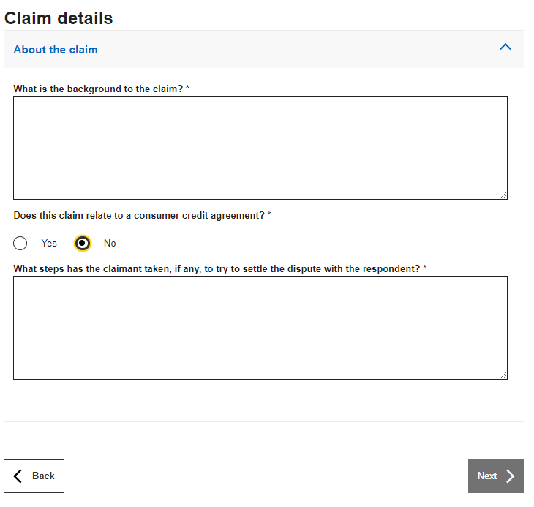

## Claim details – About the claim

Users are then required to enter the details of the claim, including steps already taken to resolve the matter.

If the claim relates to a consumer credit agreement and the user selects “yes” a further field will display where the user is required to enter the details of the consumer credit agreement.

**NOTE**: The “What is the background to the claim?” and “What are the details of the consumer credit agreement?” fields have a 5000 character limit.   
  
The “What steps has the claimant taken, if any, to try and settle the dispute with the respondent?” has a 4000 character limit.

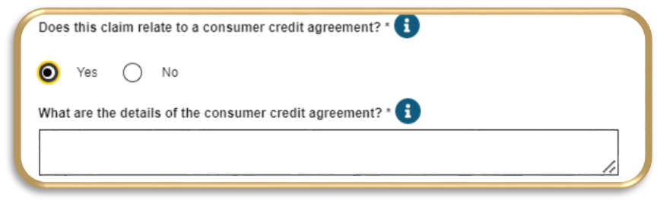

# **SUBMITTING A NEW SIMPLE PROCEDURE CLAIM**

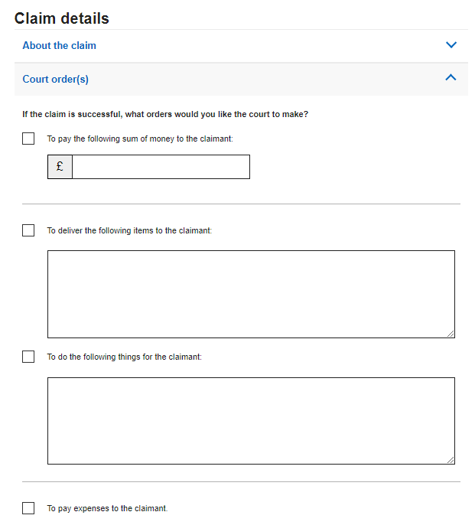

# Claim details – court order(s)

The user is then required to enter details about what orders they would like the court to make if the claim is successful.

Users can select multiple options.

If the user selects the option for payment of a sum of money, a new additional option will be presented to the user, so they can select if they wish to seek interest on that sum of money. The interest rate box is populated with” 8.0% annually commencing on the last date for service” but can be amended as appropriate, if applicable.  
  
The interest rate textbox can also be used to detail and breakdown interest on sums that may run from varying dates.

.

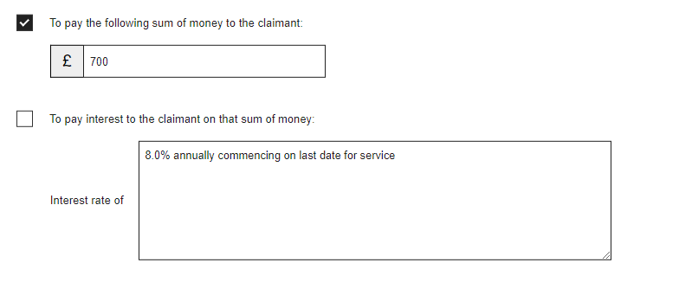

# **SUBMITTING A NEW SIMPLE PROCEDURE CLAIM**

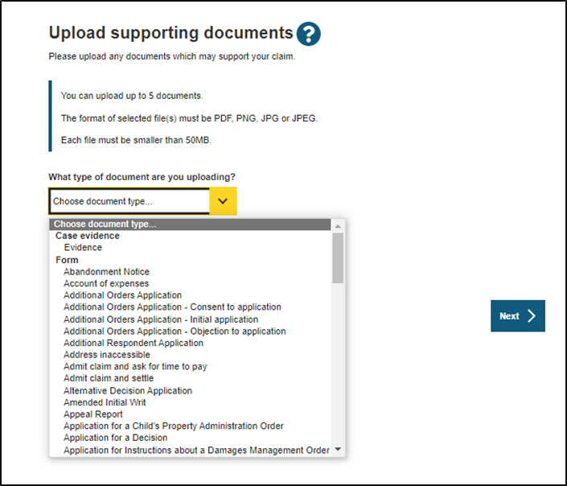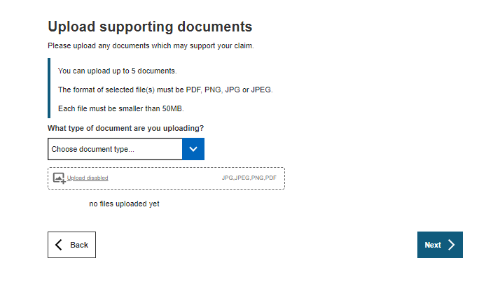

1

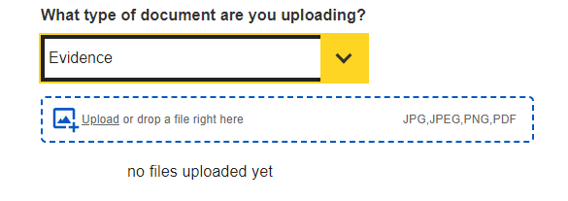

# Upload supporting documents

The relevant document type should be selected from the drop down menu. Upload functionality is disabled until the document type is selected.   
  
Once a document type has been selected the user can either, click on the word “Upload” (see 1) and this will open the users file explorer and allow them to navigate to the document(s) saved on their device, or they can simply drag and drop the required file(s) into the upload window (bordered in blue, see 1).

If selecting or dragging and dropping multiple files at once, please ensure that they are all the same document type e.g. evidence. If they are not, e.g. one document is evidence the other is a list of witnesses, the user should upload all the documents of one document type, then ensure they change the selected document type prior to selecting or dragging and dropping the next document type for upload.

If the user does not wish to upload any supporting documents they can simply press “Next”.

porting documentation with the claim form they can click “next”

# **SUBMITTING A NEW SIMPLE PROCEDURE CLAIM**

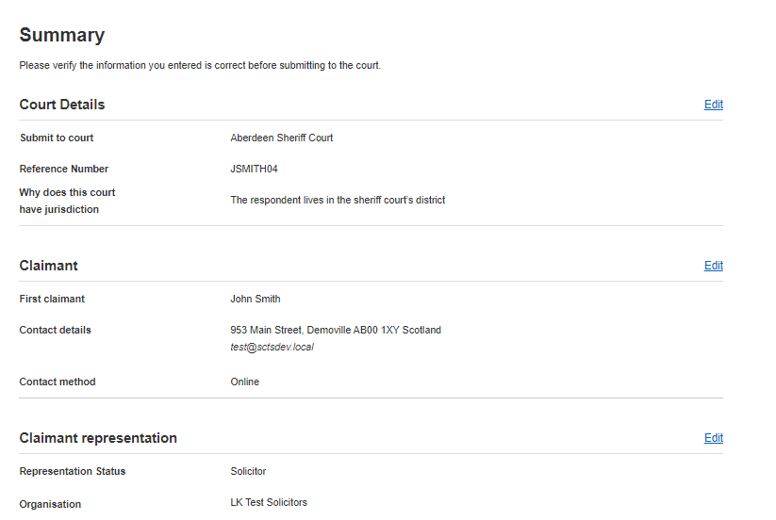

## Summary

Users will then be taken to the summary page where they can check the details of the claim prior to submitting.

If any amendments to the claim are required users can select the “Edit” button at the relevant section and this will direct users to the relevant screen.

Alternatively, users can use the “Back” button at the bottom of the screen to navigate through each of the screens until they get the relevant one.

Once the user is content with the claim they should click “Submit” which will direct them to the screen to the “pay for your document” i.e. claim form.

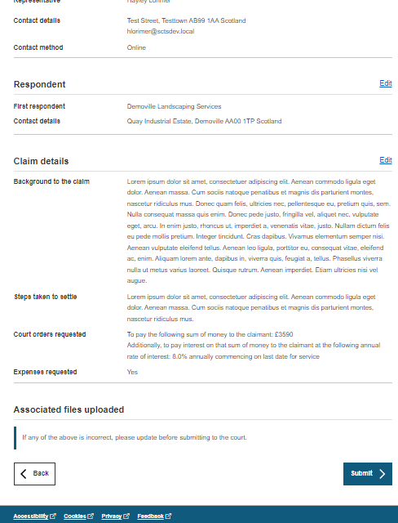

**NOTE:** If navigating to the previous section please use the “Back” button indicated in the screenshot and not the back button of your browser. Using the browser back button could re-direct users to the home page.   
  
Claim forms are auto-saved to drafts so if you do accidently exit, you will be able to resume completion of the claim.

# **SUBMITTING A NEW SIMPLE PROCEDURE CLAIM**

## Pay for your document

If the office that the user has selected or is logged in with holds an SCTS credit account, they will be advised that the credit account will be charged for the lodging of the document unless the user selects that the client is fee exempt.

If the office does not have an SCTS credit account, they will be presented with the Worldpay card payment component instead.

If the client is fee exempt and the user selects “Yes” then they will be presented with functionality to upload the required fee exemption form and appropriate supporting documentation.

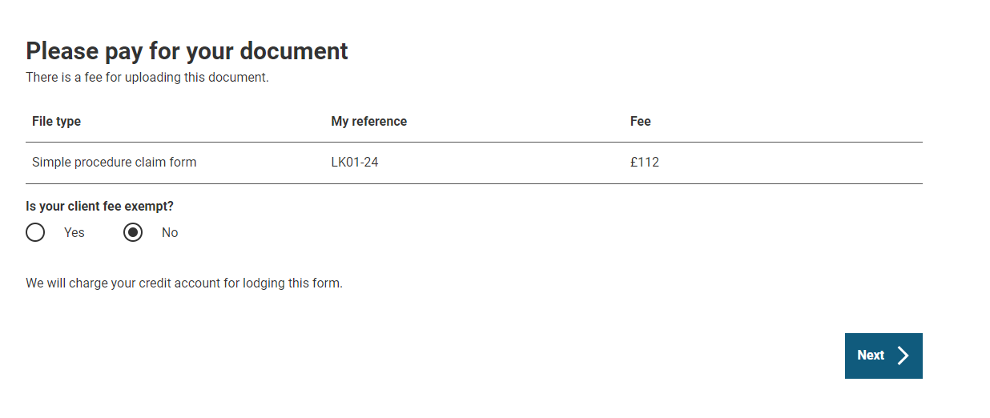

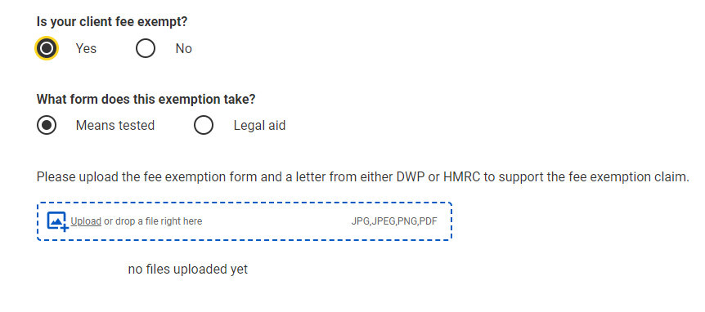

**NOTE:** For further information regarding fees and fee exemption forms please refer to the SCTS website.   
  
[Sheriff Court Fees (scotcourts.gov.uk)](https://scotcourts.gov.uk/rules-and-practice/fees/sheriff-court-fees)

[Fee Exemption Forms (scotcourts.gov.uk)](https://scotcourts.gov.uk/rules-and-practice/forms/fee-exemption-forms)

# **SUBMITTING A NEW SIMPLE PROCEDURE CLAIM**

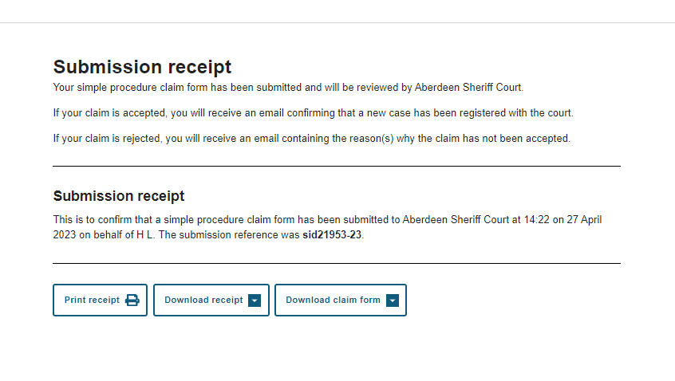

## Submission receipt

This page confirms that the claim has been submitted to the selected Court.

The user is provided with the submission ID (sid) number.

The user can also download their claim form and print or download the receipt.

The claim form and any other supporting documents will be considered by the court and either accepted or rejected. An email advising that the claim was accepted or rejected will be sent to the email address of the user who submitted the claim.

# **RESPONDING TO A SIMPLE PROCEDURE CLAIM**

When the tile “New response” is selected on the home page, users will be taken to the start of the response journey.

In order to respond to a claim users are required to enter some details about the claim. This information can be obtain from the documentation that was served on the respondent.

Firstly, if the claimant is an individual the user is required to enter only the surname of the first claimant. If the claimant is a company or an organisation, the user should enter the full name of the first claimant in the field.

Users are also required to enter the case reference number of the case they are responding to.

Once the user adds these details the page will refresh. If there is more than 1 respondent named in the claim the user will be asked to confirm which respondent they are representing

The user will be required to select whether the respondent is a person or a company/ organisation. The option selected here will determine which fields are shown on the following screens.

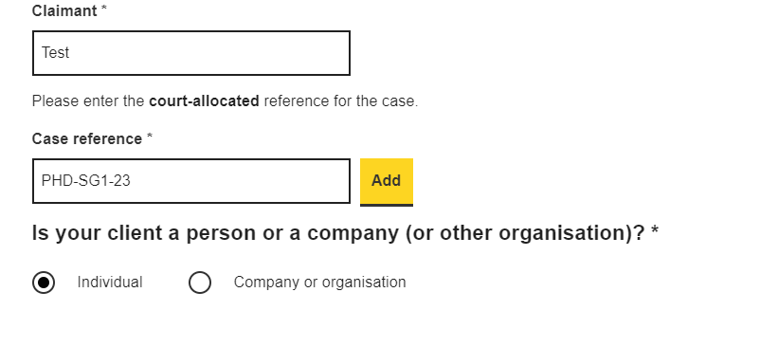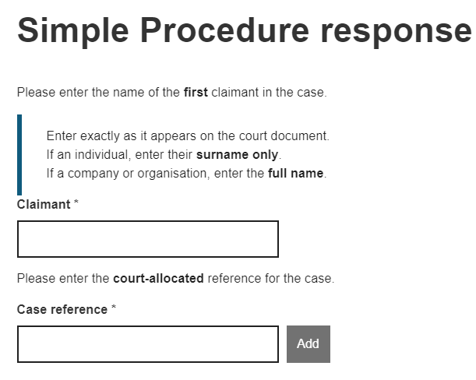

# **RESPONDING TO A SIMPLE PROCEDURE CLAIM**

# How does your client wish to respond to the claim?

The user will then be asked to select how the client wishes to respond to the claim. The steps that follow after pressing “next” will differ slightly, depending on the response selection made. This guide covers each response option. Users can skip to the one that is required, the start pages are listed below for ease of reference.   
  
Admit the claim and settle – page 28

Admit the claim and seek time to pay the money – page 34

Dispute the claim or part of the claim – page 35

# **RESPONDING TO A SIMPLE PROCEDURE CLAIM**

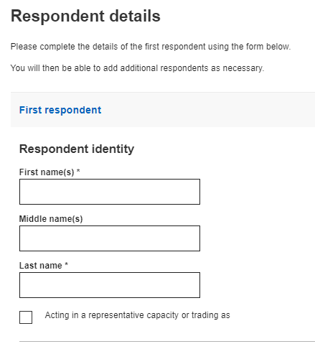

# ADMIT THE CLAIM AND SETTLE

# Respondent details

If users select “I want to admit the claim and settle before the last date for response” they will firstly be brought to this screen where they are required to enter details about the respondent.

Any mandatory fields are marked with *

Should the user wish to add an additional respondent or respondents there is a button at the bottom of the page which, if selected, will open a further section for users to enter details as appropriate.

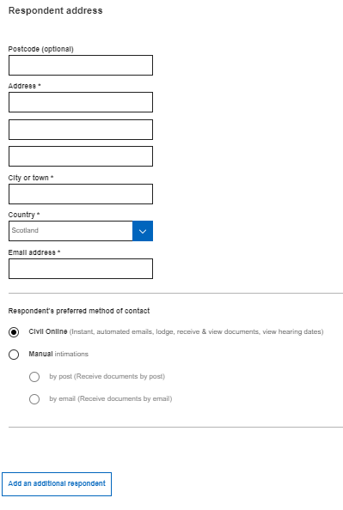

# **RESPONDING TO A SIMPLE PROCEDURE CLAIM**

# Additional respondent(s)

If a user has clicked the button to add an additional respondent this section populates on screen where the user can enter the required or relevant details for that respondent, including the reason for adding an additional respondent to the claim.

Users can add up to 20 respondents

Users can also remove any additional respondents entered should they need to do so by clicking remove next to the desired additional respondent.

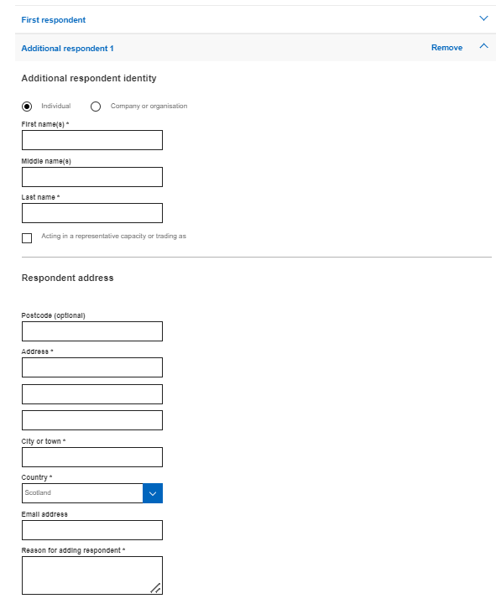

# **RESPONDING TO A SIMPLE PROCEDURE CLAIM**

# Respondent representation

Information on this screen is pre-populated into the appropriate fields. It is designed to save users time by not having to enter their details each time they respond to a claim.

1. When “yes” is selected, the first name, last name and email address fields cannot be amended.
2. If the user responding to the claim is not the solicitor (e.g. the response is being submitted by a legal secretary on behalf of a solicitor) they can select the “No” radio button. The first name, last name and email address fields become editable and the user can enter the details of the appropriate solicitor.
3. Users can amend the preferred method of contact. Civil Online is selected by default.

Users are encouraged to keep the method of contact set to “Civil Online” as users will receive instant automatic case updates known as portal notifications.  
  
Manual intimations can be selected however, this may require court staff to manually issue case documents by either post or email and therefore is not instantaneous

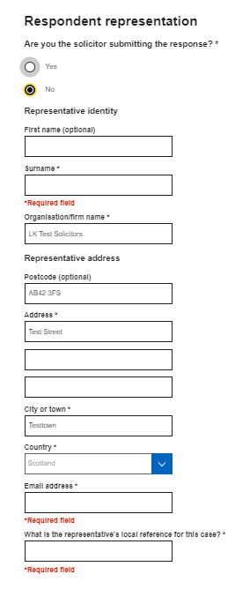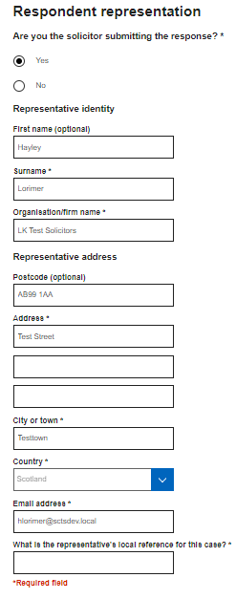 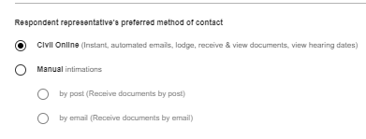

3

1

2

**NOTE:**  The organisation/firm name and address fields are not editable. If these details are incorrect and require to be updated please contact [civilonlinelab@scotcourts.gov.uk](mailto:civilonlinelab@scotcourts.gov.uk)

# 

# **RESPONDING TO A SIMPLE PROCEDURE CLAIM**

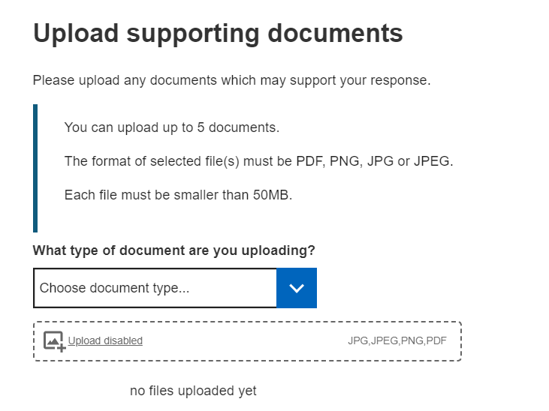

# Upload supporting documentation

Users can choose to upload any supporting documents if they wish.

1. The upload functionality is disabled and the box appears grey in colour until the document type has been selected from the drop-down menu (see image 1).
2. Once the document type has been selected, the upload functionality component changes to a blue border.

Once a document type has been selected the user can either, click on the word “Upload” and this will open the users file explorer and allow them to navigate to and select the document(s) they wish to upload, or they can simply drag and drop the required file(s) into the upload window (bordered in blue in image 2).

If selecting or dragging and dropping multiple files at once, please ensure that they are all same type of document e.g. evidence. If they are not, e.g. one document is evidence the other is a list of witnesses, the user should upload all the documents of one document type, then ensure they change the selected document type prior to selecting or dragging and dropping the next document type for upload.

1

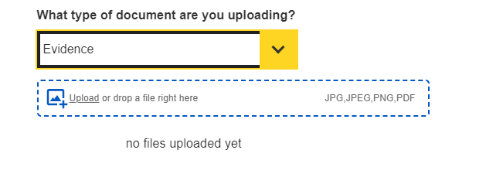

2

# **RESPONDING TO A SIMPLE PROCEDURE CLAIM**

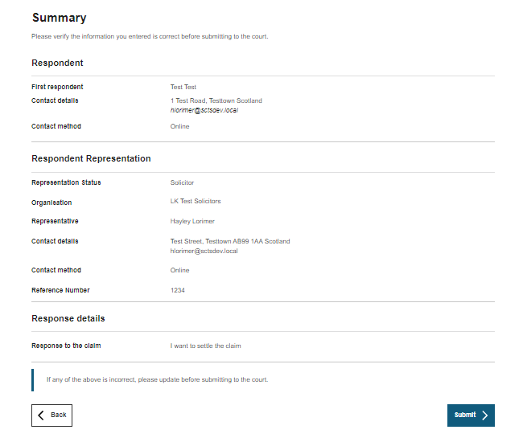

**NOTE:** Please ensure that you use the “Back” button indicated in the screenshot and not the back button of your browser. If you use the browser back button this will return you to the home page. Response forms are auto-saved to drafts so if you do accidently exit, you will be able to resume completion of your response.

Respondent Summary Page  
  
Users will then be taken to the summary page where they can check the details of the response prior to submitting.

1. If any amendments to the response are required users should utilise the “Back” button to navigate to the relevant screen.

# **RESPONDING TO A SIMPLE PROCEDURE CLAIM**

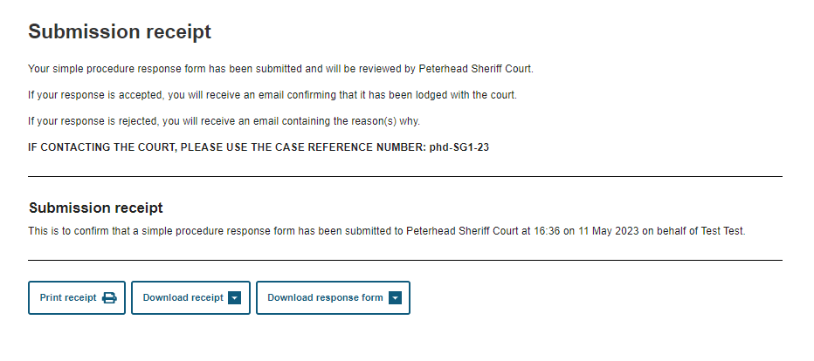

# SUBMISSION RECEIPT

This page confirms that the claim has been submitted to the selected Court.

The user can also download their claim form and print or download the receipt.  
  
The response and any other supporting documents will be considered by the court and either accepted or rejected. An email advising that the response was accepted or rejected will be sent to the email address of the user who submitted the response.

# **RESPONDING TO A SIMPLE PROCEDURE CLAIM**

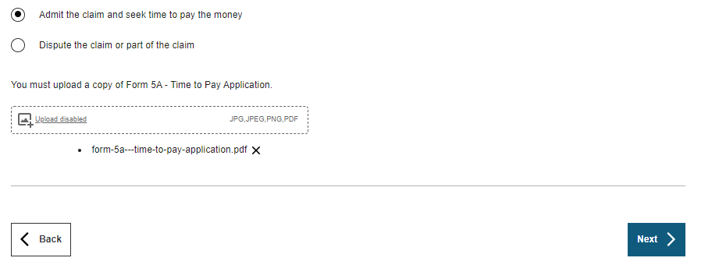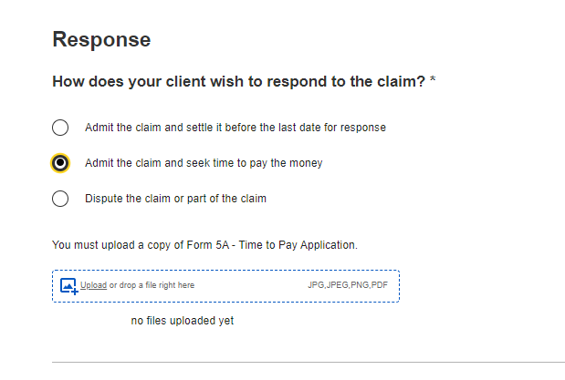

## ADMIT THE CLAIM AND SEEK TIME TO PAY THE MONEY

If the user selects this radio button option. An upload component will populate on screen.

Users must upload a completed copy of the Form 5A – Time to Pay Application.  
These forms are available for download on the website. [Simple Procedure Forms (scotcourts.gov.uk)](https://www.scotcourts.gov.uk/rules-and-practice/forms/sheriff-court-forms/simple-procedure-forms)

Users can either, click on “Upload” and this will open the user’s file explorer and allow them to navigate to and select the required file, or they can simply drag and drop the required file into the upload window (bordered in blue)

Users are only able to upload one file at this stage.

Once this is completed, users can select “Next”.

The user will then be brought to the “Upload Supporting Documents” screen (see page 31), followed by the “Summary” screen (see page 32), followed by the “Submission Receipt” screen (see page 33).  
  
These sections work in the same way regardless of the response selected so please refer to the earlier guidance pages for information on these.

# **RESPONDING TO A SIMPLE PROCEDURE CLAIM**

# 

# 

## DISPUTE THE CLAIM OR PART OF THE CLAIM

If the user selects “Dispute a claim or part of the claim” then the user will be required to complete the fields shown.

“What is the background to the claim?” has a 4000 character limit and the “What steps has your client taken to try and settle the dispute with the claimant?” has a 4000 character limit.

The user will then be brought to the “Upload Supporting Documents” screen (see page 31), followed by the “Summary” screen (see page 32), followed by the “Submission Receipt” screen (see page 33).  
  
These sections work in the same way regardless of the response selected so please refer to the earlier guidance pages on these for information.

# **MY DRAFTS**

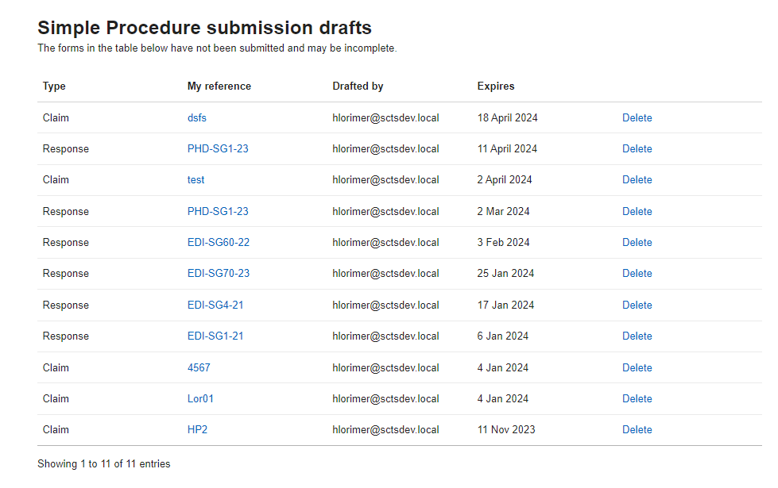

When the user selects the “My drafts” they will be brought to this screen where they can see any simple procedure claims or responses that have not been fully completed and submitted to the court. They will also see any rejected claims that the user has started reviewing but not re-submitted to court.

Drafts are arranged with the newest created draft appearing at the top of the list.

Users can resume drafting their claim or response by clicking on the required reference number.

Drafts are retained for 1 year from the date of creation. After this time they will be automatically deleted.

A user can also delete a draft should they wish to do so. After clicking delete the user will be prompted to confirm they wish to delete the draft as once the draft is deleted it cannot be recovered.

# **MY CASES**

When on the “My cases” page a user can view all of the current live cases for the selected office.   
  
There are 3 filters and a search bar that can be utilised to assist users in locating a case quickly. The drop-down lists of these filters are dynamically populated so users will only see options that are relevant to their list of cases.

Once a case has been registered by a court, if your company/office is marked as a representative of a party in the action, the case will appear on your list of cases. Cases are sorted by date of registration with the earliest date displaying first. Any cases that have a notification present, indicated by the bell icon, appear at the top of the list of cases to bring it to the attention of users. Notifications are covered in more detail on page 41.  
  
Any cases that have been disposed will display for 1 year after disposal and thereafter will automatically be removed from the list of cases.   
  
If a Simple Procedure claim has been rejected by a court, it will also be listed here with a status of rejected. Further information on rejected claims is available on page 42.

References that are hyperlinked indicates that case tracker functionality is available. Any case reference numbers that appear in plain black (such as EDI-A103-22 above) indicates that the case cannot be tracked and is available on the portal for document submission only.

1

# **SUBMIT DOCUMENTS**

Users can choose to submit documentation for cases shown in the “My Cases” list.   
  
If you are the representative of a claimant in a Simple Procedure action, when you click “Submit documents” you will also be presented with the option to submit an “Application for a Decision” which is an online form that can be completed.

When submitting other documents or evidence, in order to upload a document the relevant document type requires to be selected from the drop down menu. Upload functionality is disabled until this step has been completed.   
  
Up to 5 documents, for the same case, can be uploaded at once. Each file must be smaller than 50MB and the format of the file(s) must be PDF, PNG, JPG or JPEG.

Once a document type has been selected the user can either, click on the word “Upload” and this will open the users file explorer where they can navigate to and select the document(s) they wish to upload, or they can simply drag and drop the required file(s) into the upload window (bordered in blue see no.2).

If selecting or dragging and dropping multiple files at once, please ensure that they are all same document type e.g. evidence. If they are not, for example one document is evidence the other is a list of witnesses, the user should upload all the documents of one document type, then ensure they change the document type in the drop down prior to selecting or dragging and dropping the next document type for upload.

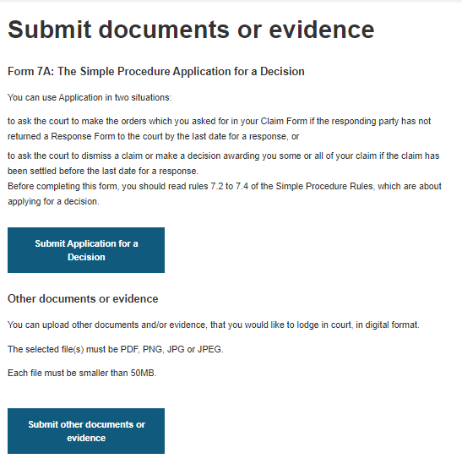



**NOTE:**  It is currently not possible to submit initiating documents for non-Simple Procedure Actions via Civil Online i.e. Initial Writs and Notices of Intention to Defend (NIDs).   
  
No documents of any kind can be submitted for cases relating to Adoptions, Permanence Orders or Human Fertilisation and Embryology.

1

2

# **SUBMIT DOCUMENTS**

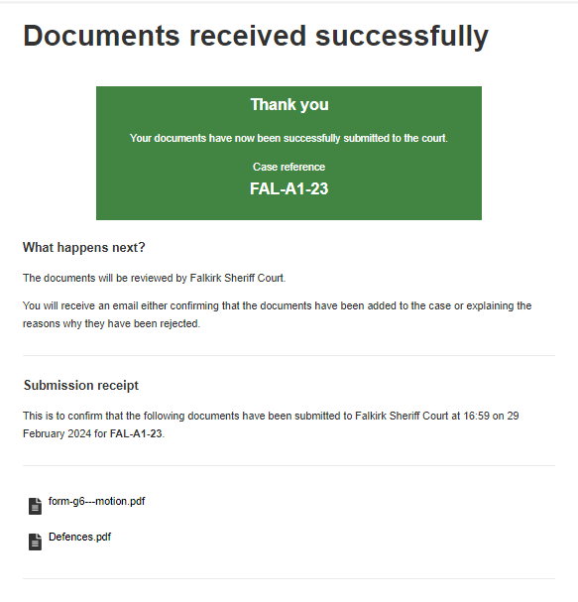

# 

Submit documents - Pay for your document(s)  
  
If any of the documents being submitted are chargeable, users will be directed to the “Pay for your document(s)” screen, which will advise of the associated fees. If you are submitting both chargeable and non-chargeable documents only the chargeable documents are shown on this list. These will be charged to your credit account once they have been checked by court staff.   
  
If you do not have a credit account, you can only submit non-chargeable documents.   
  
If you have no chargeable documents, you will be directed straight to the submission confirmation screen.

# **CASE TRACKING – SIMPLE PROCEDURE**

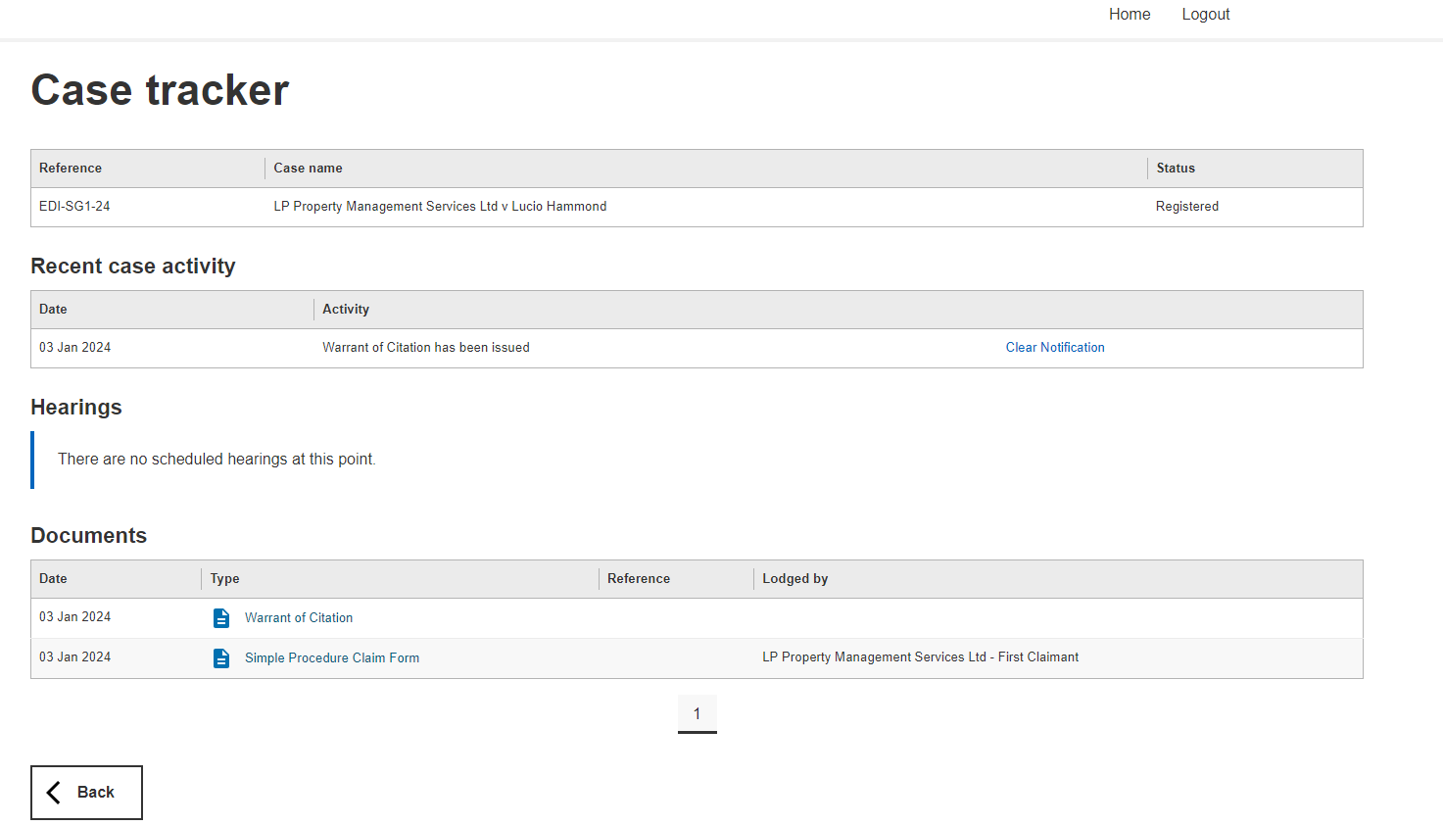

When a user clicks on the hyperlinked reference number of a case they will be brought to the case tracking screen. Case tracking for Simple Procedure is slightly different from case tracking for ordinary cause actions, therefore this guide covers each separately.

Users will see a table called “Recent case activity” this is where any notifications for the case will appear. Notifications do not clear automatically and require the “Clear Notification” button to be selected. This prevents notifications inadvertently disappearing. More information on notifications is available on page 41.

Below this are 2 further sections, hearings and documents. These sections will be populated as appropriate.

Documents that are submitted to the court by a party will not appear on the list of documents until they have been accepted by the court. Users can view a document by clicking on document icon or document type, this will open the document in a new tab. Once the document has opened users can opt to print or save the document should they wish.

# **NOTIFICATIONS**

Users can check for notifications by accessing the “My Cases” screen. Notifications are only available for Simple Procedure cases.   
  
In order to receive portal notifications in a case, the representative’s contact preference must be set to “Online”. The contact preferences are selected when completing claim and response forms. Should this require to be updated please contact the appropriate court.

Where there is notification present in a case, a bell icon will be displayed next to the reference number and the case is moved to the top of the “My Cases” list, to bring it to the attention of the user. Notifications show for all users of an office/company.  
  
Notifications are received when someone else has initiated something for example, another party in the case has lodged evidence, or the court has issued an Order of the Sheriff or Judge.

In order to remove the bell icon, users will require to access the case tracker screen and click “clear notification” for all recent case activity. Clearing the notification, clears it for all users of the company or office. A confirmation message is displayed when a notification has been cleared and the recent case activity table will no longer be visible.   
  
Once all notifications have been cleared the bell icon will be removed and the case will revert back to its normal sort order on the “my cases” screen.

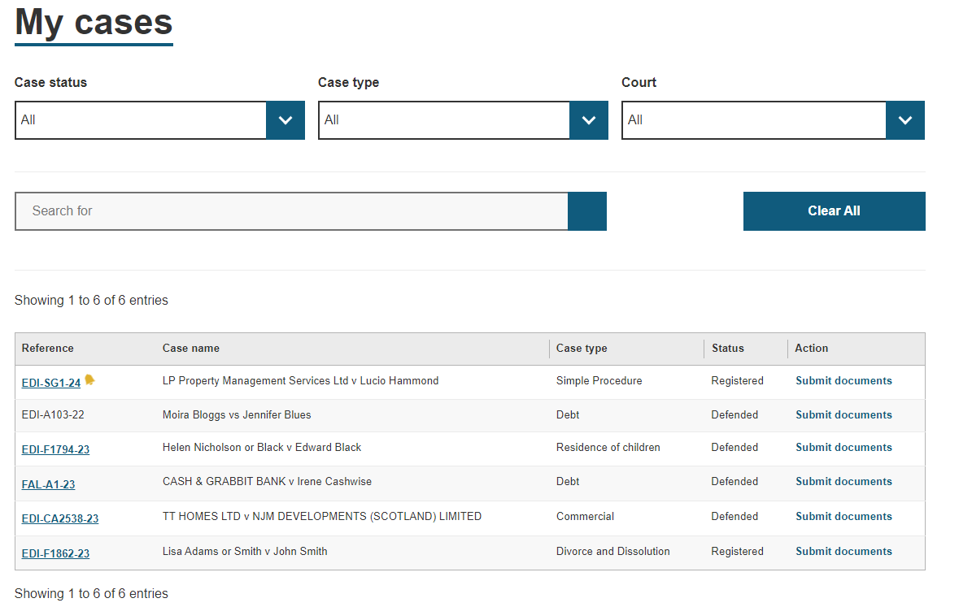

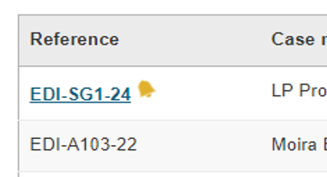

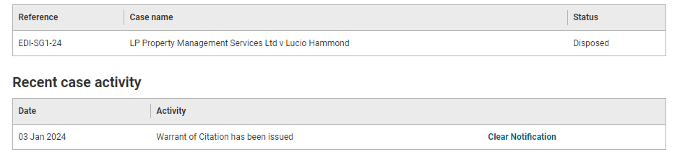

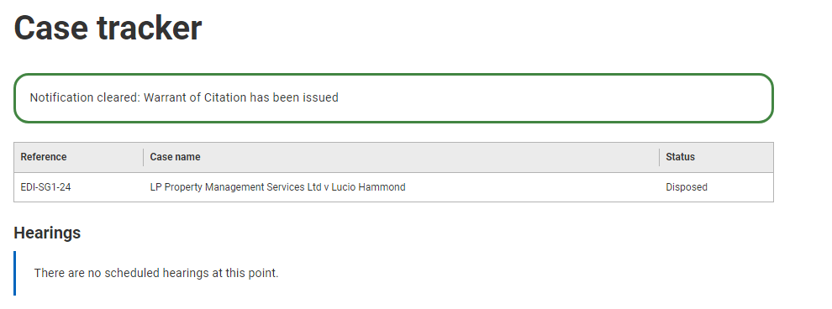

# **REJECTED SIMPLE PROCEDURE CLAIMS**

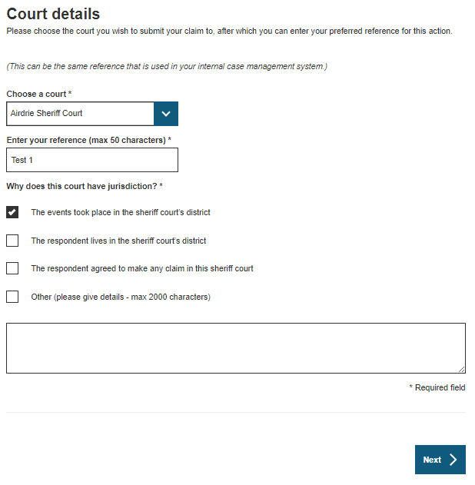****

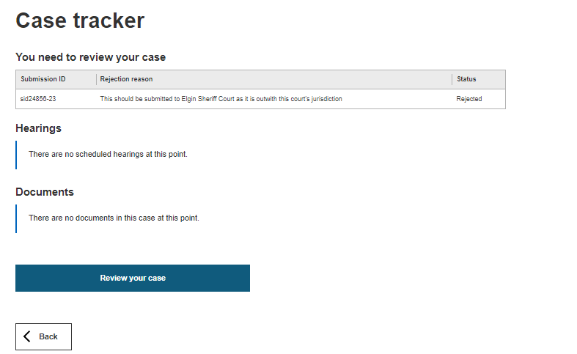

If a Simple Procedure Claim has been rejected by the court, the user that submitted the claim will receive an automated email advising that the claim has been rejected and that you can view the rejection reasons and re-submit your claim on Civil Online.  
  
Rejected simple procedure claims will be listed on the “My Cases” screen. Users should click the reference hyperlink and this will bring them to the “Case Tracker” screen where they can view the rejection reason. Users can select “Review your case” to start amending their rejected claim.   
  
Once a user has commenced review, the rejected claim will no longer appear on the “My Cases” screen. It will instead be displayed under “My Drafts” until it is resubmitted or deleted.

# **CASE TRACKING – ORDINARY ACTIONS**

# 



Case tracker functionality for Ordinary Cause actions registered in the Sheriff Court and All-Scotland Sheriff Personal Injury Court will go live on the evening of 31st July 2024. This case tracking functionality will not be available for cases registered before the deployment.

When a user clicks on the hyperlinked reference number of a case they will be brought to the case tracking screen.  
  
The first table provides details of the case that you are tracking such as the court reference, case name and status. Above this there is a button to “Submit Documents” for this case, to save users from having to navigate back to the “My Cases” screen

**Inventory of process (IoP)**

The Inventory of Process on Civil Online is designed as a replica of the digital inventory of process on ICMS which is the case management system used by court staff and Sheriff’s. This digital inventory of process follows the same numbering system that was used for paper processes, with some small tweaks.

Items 1-9 are set document types. If a document is lodged or issued that falls into one of these set document categories, it will show in the appropriate section, for example motions will be number 7 of process. Any documents that don’t fall into the pre-set categories are given the next number of process. There is no number 4 of process, because in paper processes this number was used for copy interlocutors, which aren’t required in a digital inventory so has been omitted.

# **CASE TRACKING – ORDINARY ACTIONS**

**Inventory of Process (IoP) continued…**

If a document type is hyperlinked, users can click the hyperlink to view the document which will open in a new tab where users can print or save the document should they wish. There may be occasions where there is no hyperlink to view the document and instead the document appears in plain black text. This is expected behaviour when no document has been uploaded to ICMS or a document has been hidden by court staff.

**Multi-Doc View**

Numbers 1-9 of process are capable of having multiple documents contained therein. If there is more than one document within a document type, then the number of documents will be indicated in brackets (see number 1). When there are multiple documents and a user clicks on the document type this will open a sub-level view, where users can see all the documents of that type (see number 2).

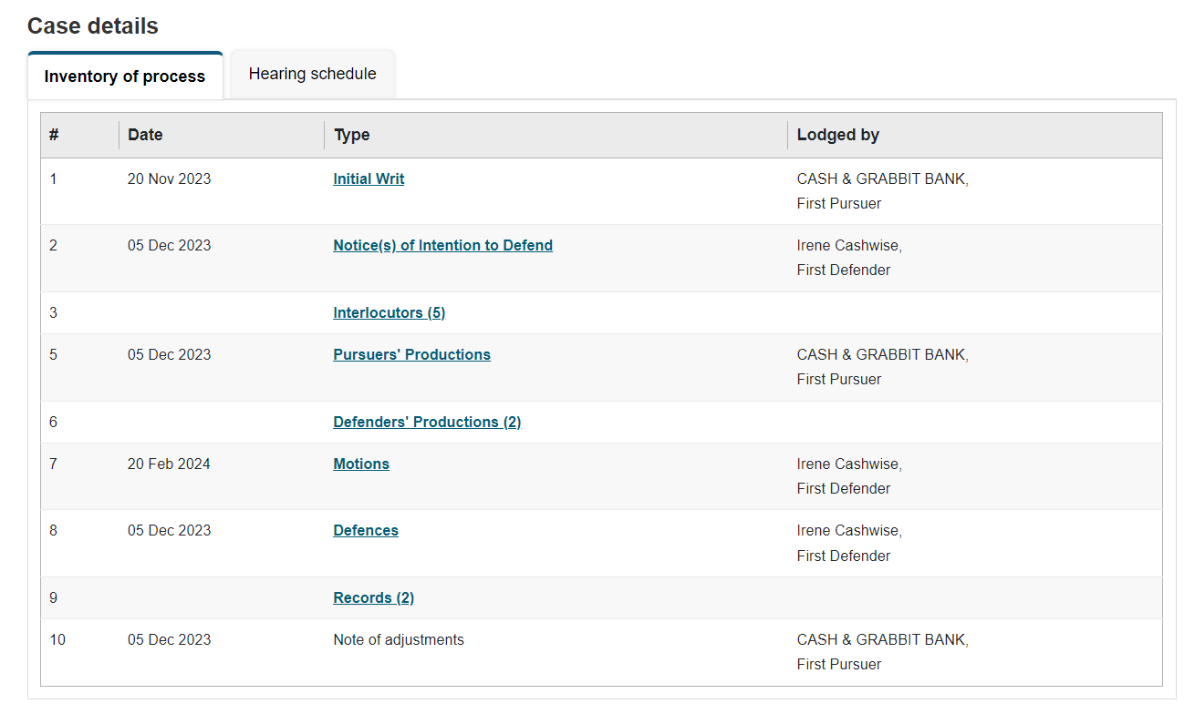

**1**

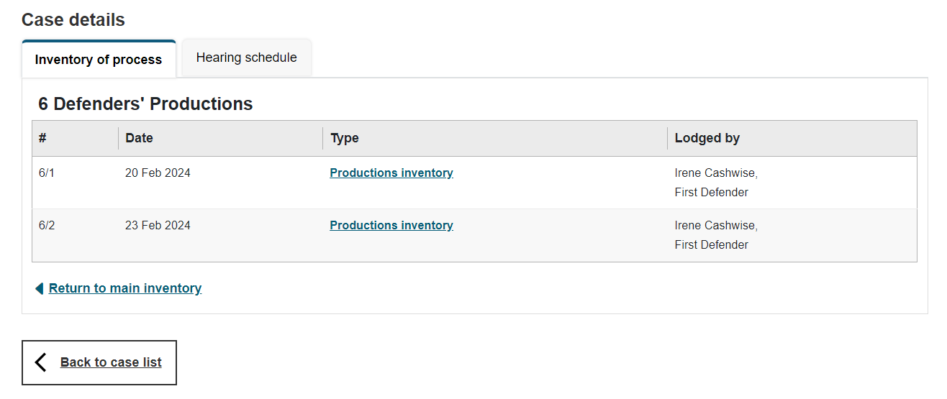

**2**

# **CASE TRACKING – ORDINARY ACTIONS**

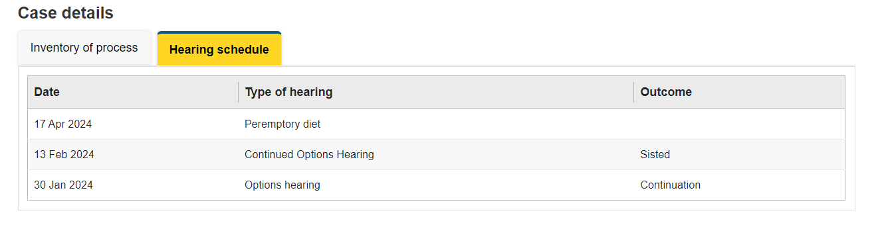

**Hearing Schedule**

This tab is populated with any hearings that are scheduled or taken place. If there are no hearings a message stating “No hearings to display” will show.

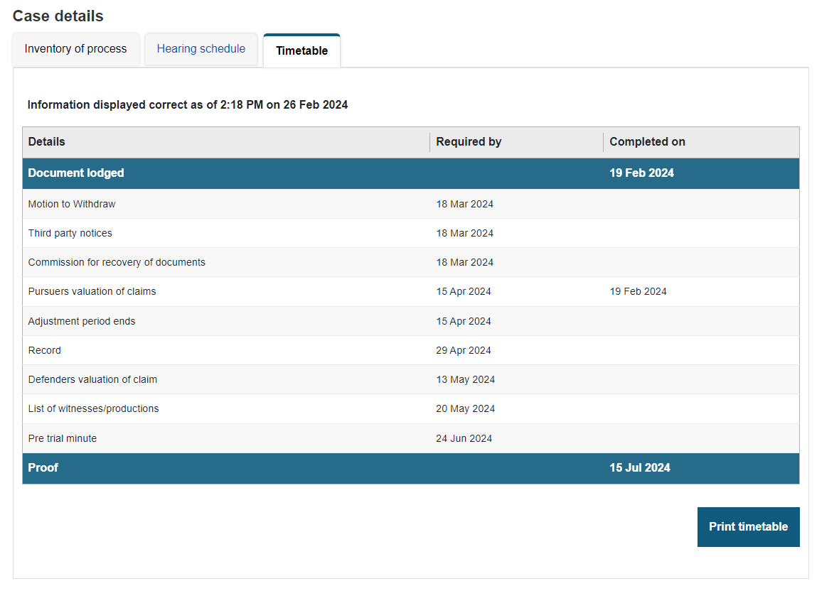

**Timetable**

This tab will only display for personal injury actions. The timetable is created when an allocated proof hearing is assigned. If a timetable has not yet been created the following message will be shown “Timetable has not been created in this case. It will be created when Allocated proof hearing is scheduled”.

Timetables in an action can be updated by court staff to enter the date events have been completed or amend the dates accordingly.

A user can opt to print the timetable. The timetable therefore has a message advising users that the information displayed is correct as of the time and date the page is loaded.

# 

# **COURT OF SESSION -** **CASE TRACKING**

Case tracking functionality for cases registered in the Court of Session will go live from Wednesday 5th February 2025. This case tracking functionality will not be available for cases registered before 1st August 2024.

When a user clicks on the hyperlinked reference number of a case they will be brought to the case-tracking screen.  
  
The first table provides details of the case that you are tracking such as the court reference, case name and status. Above this there is a button to “Submit Documents” for this case. Please be aware that with Court of Session cases you will not initially be able to submit documents, however it is expected that this will be introduced at a later date.

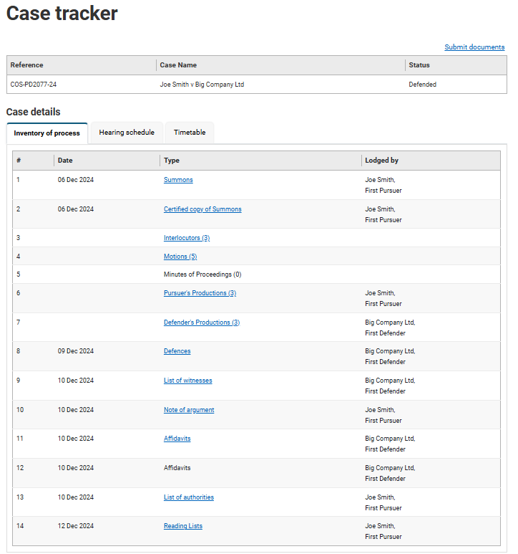

**Inventory of process (IoP)**

The Inventory of Process is designed as a replica of the digital inventory of process on ICMS (which is the case management system used by court staff and judges). This digital inventory of process follows the same numbering system that was used for paper processes within the Court of Session.

Items 1-7 are set documents and parts of process. If a document is lodged or issued that falls into one of these set document categories it will show in the appropriate section. For example Interlocutors will be number 3 of process, Motions as number 4 and Productions are set as 6 for the pursuer and 7 for the defender. Any documents that don’t fall into the pre-set categories are given the next number of process and will be hyperlinked in order to click and view.

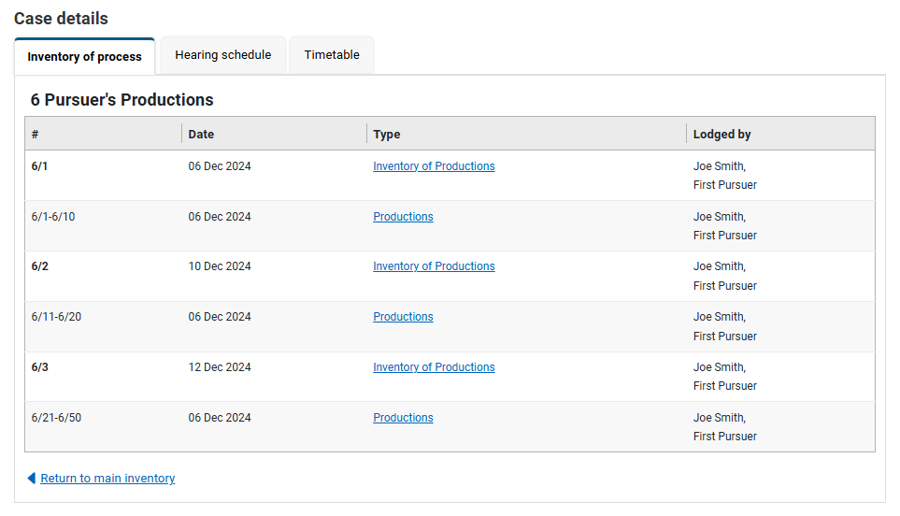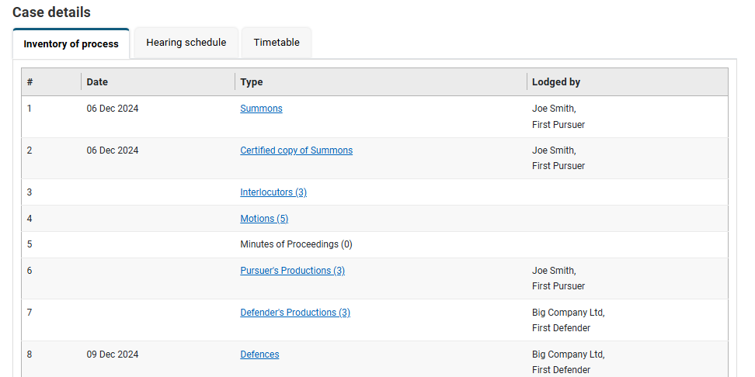

**2**

**1**

**Inventory of Process (IoP) continued…**

If a document type is hyperlinked, users can click the hyperlink to view the document which will open in a new tab where users can print or save the document should they wish. There may be occasions where there is no hyperlink to view the document and instead the document appears in plain black text. This is expected behaviour when no document has been uploaded to ICMS or a document has been hidden by court staff.

**Multi-Doc View**

Numbers 1-7 of process are capable of having multiple documents contained therein. If there is more than one document within a document type, then the number of documents will be indicated in brackets (see number 1). When there are multiple documents and a user clicks on the document type this will open a sub-level view, where users can see all the documents of that type (see number 2).





**Hearing Schedule**

This tab is populated with any hearings that are scheduled or taken place. If there are no hearings a message stating **“No hearings to display”** will show.

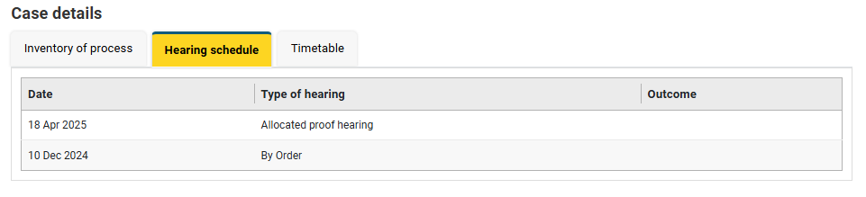

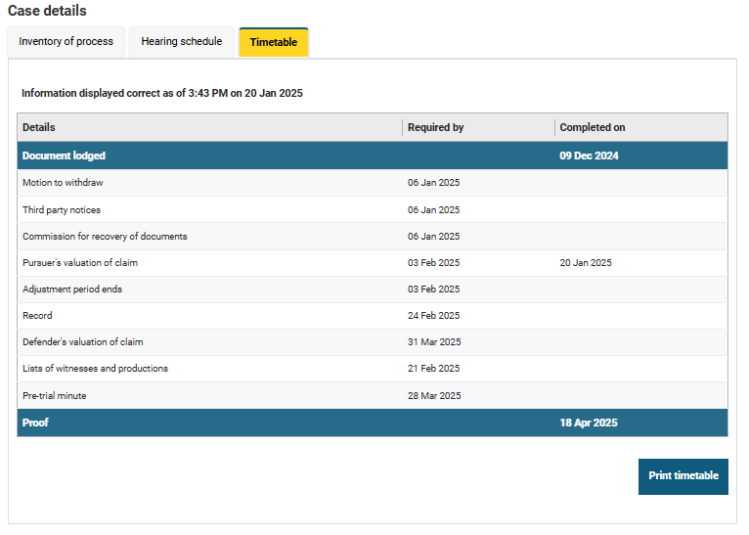

**Timetable**

This tab will only display for personal injury actions. The timetable is created when an allocated proof hearing is assigned. If a timetable has not yet been created the following message will be shown **“Timetable has not been created in this case. It will be created when Allocated proof hearing is scheduled”**.

Timetables in an action can be updated by court staff to enter the date events have been completed or amend the dates accordingly.

A user can opt to print the timetable. The timetable therefore has a message advising users that the information displayed is correct as of the time and date the page is loaded.

# **Frequently Asked Questions (FAQs)**

|  |
| --- |
| What is Civil Online? |
| Civil Online is an online facility that enables users to securely raise, respond to and track the progress of civil actions.  Solicitor users can use Civil Online to:   * Submit, track and renew caveats * Submit, respond to and track Simple Procedure cases. * Submit documentation for other civil action types. * Track Ordinary Cause action cases. * Make bulk submissions of Simple Procedure claims directly from your own case management system, using the Civil Online API. |
| How do I find Civil Online? |
| Access <http://www.scotcourts.gov.uk/> and follow the link to access Civil Online OR click the following link to go directly to [Civil Online (scotcourts.gov.uk)](https://civilonline.scotcourts.gov.uk/).  You must register your company/organisation before accessing Civil Online |
| Can I submit a document in a Court of Session case |
| A user will only be able to view the details of the case as well as print Timetables. There is currently no functionality to submit documents to the Civil Online Portal for Court of Session cases. It is expected that this will be added at a later date. In the meantime documents should continue to be submitted in the current manner. |
| What case types are not available to be tracked with the Court of Session |
| Cases that are unavailable to be tracked with Court of Session are   * Adoption and Permanence Orders * Human Fertilisation and Embryology * Simplified Divorce/Dissolution * Administration Notice of Appointment * Company Voluntary Agreement |
| How do I register my company/organisation for access to Civil Online? |
| Complete the Civil Online Registration form and email it to [civilonlinelab@scotcourts.gov.uk](mailto:civilonlinelab@scotcourts.gov.uk).   You will need to provide the following details:   * The company/organisation name and office address; * the Law Society reference for your branch/office (if you are registered with the Law Society of Scotland) and * The name and email address for one or more persons within your company/organisation to be an admin user. |
| How do I sign-up to Civil Online? |
| Firstly, your company/organisation requires to be registered for access to Civil Online. If this has already been done and your email address is listed as an admin user, please follow the solicitor sign-up process on Civil Online (see page 3).   If you are not an admin user, and require access to Civil Online please speak to an admin user for your company/organisation who can set-up your email address as a non-admin user.   If you require to be set up as an admin user and your firm is already registered please complete the Civil Online Admin User Modification Form and send it to [civilonlinelab@scotcourts.gov.uk](mailto:civilonlinelab@scotcourts.gov.uk) |
| What is an admin user? |
| An admin user can use the ‘User Admin’ feature when logged in to Civil Online. This enables them grant access to additional users from within their office – putting them in control of their list of users without the necessity to contact SCTS.  Each admin user needs to have a unique email address, so the same person cannot be an admin user across multiple offices unless they supply a different email address for each office. |



**FAQs**

|  |
| --- |
| Does a non-admin user have the same permissions as an admin user? |
| A non-admin user (i.e. a user who has been added through the “User Admin” feature) will not be able to see or access the “User Admin” feature as this remains restricted to admin users. Otherwise, the permissions are the same |
| Can a user have access to more than one office on Civil Online? |
| A user can have access to more than one office on Civil Online without the necessity of supplying different email addresses.  To obtain access to another office on Civil Online, please contact an admin user from the office you wish to gain access too. If that office has not been registered with civil online, please complete the registration form and email it to civilonlinelab@scotcourts.gov.uk |
| Why do I not see the Caveats options when I log into Civil Online? |
| Caveats functionality on Civil Online is currently only available to solicitor users whose company/organisations has an active SCTS credit account.  For information on SCTS credit accounts, please refer to the website [Credit Accounts (scotcourts.gov.uk)](https://www.scotcourts.gov.uk/finance/credit-accounts) |
| Can I submit commissary caveats via Civil Online? |
| Civil Online cannot be used to submit commissary caveats to the courts. These should be submitted in the usual way. |
| Is there a draft functionality available for caveats? |
| Draft functionality is only available for Simple Procedure claims and responses. |
| What details can I amend when renewing a caveat? |
| A user can amend the contact details for the primary and out-of-hours contacts, they can also update the name of the solicitor who is signing the caveat.  If any changes are required to be made for something other than the above, (for example, amending the address of the party the caveat applies to) then a new caveat would require to be submitted. |
| The details of my solicitor firm/organisation on Civil Online are incorrect, how do I change this? |
| Solicitor firm/organisation details are pre-populated on Civil Online where appropriate. It is based upon information held on SCTS records.  If these require to be updated, please send confirmation of the required changes on headed paper to:  For SCTS credit account holders - [scts-ar@scotcourts.gov.uk](mailto:scts-ar@scotcourts.gov.uk); Or For non-credit account holders - [civilonlinelab@scotcourts.gov.uk](mailto:civilonlinelab@scotcourts.gov.uk) |
| Why can’t I case track some Ordinary or Court of Session actions? |
| Case tracking for Ordinary Cause actions and Court of Session cases is new functionality and is only available for actions registered by the court after the functionality was deployed i.e. registered after 1 August 2024. |
| Can I claim a fee exemption? |
| If your client is exempt from court fees you can indicate this when submitting a chargeable document. You can upload the Fee Exemption form and supporting evidence of the exemption – such as a copy of the legal aid certificate. |



|  |
| --- |
| Can I submit an initial writ or notice of intention to defend? |
| Currently you cannot submit Initial Writs or Notices of Intention to Defend via Civil Online.   These require to be submitted to the appropriate court in the usual way e.g. via email or post. |
| I have an enquiry who do I contact? |
| If your enquiry is regarding a request to register your company/organisation/office for Civil Online or make any modifications to the list of admin users, please contact [civilonlinelab@scotcourts.gov.uk](mailto:civilonlinelab@scotcourts.gov.uk)  If your enquiry relates to a case or if you require technical support with Civil Online, please contact the court handling the case or your local Sheriff Court or the Court of Session.   Contact details for all our courts are available on the website   [Find a court (scotcourts.gov.uk)](https://scotcourts.gov.uk/the-courts/sheriff-court/find-a-court) |
| Troubleshooting |
| If you are experiencing difficulties with Civil Online, you could try some of the following steps to see if it alleviates the issue:   * Often problems with loading web pages can be resolved by clearing cookies and cached data. * If this doesn’t resolve the issue please try an alternative browser i.e. Microsoft Edge or Google Chrome.   If contacting the court regarding a technical support issue, it can be helpful for users to provide the following information:   * Description of the issue * Screenshot of the error/issue (where appropriate) * Browser * Device * Operating System   If required, this information can then be passed on to our Service Desk team to investigate the matter. |

# **FAQs**