# Connecting to SCTS Business Wi-Fi for Justice Partners

Change History and Version Control

|  |  |  |  |  |
| --- | --- | --- | --- | --- |
| **Version** | **Status** | **Date** | **Author** | **Description Of Change** |
| 0.1 | Draft | 26/03/2024 | Ross Purvis | Initial Draft |
| 1.0 | Baselined | 13/05/24 | S Morris | Baselined after review |

Approval and Distribution List

|  |  |  |  |
| --- | --- | --- | --- |
| **Name** | **Title** | **Distribution or Sign Off** | **Link to Approval** |
| Stephen Morris | Project Manager | Sign Off | N/A |
| Alan Johnson | Project Manager | Distribution | N/A |
| Ross Purvis | Business Analyst | Distribution | N/A |
| Daniel Kelly |  | Distribution | N/A |

**Contents**

**Introduction** 4

**Before you start – Signing up for Usage** 4

**Connecting to the SCTS Business wifi** 4

**Connecting to the Captive Portal – Future Use** 8

**Troubleshooting & Support** 9

## **Introduction**

## SCTS have deployed a new Business Wi-Fi solution for use by justice partners. This network will provide justice partners with improved bandwidth enabling them to connect back to their corporate networks. You may have two devices registered but at this time can only use one device at the same time.

## Unlike connecting to Wi-Fi at home, Business Wi-Fi connects using a Captive Portal, which is a landing page asking the user to provide more info to be able to sign in. This means that there are a few more steps before you can get online using a captive portal Wi-Fi.

## **Before you start – Signing up for Usage**

To register to use the new Business Wi-Fi solution, justice partners will need to contact the appropriate contact. The contacts for each justice partner for registration are captured in the table below:

|  |  |
| --- | --- |
| **User Group** | **Contact Details** |
| Faculty of Advocates | [servicedesk@Advocates.org.uk](mailto:servicedesk@Advocates.org.uk) |
| Law Society | [member.registration@lawscot.org.uk](mailto:member.registration@lawscot.org.uk) |
| SLAB | [MacIsaacLi@slab.org.uk](mailto:MacIsaacLi@slab.org.uk) |
| Victim Support Scotland | [Stephen.Wheeler@victimsupportsco.org.uk](mailto:Stephen.Wheeler@victimsupportsco.org.uk) |
| SCRA | [itservicedesk@scra.gov.uk](mailto:itservicedesk@scra.gov.uk) |
| CJSW | [Helpdesk@scotcourts.gov.uk](mailto:Helpdesk@scotcourts.gov.uk) |
| Litigants and Social Security Workers | Clerk of Court |

You will then be provided with an email containing your portal username and password.

For Litigants and our colleagues at Social security – access can be requested via the clerk of court ahead of your hearing date.

## **Connecting to the SCTS Business Wi-Fi**

Select the Wi-Fi symbol found in your system tray on the bottom right hand side of the screen (next to the clock).

**C:\Users\rpurvis\AppData\Local\Microsoft\Windows\INetCache\Content.MSO\AE8471FE.tmp**

This will open up a list of all available wireless networks.

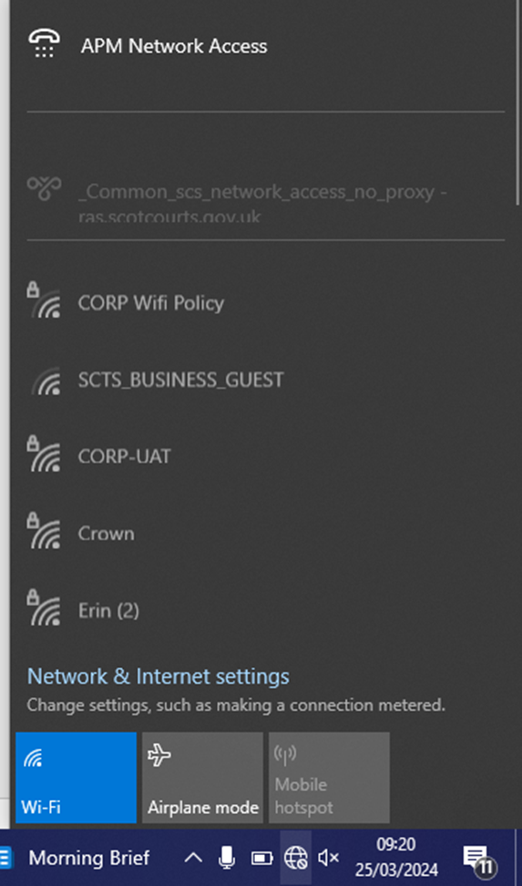

Select **SCTS_BUSINESS_GUEST** then click **Connect**.

The SCTS sign in window appears.

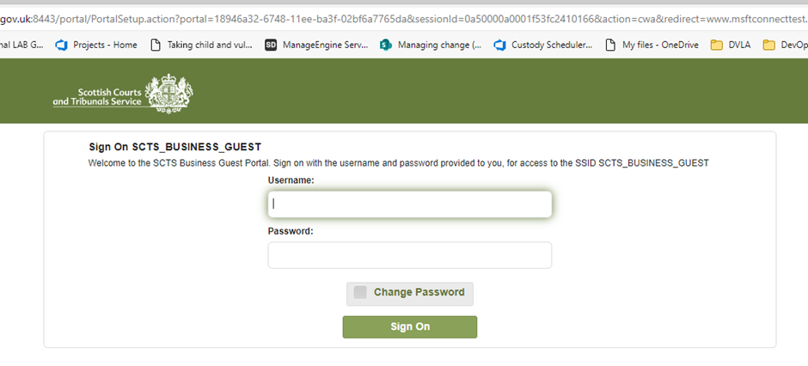

When logging in for the first time enter in the username and password provided to you from the registration email and select the ‘Sign On’ button.

After the first time you must enter in the username provided and the password you chose as part of step 5 of the initial log in journey

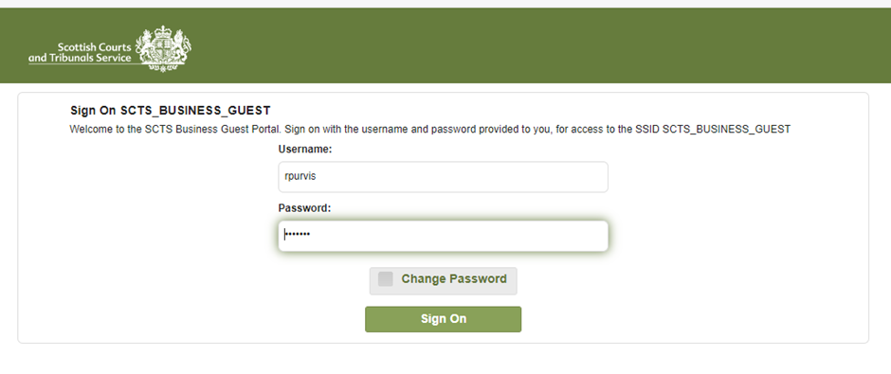

On the following page the Acceptable Use Policy will appear where you must select the ‘Accept’ button to continue.  If you do not accept this policy you will be unable to use the network.

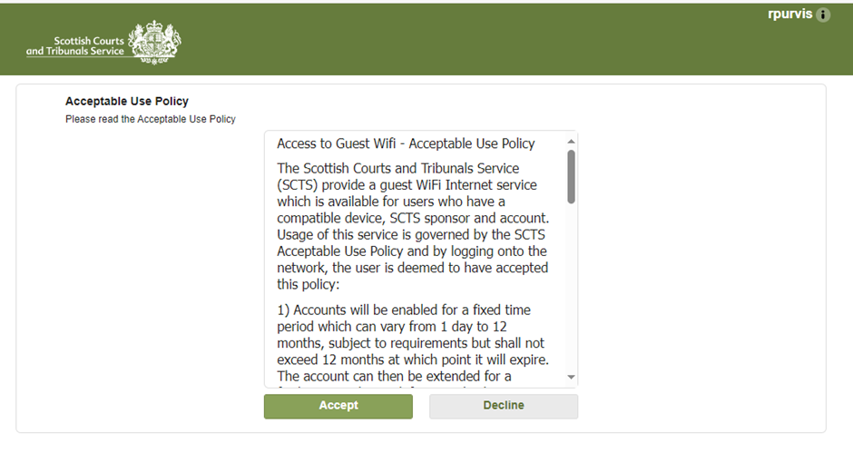

During your first log-in journey you will be asked to create a new password.  Once Current and New password entered press the ‘Submit’ button to continue.

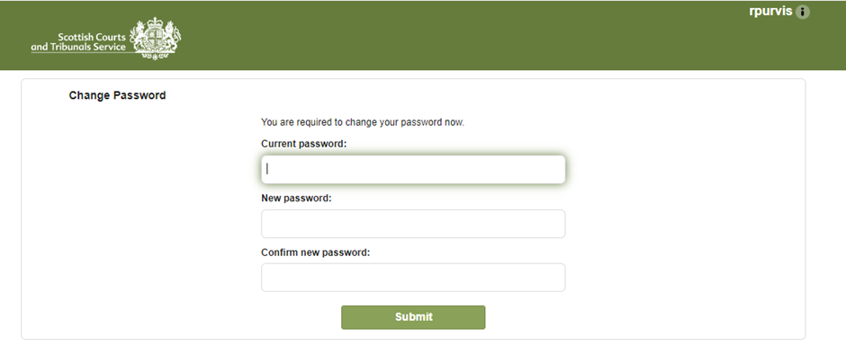

You are then taken to a page providing the details on the SCTS Business Guest Wi-Fi where at the bottom they click the ‘Continue’ button.

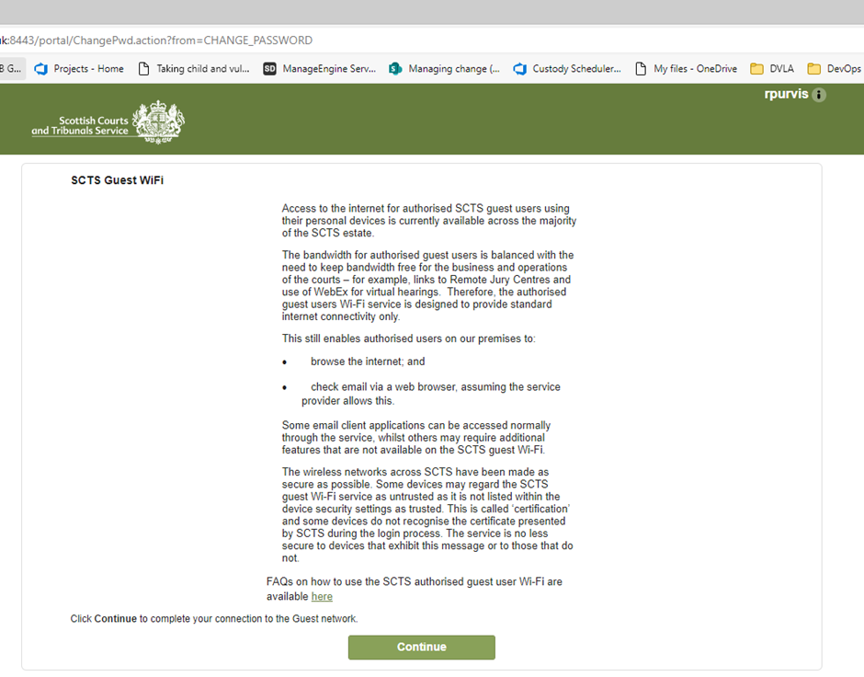

The final page you will be displayed is confirming you have successfully connected

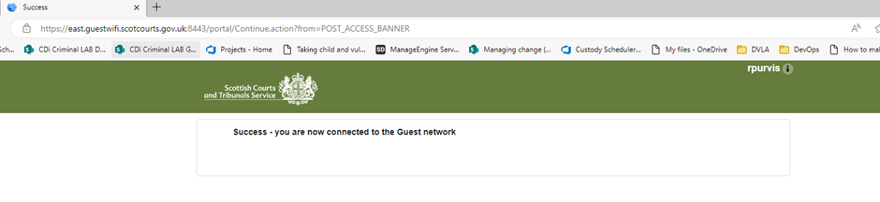

You are now connected to **SCTS_BUSINESS_GUEST.**  You can test this by browsing to a web page or using any application such as Teams.

## **Connecting to the Captive Portal – Future Use**

If you are connecting again using the same device within 24 hours, you will not need to re-enter your username and password. You are allowed up to two devices in total and currently only one can be connected at one time. The network will connect you automatically. If it has been longer than 24 hours since you last connected you will need to authenticate.

## **Troubleshooting & Support**

The SCTS_BUSINESS_GUEST Wi-Fi is offered by the court. If you can’t see the network, or experience slow speeds or drop-outs when using the Wi-Fi, the Sheriff Clerk’s office will be able to let you know if there are any known issues affecting the service.

If there are no known issues, you are a registered user and connected to the network and experiencing slow speeds or drop-outs then please contact the SCTS helpdesk on 0131 444 3333 and select option 4.

For anything else, please contact your local support team:

|  |  |
| --- | --- |
| **User Group** | **Contact Details** |
| Faculty of Advocates | [servicedesk@Advocates.org.uk](mailto:servicedesk@Advocates.org.uk) |
| Law Society | [member.registration@lawscot.org.uk](mailto:member.registration@lawscot.org.uk) |
| SLAB | [McGeePa@slab.org.uk](mailto:McGeePa@slab.org.uk) |
| Victim Support Scotland | [Stephen.Wheeler@victimsupportsco.org.uk](mailto:Stephen.Wheeler@victimsupportsco.org.uk) |
| SCRA | [itservicedesk@scra.gov.uk](mailto:itservicedesk@scra.gov.uk) |
| CJSW | [Helpdesk@scotcourts.gov.uk](mailto:Helpdesk@scotcourts.gov.uk) |
| Litigant and Social Security Workers | Clerk of Court |