

# SCTS PEOPLE COMMITTEE – NON-EXECUTIVE COMMITTEE MEMBER

# INFORMATION FOR APPLICANTS

**The Organisation**

The Scottish Courts and Tribunals Service (SCTS) is a Non-Ministerial office established on 1 April 2010 as the Scottish Court Service, by the Judiciary and Courts (Scotland) Act 2008. Following enactment of provisions of the Courts Reform (Scotland) Act 2014, the organisation merged with the Scottish Tribunals Service and was renamed.

The functions of the SCTS are to support the:

* Scottish courts and the judiciary of those courts;
* Scottish tribunals and the members of those tribunals;
* Lord President or his delegates in respect of his functions as Head of the Scottish Judiciary and other non-judicial functions;
* Sheriffs Principal in respect of their functions under the relevant provisions of the Courts Reform (Scotland) Act 2014;
* Office of the Public Guardian and Accountant of Court (OPG); and
* Criminal Courts Rules Council, Scottish Civil Justice Council and the Scottish Sentencing Council.

Information on the current structure of the SCTS can be found in the most recent [Annual Report and Accounts](https://www.scotcourts.gov.uk/media/t2pjqg2t/scts-annual-report-and-accounts-22-23.pdf). Further information on the organisation can be accessed from the SCTS [website](http://www.scotcourts.gov.uk/).

# SCTS Priorities

The purpose of the SCTS is “Supporting Justice”. By focusing on seven key priorities, detailed below, we ensure that everything we do is of benefit to Scotland’s justice system, those who rely on it and those who work to uphold and improve it on a daily basis.

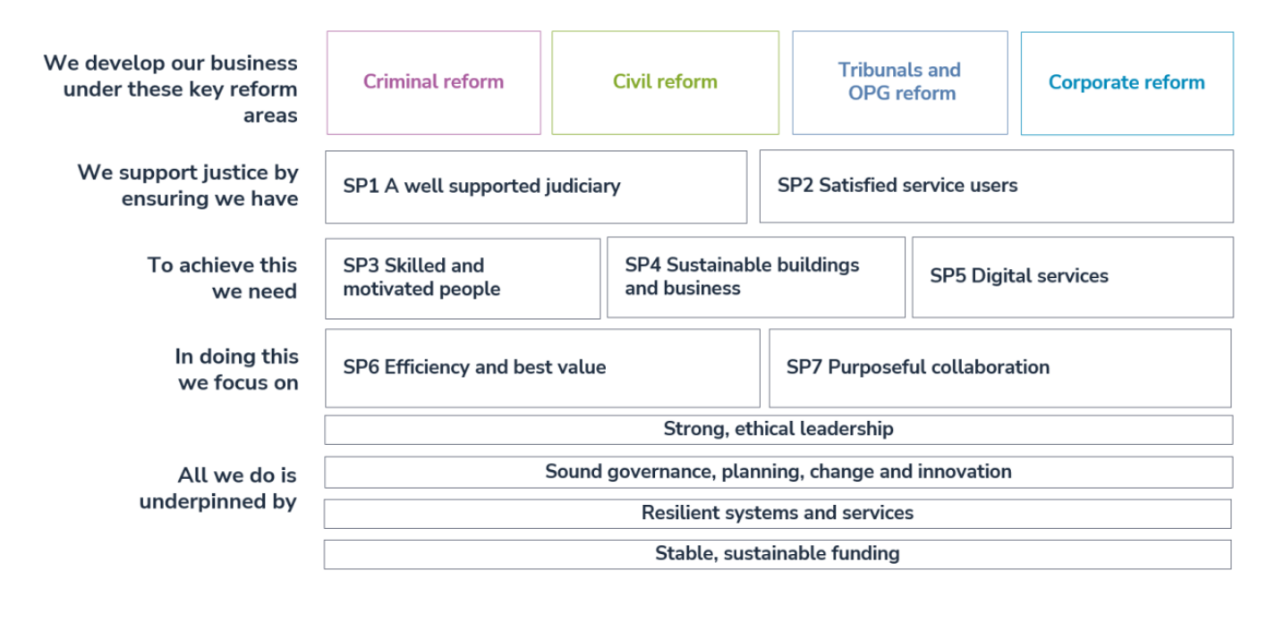

The SCTS has approximately 1,950 staff whose motivation and skill is critical to the success of the organisation. [The SCTS Business Plan 2024-25](https://www.scotcourts.gov.uk/media/bq4hxibv/scts-business-plan-2024-25.pdf)sets out the organisation’s plans and ambitions for the coming year. The Business Plan supports the delivery of the strategic objectives in our [Corporate Plan for 2023-26](https://www.scotcourts.gov.uk/media/pqnbp4po/scts-corporate-plan-2023-26.pdf).

To achieve our ambitions, we aim to have the right people with the right skills to deliver our services. Across the justice sector everyone is having to deal with a challenging economic and fiscal outlook – requiring us to innovate and provide services in the most efficient way. Whilst the challenges are significant, we continue to focus on supporting our people as we develop more effective and efficient services to support justice.

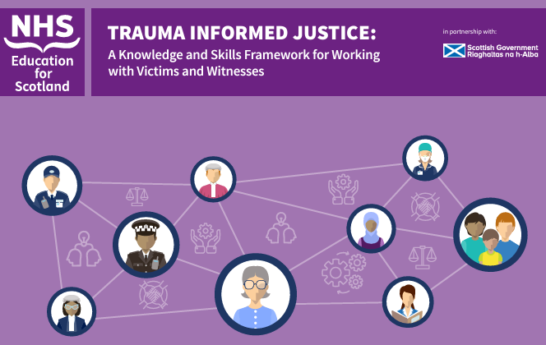There is widespread acknowledgement that the way in which complainers and witnesses experience the justice system can sometimes exacerbate the impact of prior trauma. This can have a detrimental effect on their ability to participate in the process, reduce the quality or quantity of evidence gathered and can prevent or delay recovery. A key goal for SCTS in the coming years is to enhance the services we provide by becoming a trauma-informed organisation. We have worked with partners, including the Scottish Government, members of the Victims Taskforce, and NHS Education for Scotland, to produce a [Knowledge and Skills Framework for Trauma Informed Justice](https://transformingpsychologicaltrauma.scot/media/2tzbc0lf/trauma-informed-justice-knowledge-and-skills-framework.pdf). This framework is designed to help organisations identify and develop training to support trauma-informed practice for all those working in the justice system

Our Education and Learning Unit is supporting the delivery of trauma-informed practice training in line with the Framework. This will build on the experience that our people already have in customer service and support, equipping those working in courts and tribunals to recognise trauma and behaviours linked to it; understand how and why trauma affects people; help our people to respond appropriately; and, ultimately, improve justice by ensuring that witnesses are able to give their best evidence.

The wellbeing of our people is paramount. SCTS is committed to creating a more open and supportive culture, enabling our people to function at their maximum capacity, without prejudice or discrimination. We embrace the different perspectives of our people and offer the skills, experience and support for them to succeed in their current roles, whilst developing for the future.

During 2023, a Wellbeing Hour Pilot was launched to allow employees one hour per week of paid time to focus on wellbeing activities. We also established new National Wellbeing and Carers groups to promote workforce wellbeing. Recognising the importance of good mental health we have trained over 40 staff as mental health first aiders. These are volunteer employees who are trained to have confidential and non-judgmental conversations regarding mental health with colleagues and help to signpost them to support. Further staff will be trained in the coming years.

From 1 October 2024, all SCTS staff will move to a 35-hour working week (part-time staff will also reduce their hours by the equivalent pro-rata reduction). This change is aimed at improving employee wellbeing.

As we look to the future, we will continue to develop a strong succession planning processes, aligned with tailored leadership programmes, to help ensure we develop future leaders who can succeed in an ever-changing system. Blended learning approaches – combining online and in-person training – will ensure that we maintain the skills and expertise required to administer an increasingly complex system with the balance of openness, and compassion for which our people are known. A range of flexible work patterns, supported by our hybrid working policy, will help to develop a more flexible and adaptive workforce.

As the range of services we administer has grown in recent years, the diversity of the organisation has changed too. The justice system must reflect the society that it serves – and for it to do so, we must ensure that the SCTS remains a great place to work for people from all walks of life. SCTS published its [Mainstreaming Equality Report](https://www.scotcourts.gov.uk/media/10oi5flk/mainstreaming-equality-report-and-equality-outcomes-2023-2027.pdf) and a new set of Equality Outcomes for 2023-27 in April 2023. The new outcomes are designed to drive our equality, diversity and inclusion (EDI) agenda, by raising awareness and embedding our Equality, Diversity and Inclusion aims and objectives throughout SCTS.

# Committee Members

Appointments to the SCTS People Committee are delegated by the [SCTS Board](https://www.scotcourts.gov.uk/about-us/scts-board/) under the direction of the Lord President in accordance with regulations made by Scottish Ministers. There are 6 Committee members and the Committee is attended by 4 SCTS officials. The People Committee [terms of reference](https://www.scotcourts.gov.uk/media/tpjmi3hm/people-committee-remit-november-2023.pdf) and [minutes of meetings](https://www.scotcourts.gov.uk/about-us/boards-and-committees/scts-people-committee/) can be accessed via the SCTS website.

# Your Role

You will require to demonstrate the personal skills to support the People Committee. You will act on behalf of the SCTS Board to ensure that all staff have the skills, support and motivation, now and in the future, to fulfill the organistion’s core functions. You will also ensure that the SCTS meets its statutory obligations as an employer.

You will be required to work collegiately and selflessly in the best interests of the SCTS and the people that it serves. You will be committed to upholding the Principles of Public Life in Scotland; namely, selflessness, integrity, objectivity, accountability, openness, honesty, duty, leadership and respect.

# Personal Qualities

The qualities sought in a member of the People Committee are as follows:

* **Leadership** – the ability to contribute to the vision, strategic direction and delivery of the people activity in the context of the wider political environment;
* **Influence & Communication** – the ability to communicate, challenge and influence at Committee level and to represent the vision, values and objectives of the organisation;
* **Governance and Risk** – the ability to work effectively as part of a strategic team, contributing experience and ideas. The ability to demonstrate a sound understanding of corporate governance, accountability structures and risk management;
* **Personal Qualities -** Commitment to the [principles of public life](https://www.gov.uk/government/publications/the-7-principles-of-public-life/the-7-principles-of-public-life--2).

**Broader Skills and Experience**

The selection panel would welcome evidence of any relevant experience you have in key areas relevant to the operation of a large & complex organisation such as SCTS. These may include previous involvement or work on – strategic and operational human resource management; organisational development and change management; learning and development.

# Ineligibility for Committee Membership

You are ineligible for membership of the People committee of the SCTS, if you are or become:

* + a member of the House of Commons, Scottish Parliament or European Parliament;
  + a councillor of any council constituted under section 2 of the Local Government etc. (Scotland) Act 1994 (c.39);
  + a Minister of the Crown; or
  + a member of the Scottish Government.

# Terms of Appointment

Appointments are for a four year term, provided performance is satisfactory, with the possibility of re-appointment, which may be for a shorter period. Members will not serve for more than 2 full terms (8 years) other than in exceptional circumstances.

The formal time commitment relates to attendance at 4 committee meetings a year and includes preparation time and participation in any induction and development activity. Committee meetings generally take up to half a day and are normally held in Edinburgh.

Members receive £340 per day, unless otherwise remunerated from the public purse, on the basis of 4 days engagement per year. Payment will be made in 12 equal monthly payments.

Travel and subsistence is also available for expenses incurred in the course of work related to Committee membership.

## Application

Applicants should complete the application form by **midnight on 18 August 2024.**

If you have any difficulty accessing any of the documents, would like them in alternative formats or have any queries about the appointment process, please feel free to contact us by sending an email to [klawrie@scotcourts.gov.uk](mailto:klawrie@scotcourts.gov.uk)

Completed applications should be submitted to [NonExecRecruitment@scotcourts.gov.uk](mailto:NonExecRecruitment@scotcourts.gov.uk) by the closing date.

## Interviews

A sift of all written applications will be carried out to select candidates for interview.

The interviews will be conducted on **23 September 2024** by a panel of three including two SCTS Board members in Parliament House, Edinburgh.