SCTS AUDIT AND RISK COMMITTEE – NON-EXECUTIVE COMMITTEE MEMBER

INFORMATION FOR APPLICANTS

The Organisation

The Scottish Courts and Tribunals Service (SCTS) is a Non-Ministerial office established on 1 April 2010 as the Scottish Court Service, by the Judiciary and Courts (Scotland) Act 2008. Following enactment of provisions of the Courts Reform (Scotland) Act 2014, the organisation merged with the Scottish Tribunals Service and was renamed.

The functions of the SCTS are to support the:
- Scottish courts and the judiciary of those courts;
- Scottish tribunals and the members of those tribunals;
- Lord President or his delegates in respect of his functions as Head of the Scottish Judiciary and other non-judicial functions;
- Sheriffs Principal in respect of their functions under the relevant provisions of the Courts Reform (Scotland) Act 2014;
- Office of the Public Guardian and Accountant of Court (OPG); and
- Criminal Courts Rules Council, Scottish Civil Justice Council and the Scottish Sentencing Council.

Information on the current structure of the SCTS can be found in the most recent Annual Report and Accounts. Further information on the organisation can be accessed from the SCTS website.

SCTS Priorities

The purpose of the SCTS is “Supporting Justice”. By focusing on seven key priorities, detailed below, we ensure that everything we do is of benefit to Scotland’s justice system, those who rely on it and those who work to uphold and improve it on a daily basis.

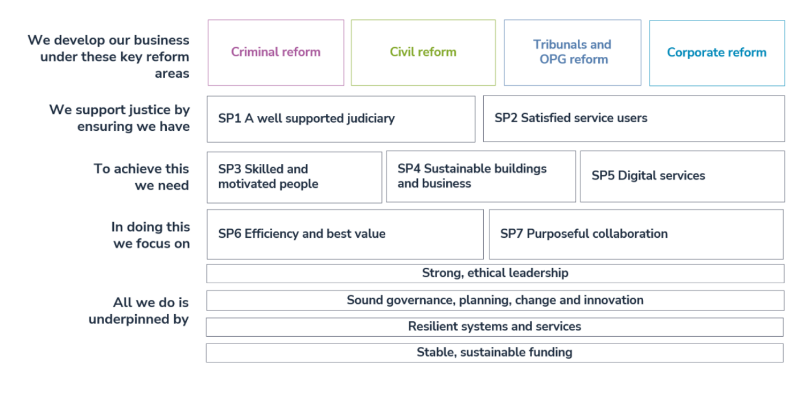
The SCTS has approximately 1,950 staff whose motivation and skill is critical to the success of the organisation. One of the biggest priorities for SCTS and other justice organisations, is tackling the backlog of criminal cases that accrued during the early stages of the COVID-19 pandemic along with managing a continued and ongoing increase in solemn business (trials with a jury). In response, the criminal court recovery programme commenced in September 2021. An additional 4 trial courts were allocated to the High Court, 2 for Sheriff Solemn business and 10 for Sheriff Summary business. In April 2023, recovery resources were switched from summary to solemn. A further 2 additional trial courts were introduced in the High court and a further 6 for Sheriff Solemn business – with Sheriff Summary trial courts returning to their normal levels during 2024-25.

Progress towards reducing the number of scheduled cases awaiting trial is tracked against our published modelling. Our latest modelling report was published in December 2023. This indicates that summary criminal court backlogs will recover during 2024-25. Solemn business is more challenging as the level of cases entering the system continues to grow – a trend that was apparent before the pandemic and shows no sign of abating. A continued increase in court capacity will be required in the longer-term to address this continued growth. The switching of recovery programme resources from summary to solemn since April 2023 has had a positive impact. Our modelling indicates that, provided these resources are sustained, it will be possible to reach a stable – albeit higher – level of outstanding High Court cases during 2025, with sheriff solemn case levels stabilising during 2026-27.

Audit Scotland carried out an audit during 2022-23, assessing the scale of criminal court system delays as a result of the backlog caused by the COVID-19 pandemic, the actions taken to address these delays, and the impact on victims, witnesses and the accused. Audit Scotland’s published report can be viewed here.

The SCTS is currently leading a number of key justice reform projects. A key component in the transformation of our criminal justice system is the implementation of the Lord Justice Clerk’s Review into the management of sexual offence cases. The Scottish Government have brought forward legislation that is required to deliver many of the recommendations. Where legislative changes are not required, SCTS is making strong progress. Most notably in relation to the delivery of trauma-informed practice training in line with the Knowledge and Skills Framework for Trauma Informed Justice. The training will build on the experience our people already have in customer service and support, equipping those working in courts and tribunals to recognise trauma and behaviours linked to it; understand how and why trauma affects people; helps our people to respond appropriately; and ultimately, improve justice by ensuring that witnesses are able to give their best evidence.

Digital transformation is at the heart of many of the reforms we are seeking to deliver. A key component transformation activity in the Office of the Public Guardian that aims to deliver a digital first, responsive, user-centered service through the development of a new case management system, which will improve efficiency, resilience and security.

Full details of the key reforms SCTS seeks to deliver over the next three years are contained within the Corporate Plan for 2023-26.

Committee Members

Appointments to the SCTS Audit and Risk Committee are delegated by the SCTS Board under the direction of the Lord President in accordance with regulations made by Scottish Ministers. There are 5 Committee members and the Committee is attended by 5 SCTS officials. The Audit and Risk Committee terms of reference and minutes of meetings can be accessed via the SCTS website.

Your Role

You will require to demonstrate the personal skills to support the Audit and Risk Committee which supports the Board in discharging its responsibilities in relation to issues of risk, control and governance by reviewing and challenging the comprehensiveness, reliability and integrity of assurance provided by the SCTS Chief Executive (Accountable Officer).

You will be required to work collegiately and selflessly in the best interests of the SCTS and the people that it serves. You will be committed to upholding the Principles of Public Life in Scotland; namely, selflessness, integrity, objectivity, accountability, openness, honesty, duty, leadership and respect.

Personal Qualities

The qualities sought in a member of the Audit and Risk Committee are as follows:

- Leadership – the ability to contribute to the vision, strategic direction and delivery of the Estates, Health and Safety, Fire and Security activity in the context of the wider political environment;

- Influence & Communication – the ability to communicate, challenge and influence at Committee level and to represent the vision, values and objectives of the organisation;

- Governance and Risk – the ability to work effectively as part of a strategic team, contributing experience and ideas. The ability to demonstrate a sound understanding of corporate governance, accountability structures and risk management;

- Personal Qualities - Commitment to the principles of public life.

Broader Skills and Experience –

There are two posts being advertised;

POST 1 – You must hold a professional accountancy qualification from one of the UK’s Consultative Committee of Accountancy Bodies (CCAB) or equivalent is essential. You must also have experience of working in audit, risk or assurance and involvement in transformational delivery or change

POST 2 – You must have experience of working in audit, risk or assurance and involvement in transformational delivery or change

For both posts, whilst not essential, the selection panel would welcome evidence of any relevant experience you have in key areas relevant to the operation of a large & complex organisation such as SCTS. These may include previous involvement or work on – digital/cyber security; organisational policy and strategy; corporate finance; human resource management; major estates management; ICT; media & communications.

Ineligibility for Committee Membership

You are ineligible for membership of the Audit and Risk committee of the SCTS, if you are or become:
  - a member of the House of Commons, Scottish Parliament or European Parliament;
  - a councillor of any council constituted under section 2 of the Local Government etc. (Scotland) Act 1994 (c.39);
  - a Minister of the Crown; or
  - a member of the Scottish Government.

Terms of Appointment

Appointments are for a four year term, provided performance is satisfactory, with the possibility of re-appointment, which may be for a shorter period. Members will not serve for more than 2 full terms (8 years) other than in exceptional circumstances.

The formal time commitment relates to attendance at 4 committee meetings a year and includes preparation time and participation in any induction and development activity. Committee meetings generally take up to half a day and are normally held on a Monday in Edinburgh.

Members receive £340 per day, unless otherwise remunerated from the public purse, on the basis of 4 days engagement per year. Payment will be made in 12 equal monthly payments.
Travel and subsistence is also available for expenses incurred in the course of work related to Committee membership.

Application

Applicants should complete the application form by midnight on 24 March 2024.

If you have any difficulty accessing any of the documents, would like them in alternative formats or have any queries about the appointment process, please feel free to contact us by sending an email to klawrie@scotcourts.gov.uk

Completed applications should be submitted to NonExecRecruitment@scotcourts.gov.uk by the closing date.

Interviews

A sift of all written applications will be carried out to select candidates for interview.

The interviews will be conducted on 16 April 2024 by a panel of three including two SCTS Board members.

