

**Visiting**

**Portree Sheriff Court**[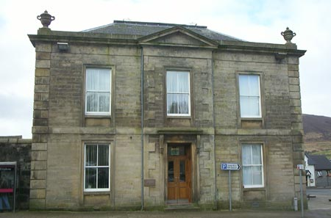](http://www.google.co.uk/url?sa=i&rct=j&q=&esrc=s&source=images&cd=&cad=rja&uact=8&ved=0ahUKEwiWjZzDzpjNAhXmL8AKHUalCFkQjRwIBw&url=http://dev.scotcourts.gov.uk/the-courts/court-locations/portree-sheriff-court&psig=AFQjCNHUpqF5OBVeydG17eLtnGh4zVB7mg&ust=1465481596118151)

This leaflet will help you to plan your visit to the Portree Sheriff Court.

If you require more information about anything here you can email:

[enquires@scotcourts.gov.uk](mailto:enquires@scotcourts.gov.uk)

or telephone the Property and Services Unit on:

**0131 440 3300**

or text phone

**18001 01478 612191**

**For specific assistance or access issues please phone the following number in advance:**

**01478 612191**





**Contents**

**Location Details**

Page 4

……………………………………………..

**Ways of getting to the Court Building**

Pages 5 to 7

………………………………………………

**On Arrival**

Pages 8 to 10

………………………………………………

**Facilities**

Pages 11 to 15

……………………………………………….

**Floor Plans**

Pages 16 and 17

………………………………………………

**Opening Times & Public Holidays**

Page 18

………………………………………………

**Contact Information**

Page 19

………………………………………………

**Additional Information**

Pages 20 to 22

**Location Details**

[](http://www.google.co.uk/url?sa=i&rct=j&q=&esrc=s&source=images&cd=&cad=rja&uact=8&ved=0ahUKEwiWjZzDzpjNAhXmL8AKHUalCFkQjRwIBw&url=http://dev.scotcourts.gov.uk/the-courts/court-locations/portree-sheriff-court&psig=AFQjCNHUpqF5OBVeydG17eLtnGh4zVB7mg&ust=1465481596118151)

Portree Sheriff Court House dates from 1865 and was designed by the architectural firm Matthews and Lawrie. The jurisdiction of the court covers the Islands of Skye, Raasay and part of Glenelg on the mainland.

The main entrance is through a set of manually operated double doors accessed by two non-highlighted steps with no handrails.

**Ways of getting to the Court Building**

**By Bus**

Buses from all the outlying and local areas stop in Somerled Square in front of the police station. The police station is situated next to the court house.



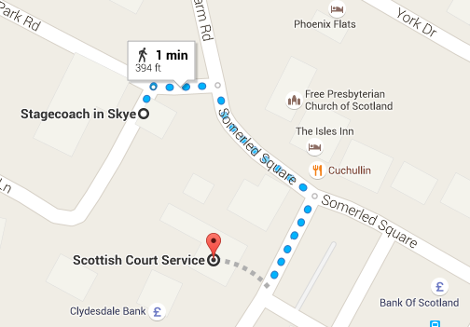

Map data @2016 Google

Bus station location



**By Train**

There is no train station near the court.

**By Public Transport**

Contact Traveline Scotland for all public transport enquiries and assistance on **0871 200 22 33** or visit

[www.travelinescotland.com](http://www.travelinescotland.com)

**By Car**

There is a public car park in Somerled Square with a number of disabled parking places. There is another long stay car park at Bayfield (five minutes’ walk from the court) which is free.

**By Taxi**

The main taxi rank is in Somerled Square in front of Portree Hotel.

The following numbers can be used to call a taxi:

• 01478 612797

• 01478 612826

• 01478 612074

• 01478 613100

• 01478 611844

• 01478 613000





**On Arrival**

**Entrance**

The public entrance faces onto Somerled Square and is accessed by two steps.

Disabled access is available from the side entrance situated in the police station car park. This is a small office and it is not always permanently staffed, please telephone to confirm that the office will be open. Language line facilities are available.

There is a ramp from the rear car park for those with restricted mobility. Users of this ramp can request assistance by intercom.

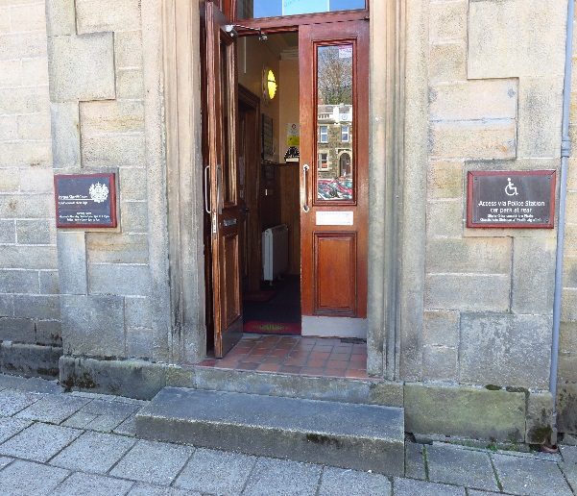

Entrance steps

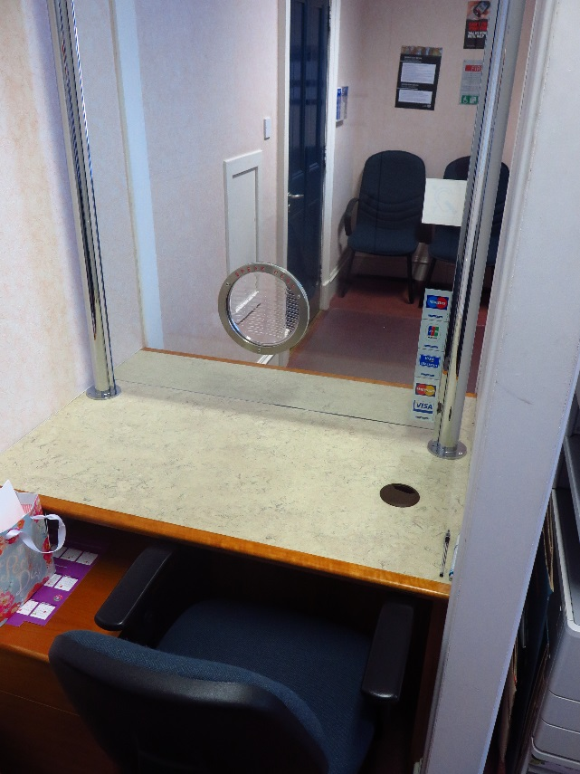

Reception

**Security Check**

When you are ready, the security staff will direct you to the reception desk located to the left of the main hall, which serves as the central point of access the rest of the building.

Please report to the reception desk and state the reason for your visit. Reception staff will then direct you accordingly.

Staff can assist you if you have any question about the court building or your visit.





If you have a wheelchair or a pushchair and you require specific access assistance, please telephone:

**01478 612191**

or textphone

**18001 01478 612191**

For further information on the layout of the court building please refer to the floor plan layouts on pages 16 and 17.

**Facilities**







**Toilets**

Public toilets are located on the ground floor.

Public accessible toilets are located on ground floor to the left side of the main hall.

**Signage**

High contrast signage is provided around all circulation areas to ensure the public zones are easily navigated.

**Refreshments**

If you are sitting on a jury, lunch and refreshments will be provided for you if the court sits into the afternoon.

**Hearing Loop**

A loop induction service is available in the courtroom for people who have hearing difficulties. Please contact the Sheriff Clerk's office if you require to use this Portable mobile loop induction facility for the courtrooms.

A fixed loop induction service is also available at all reception counters.





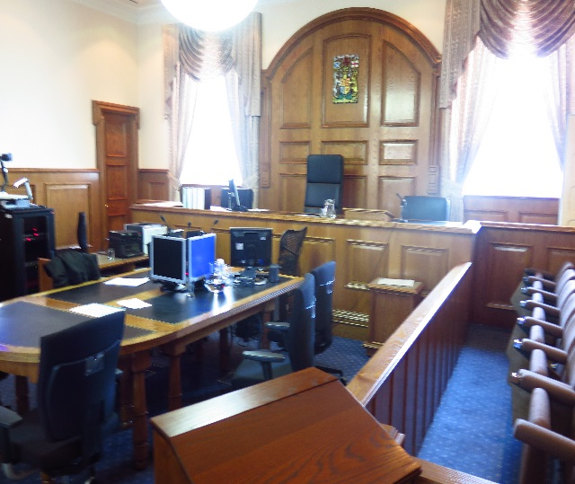Typical court room

[](https://www.google.co.uk/url?sa=i&rct=j&q=&esrc=s&source=images&cd=&cad=rja&uact=8&ved=0ahUKEwijmeXk2NnJAhWFLhoKHaetCAcQjRwIBw&url=https://www.iconfinder.com/icons/41952/elevator_lift_icon&psig=AFQjCNFBzdPzzcb-7dUs7YIenjllh-kU0g&ust=1450125533140326)

**Courtroom**

The court is well lit, spacious and have good acoustic qualities including full induction loop facilities. As such it demonstrates a good ability to access all users.

While no provision is given for wheelchair users to access the seated area in the public gallery or the witness box, the space in the court room is ample.

Wheelchairs can be accommodated in areas just outside the witness box and the gallery.

When accessing the court itself, assistance may be needed to negotiate the double doors.

**Lifts**

There is no lift within the building however a stairlift is available for wheelchair users to access the courtroom on the first floor.

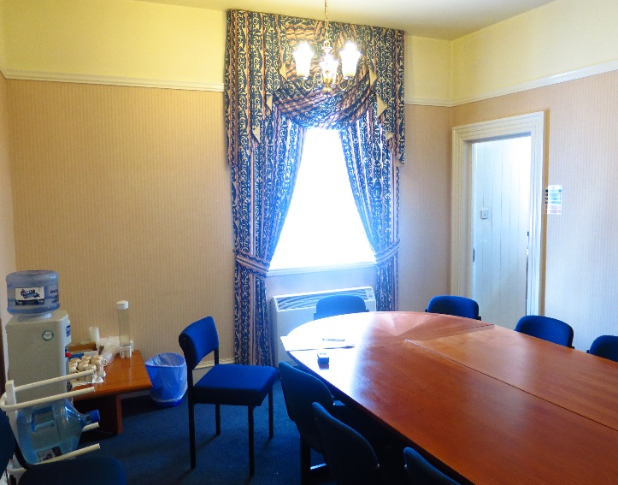

Typical Jury room

**Witness Rooms**

Witness rooms can easily be reached on the ground floor by all users.

**Jury Rooms**

The main circulation zones accessing these rooms are wide and well lit. The corridors serving these rooms do not have push-pad opening for wheelchair users to access without assistance. Jury rooms and witness rooms are easily accessible to wheelchair users.

**Fines, Criminal and Civil Office**

This is located on the ground floor to the left side of the entrance hall. Operational times can be found on page 18 of this publication.

**Floor Plans**



**Stair Lift**

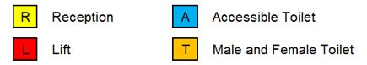

**S**

**Stairs & lifts**

Ground Floor Layout



**Stair Lift**

**S**

**S**



**S**

**Stairs & lifts**

First Floor Layout

**Opening Times**

**Weekly**

Mon - Thurs - 09:00 - 13:00 and 14:00 - 17:00

Friday - 09:00 - 13:00 and 14:00 - 16:30

Please note that this office is not always permanently staffed. If you are travelling from a distance to attend the office please telephone to confirm that the office will be open

**Public Holidays**

**2019**

01 – January Tuesday **New Year’s Day**

02 – January Wednesday **2nd January**

19 – April Friday **Good Friday**

22 – April Monday

06 – May Monday **Early May Bank Holiday**

10 – June Monday

19 – August Monday **Summer Bank Holiday**

16 – September Monday

02 – December Monday **St Andrew’s Day (substitute day)**

25 – December Wednesday **Christmas Day**

26 – December Thursday **Boxing Day**

**Contact Information**

**Postal Address**

Sheriff Clerk’s Office,

Sheriff Courthouse,

Somerled Square,

Portree,

Isle of Skye,

IV51 9EH

**Sheriff Clerk**

Stewart Retsis

**Main Telephone**

01478 612191

### Jury helpline

01478 612191 (recorded message after 17.00)

**Email**

[Portree@scotcourts.gov.uk](mailto:Portree@scotcourts.gov.uk)







**Additional Information**

If you require this document

in an alternative format

please contact the Property

and Services Unit at the

below address.

[enquires@scotcourts.gov.uk](mailto:enquires@scotcourts.gov.uk)

**The Scottish Courts and**

**Tribunals Service**

Saughton House

Broomhouse Drive

Edinburgh

EH11 3XD

**0131 444 3300**

or text phone

**18001 0131 444 3300**







### Accessibility contact

If you want to contact us using text relay please follow the guidance at this link -  [the Next Generation Text Service](https://www.btplc.com/inclusion/MakingCallingEasier/Textrelay/index.htm)

If you require the support of an interpreter when you contact a court (by phone or attend in person), a telephone interpretation service is available.  To access this service ask for telephone interpreting and the language required. This service is NOT available during actual court proceedings.

If you use British Sign Language (BSL) and wish to phone us using a sign language interpreter, you can use the online video relay interpreting service. For more information see the contactSCOTLAND website. [www.contactscotland-bsl.org](http://www.contactscotland-bsl.org/)

**This Report**

This report has been compiled using the Scottish Accessible Information Forum, ‘Making Information Accessible’ guidance published September 2014.

A copy of our Court Users’ Charter can be accessed [here](http://www.scotcourts.gov.uk/docs/default-source/scs-board/charter.pdf?sfvrsn=8)

Should you require this document in another language or format please contact:

Court Services Branch

Scottish Courts and Tribunals Service

Spur N1,

Saughton House

Broomhouse Drive

Edinburgh

EH11 3XD

[csbenquiries@scotcourts.gov.uk](mailto:csbenquiries@scotcourts.gov.uk)

0131 444 3455

