

**Visiting**

**Fort William Sheriff Court and**

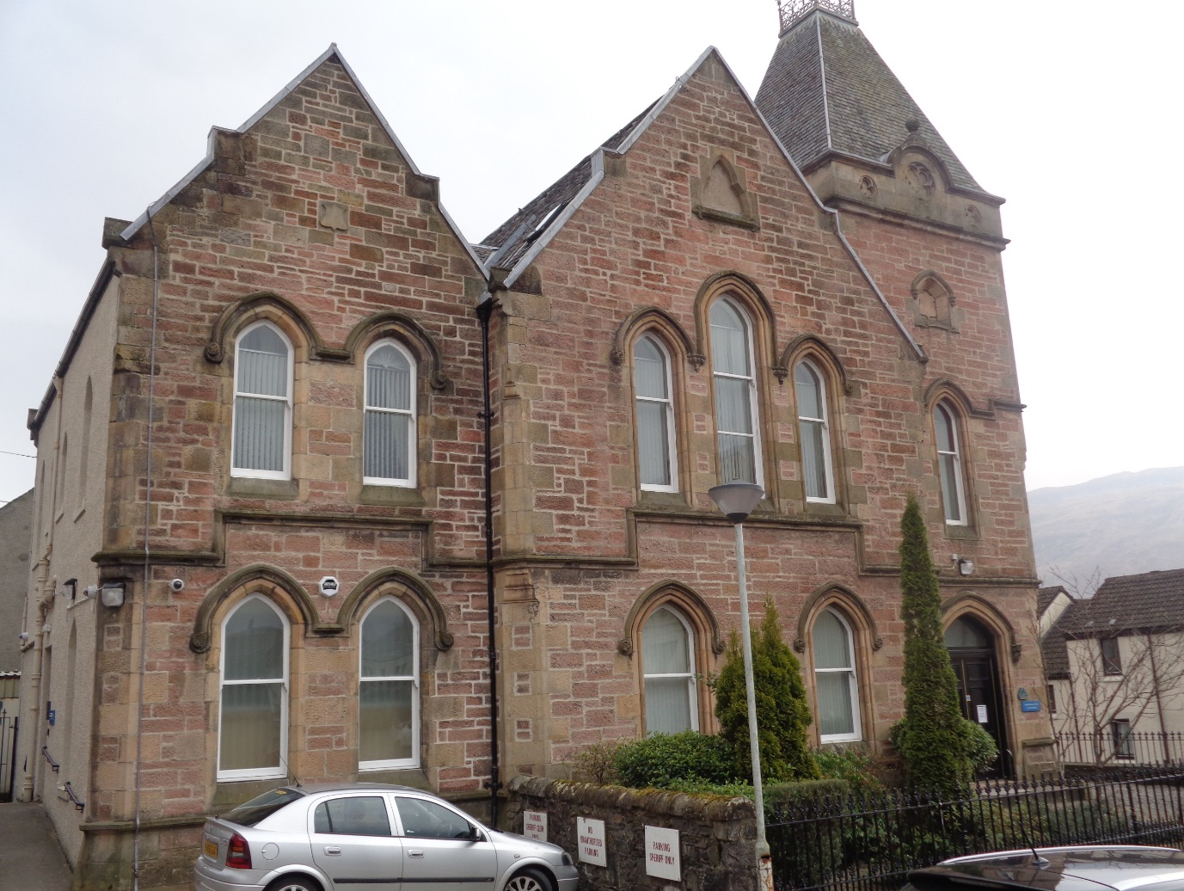**Justice of the Peace Court**





This leaflet will help you to plan your visit to the Fort William Sheriff Court and Justice of the Peace Court.

If you require more information about anything here you can email:

[enquires@scotcourts.gov.uk](mailto:enquires@scotcourts.gov.uk)

or telephone the Property and Services Unit on:

**0131 440 3300**

or text phone

**18001 0131 444 3300**

**For specific assistance or access issues please phone the following number in advance:**

**01397 702087**

**Contents**

**Location Details**

Page 4

……………………………………………..

**Ways of getting to the Court Building**

Pages 5 to 8

………………………………………………

**On Arrival**

Pages 9 to 11

………………………………………………

**Facilities**

Pages 12 to 16

……………………………………………….

**Floor Plans**

Pages 17 and 18

………………………………………………

**Opening Times & Public Holidays**

Page 19

………………………………………………

**Contact Information**

Page 20

………………………………………………

**Additional Information**

Pages 21 to 23

**Location Details**

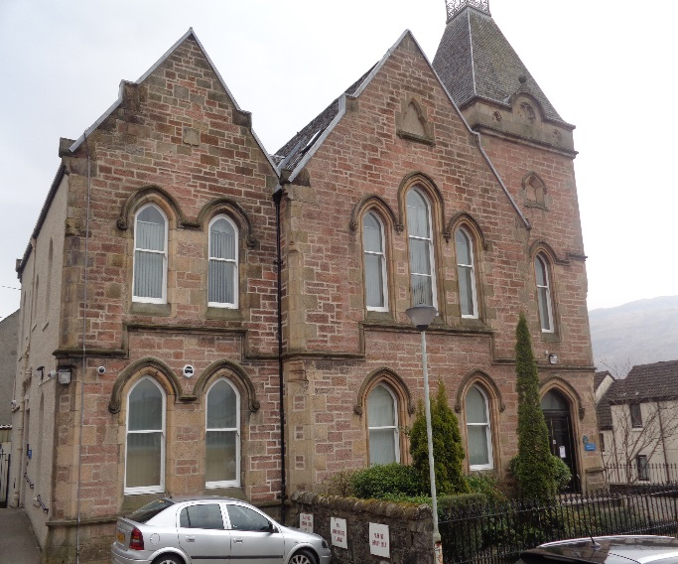

Fort William Sheriff Court and Justice of the Peace Court is located at the West end of the High Street immediately in front of the Garrison Hotel and is easily accessed from both roads entering from North and South

**Ways of getting to the Court Building**

**By Bus**

The main bus station in Fort William is just an 11 minute walk from the court building.



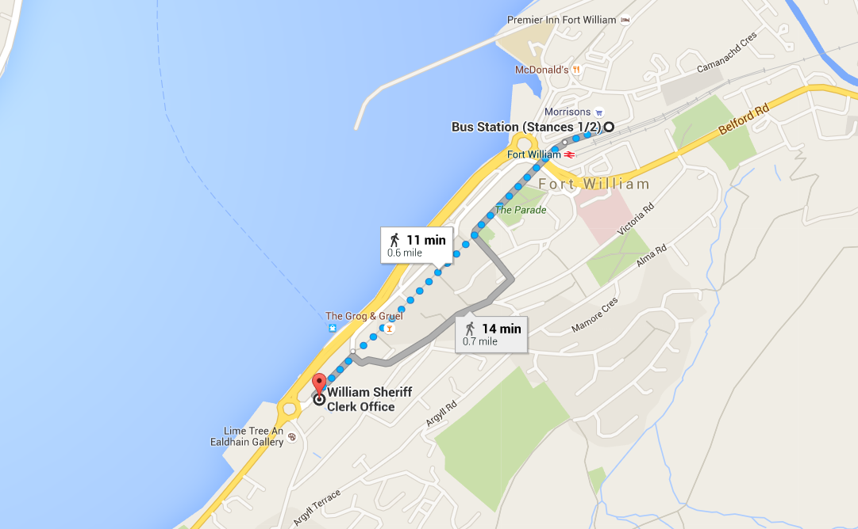

Map data @2016 Google

Bus station location



**By Train**

The nearest railway station is Fort William, which is 0.5 mile or 10 min walk from the court building. Trains run to and from Glasgow regularly.

Visit [www.nationalrail.co.uk](http://www.nationalrail.co.uk) ,

[scotrail](https://www.scotcourts.gov.uk/the-courts/court-locations/www.scotrail.co.uk) or call **03457 484 950** for train times.

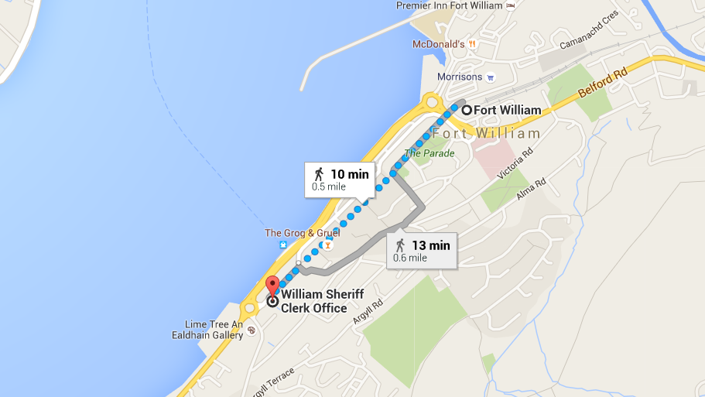

Map data @2016 Google

Train station location

**By Public Transport**

Contact Traveline Scotland for all public transport enquiries and assistance on **0871 200 22 33** or visit

[www.travelinescotland.com](http://www.travelinescotland.com)

**By Car**

There is a disabled car space for wheelchair users within the Court parking spaces. There is no general public car parking within car park at the Court. The nearest public car park is at the West end roundabout situated diagonally across from the Court.



**By Taxi**

Nearest taxi rank is at Tesco metro supermarket at East end of High Street approximately 5 minutes walk from Court. There is no space for visitors to be dropped off at the front entrance.



**On Arrival**

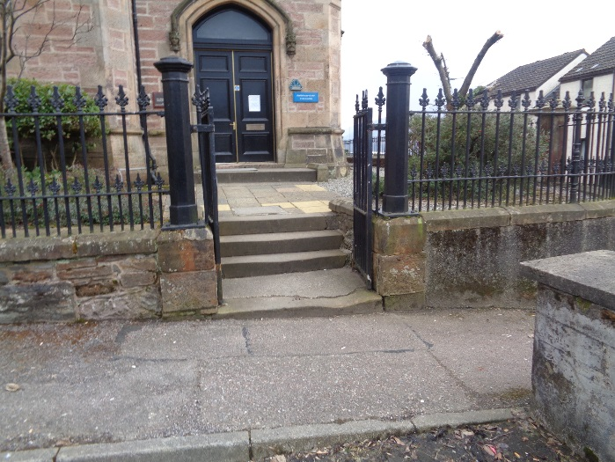

Entrance steps

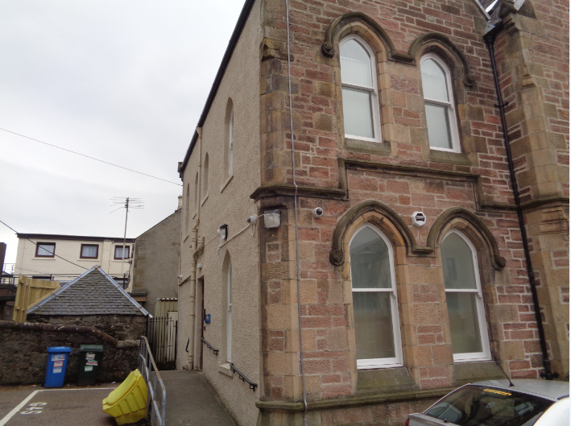

Entrance ramp

**Entrance**

The main public entrance is raised from pavement level and is accessed via steps extending up from adjacent car-parking area. The reception desk is accessed directly from the entrance lobby area which also accommodates the central stairwell

Wheelchair users can use the entrance ramp to the side of the building, located at the rear of the car park area.

Please report to the reception desk and state the reason for your visit. It is here that all visitors should report to for advice on direction to the appropriate court. The area around this reception is ample enough for wheelchair users to manoeuvre freely. A public telephone is located in this lobby next to the entrance door. Court cases are highlighted on both a video screen and the wall adjacent to the reception desk.

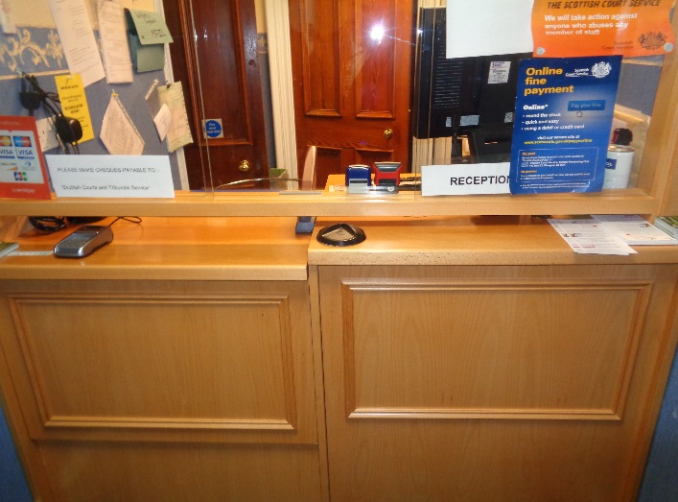

Reception





If you have a wheelchair or a pushchair and you require specific access assistance, please telephone:

**01397 702087**

or textphone

**18001 01397 702087**

For further information on the layout of the court building please refer to the floor plan layouts on pages 17 and 18.

**Facilities**







**Toilets**

Public toilet are available on ground floor, which also provides the accessible toilet.

**Signage**

High contrast signage is provided around all circulation areas to ensure the public zones are easily navigated.





**Refreshments**

There are no refreshments provided at the Court. A water cooler station is situated within each Witness Room.

**Hearing Loop**

For people who are hard of hearing a fixed loop induction service is available at all reception counters. Portable mobile loop induction services are available for all courtrooms.

On arrival please inform the reception desk staff if you require this facility.

**Courtrooms**

The court room is well lit, spacious and has good acoustic qualities including full induction loop facilities. The court room is located on the first floor and as such, this room is not accessible for wheelchair users.

**Internal Access**

The ground floor main lobby serves as the central point of orientation to access the rest of the building. This lobby is wide, spacious and able to accommodate large numbers at peak times.

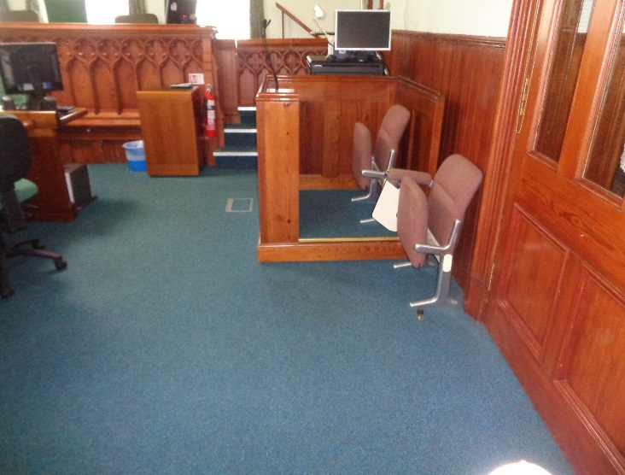

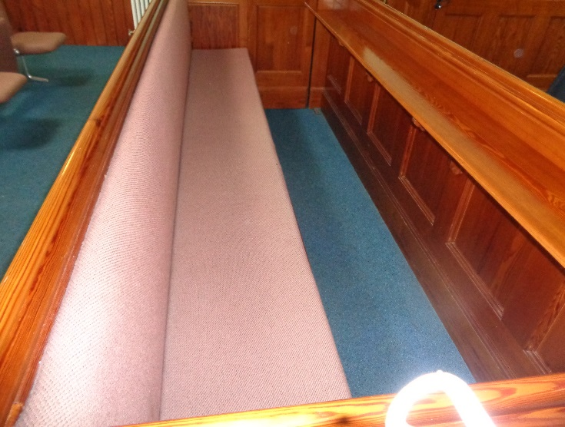

Typical court room

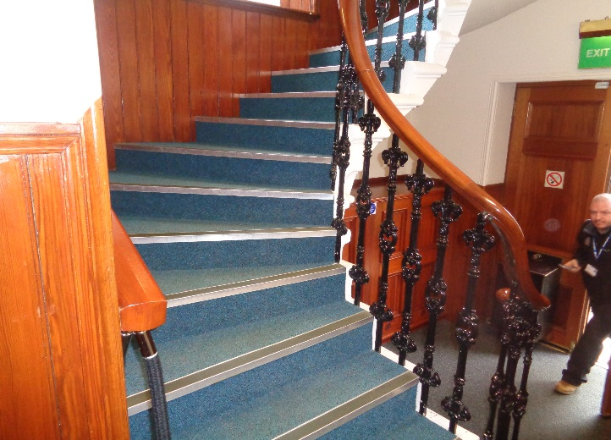

Stairs to first floor

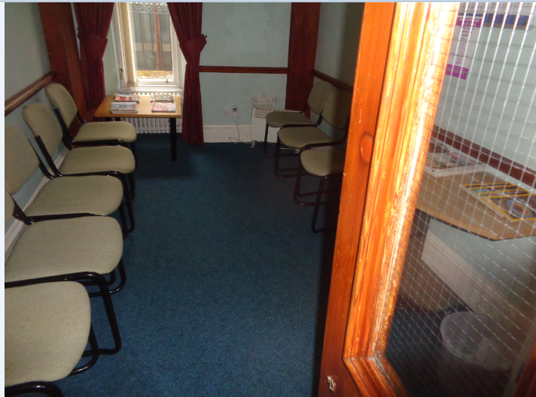

Typical witness room

**Witness Rooms**

There are two witness rooms available on the ground floor, both of which are wheelchair accessible.



Fines and Criminal Office

**Fines and Criminal Office and**

**Sheriff Clerks Office**

The Sheriff clerk’s office is located on the ground floor behind the main reception. General enquiries can be made here and the payment of fines. An induction loop facility is provided for the hard of hearing in both these offices. While a good amount of space is provided in door sizing and the width of corridors for wheelchairs to manoeuvre freely in, powered doors are not fitted presently and assistance may be needed to open these doors.

**Floor Plans**



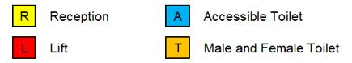

**S**



Stairs

Ground Floor Layout





**S**

**S**

Stairs

First Floor Layout

**Opening Times**

**Weekly**

Monday to Thursday: 9 am to 16:30 pm

Friday: 9 am to 16:00 pm

**The office is closed between 13:00 to 14:00 daily.**

**Public Holidays**

**2019**

01 – January Tuesday **New Year’s Day**

02 – January Wednesday **2nd January**

06 – May Monday **Early May Bank Holiday**

03 – June Monday **Spring Bank Holiday**

5 – August Monday **Summer Bank Holiday**

30 - September Monday

02 – December Monday **St Andrew’s Day (substitute day)**

25 – December Wednesday **Christmas Day**

26 – December Thursday **Boxing Day**

**Contact Information**







**Postal Address**

Sheriff Court House,

High Street,

Fort William,

PH33 6EE

**Sheriff Clerk**

Sujatha Amarnath

**Main Telephone**

01397 702087

**Email**

[fortwilliam@scotcourts.gov.uk](mailto:fortwilliam@scotcourts.gov.uk)

**Additional Information**

If you require this document

in an alternative format

please contact the Property

and Services Unit at the

below address.

[enquires@scotcourts.gov.uk](mailto:enquires@scotcourts.gov.uk)

**The Scottish Courts and**

**Tribunals Service**

Saughton House

Broomhouse Drive

Edinburgh

EH11 3XD

**0131 444 3300**

or text phone

**18001 0131 444 3300**







### Accessibility contact

If you want to contact us using text relay please follow the guidance at this link -  [the Next Generation Text Service](https://www.btplc.com/inclusion/MakingCallingEasier/Textrelay/index.htm)

If you require the support of an interpreter when you contact a court (by phone or attend in person), a telephone interpretation service is available.  To access this service ask for telephone interpreting and the language required. This service is NOT available during actual court proceedings.

If you use British Sign Language (BSL) and wish to phone us using a sign language interpreter, you can use the online video relay interpreting service. For more information see the contactSCOTLAND website. [www.contactscotland-bsl.org](http://www.contactscotland-bsl.org/)

**This Report**

This report has been compiled using the Scottish Accessible Information Forum, ‘Making Information Accessible’ guidance published September 2014.

A copy of our Court Users’ Charter can be accessed [here](http://www.scotcourts.gov.uk/docs/default-source/scs-board/charter.pdf?sfvrsn=8)

Should you require this document in another language or format please contact:

Court Services Branch

Scottish Courts and Tribunals Service

Spur N1,

Saughton House

Broomhouse Drive

Edinburgh

EH11 3XD

[csbenquiries@scotcourts.gov.uk](mailto:csbenquiries@scotcourts.gov.uk)

0131 444 3455

