

**Visiting**

**Kilmarnock Sheriff Court and**

**Justice of the Peace Court**

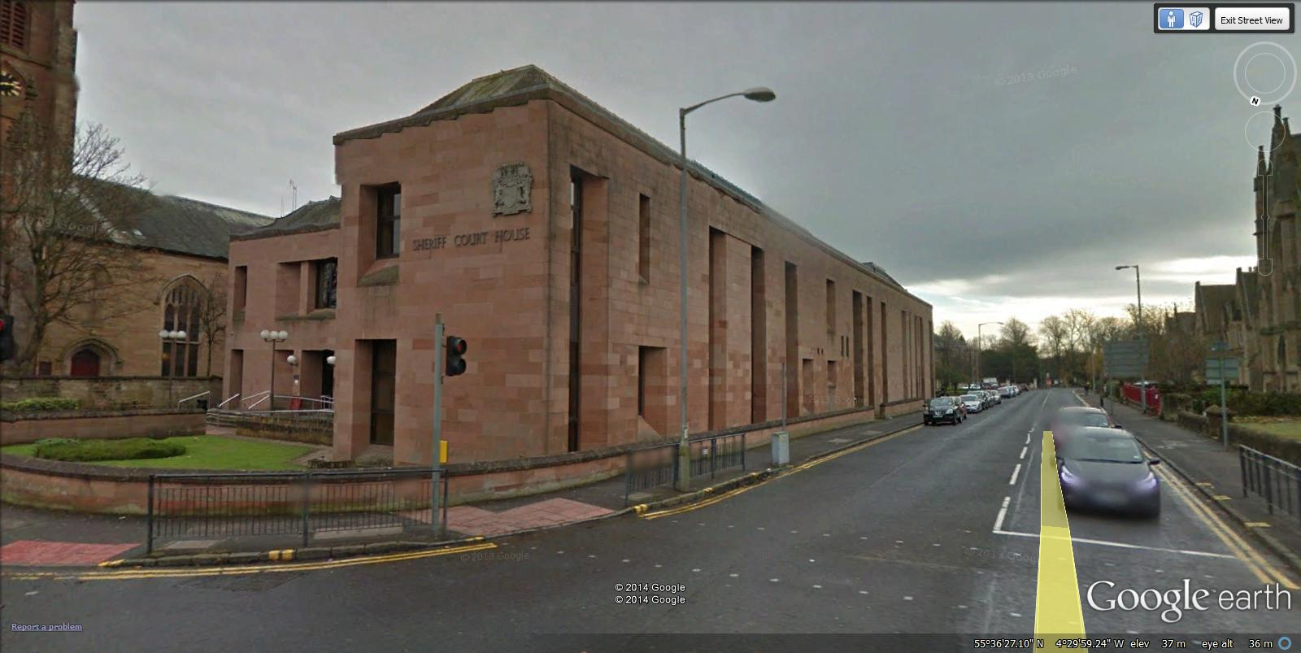

This leaflet will help you to plan your visit to Kilmarnock Sheriff and Justice of the Peace Court.

If you require more information about anything here you can email:

[enquires@scotcourts.gov.uk](mailto:enquires@scotcourts.gov.uk)

or telephone the Property and Services Unit on:

**0131 440 3300**

or text phone

**18001 0131 444 3300**

**For specific assistance or access issues please phone the following number in advance:**

**01563 550024**





**Contents**

**Location Details**

Page 4

……………………………………………..

**Ways of getting to the Court Building**

Pages 5 to 8

………………………………………………

**On Arrival**

Pages 9 to 11

………………………………………………

**Facilities**

Pages 12 to 16

……………………………………………….

**Floor Plans**

Pages 17 and 18

………………………………………………

**Opening Times & Public Holidays**

Page 19

………………………………………………

**Contact Information**

Page 20

………………………………………………

**Additional Information**

Pages 21 to 23

**Location Details**



Kilmarnock Sheriff and Justice of the Peace Court is located on St Marnock Street. The main public entrance is located on the same street.

**Ways of getting to the Court Building**

**By Bus**

The main bus station in Kilmarnock is just a 10 minute walk from the court building. For up to date timetables or to plan your journey visit [stagecoach website](http://www.stagecoach.com/)



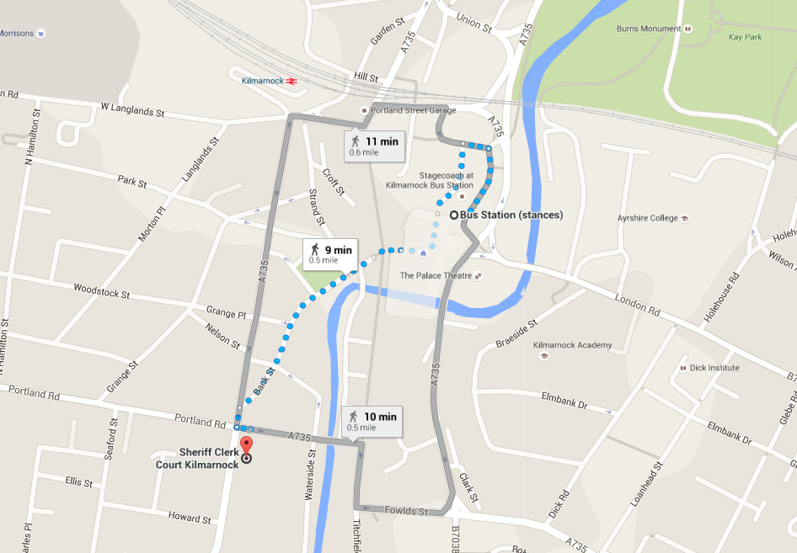

Bus station location

Map data @2016 Google

**By Train**

The nearest railway station is Kilmarnock, which is a 0.4 mile walk from the court building. Trains run to and from Glasgow regularly.

Visit [www.nationalrail.co.uk](http://www.nationalrail.co.uk)

or [ScotRail](http://www.scotrail.co.uk/) or call **03457 484 950** for train times.



Map data @2016 Google

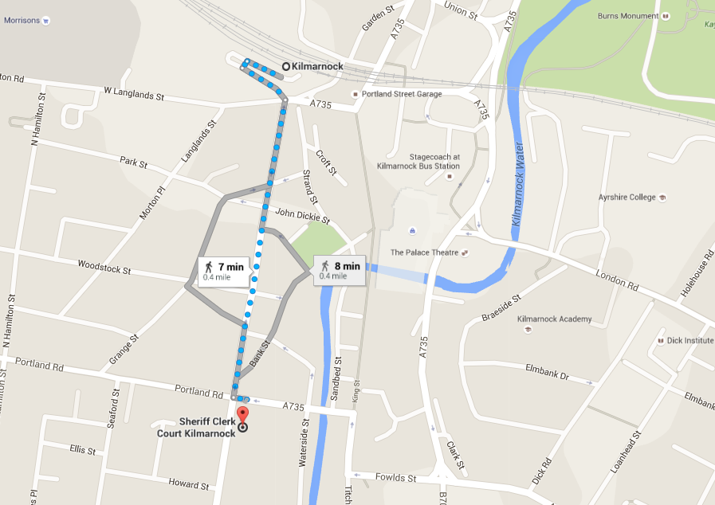

Train station location

**By Public Transport**

Contact Traveline Scotland for all public transport enquiries and assistance on **0871 200 22 33** or visit

[www.travelinescotland.com](http://www.travelinescotland.com)

**By Car**

There is no public car parking available at the court. The approaches to the Court have electronic availability signs for the nearby car parks. Pay and display is available at St Marnock Street but parking is limited to 2 hours. Blue badge holders can park here without restriction. On street pay parking is found on Dundonald Road and Portland Road, currently costing 80p per hour.



Blue Badge Parking at St Marnocks is Free 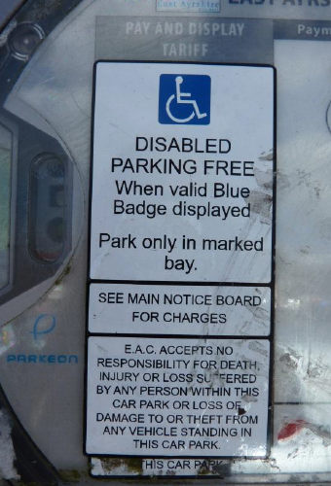



**By Taxi**

There is a taxi rank situated on John Finnie Street and also at the bus station.

The nearest airport is [Prestwick Airport](http://www.prestwick-airport-guide.co.uk/) (11 miles)

There is a bus stance outside the airport which arrives at Kilmarnock bus station. From there, the court building is a ten minute walk. Current travel information is available from: [timetables](http://www.stagecoach.com/) or to [plan your journey](http://www.travelinescotland.com/lts/#/travelInfo).

**On Arrival**

**Entrance**

The main entrance to the building is off St Marnock Street. The entrance is set back from the street. There is a ramp available for disabled wheelchair access.

The Main entrance has fully automatic sliding doors.

There is a disabled access at the front of the building and a lift within the building.

A small step where the ramp meets the adjacent ground could be an issue for self -propelling wheelchairs.

If you have any specific access requirements please contact the sheriff clerk.

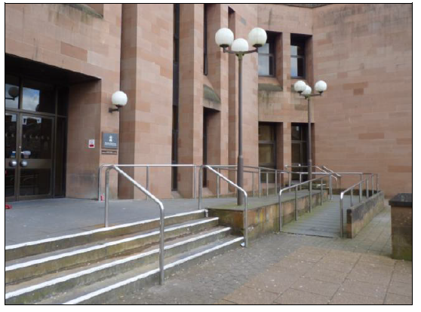

Entrance steps

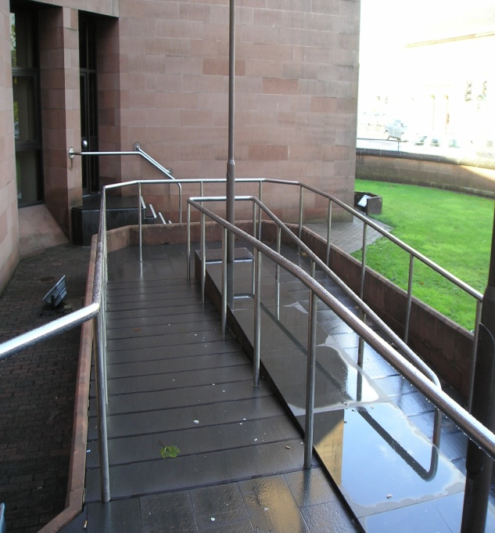

Access ramp



[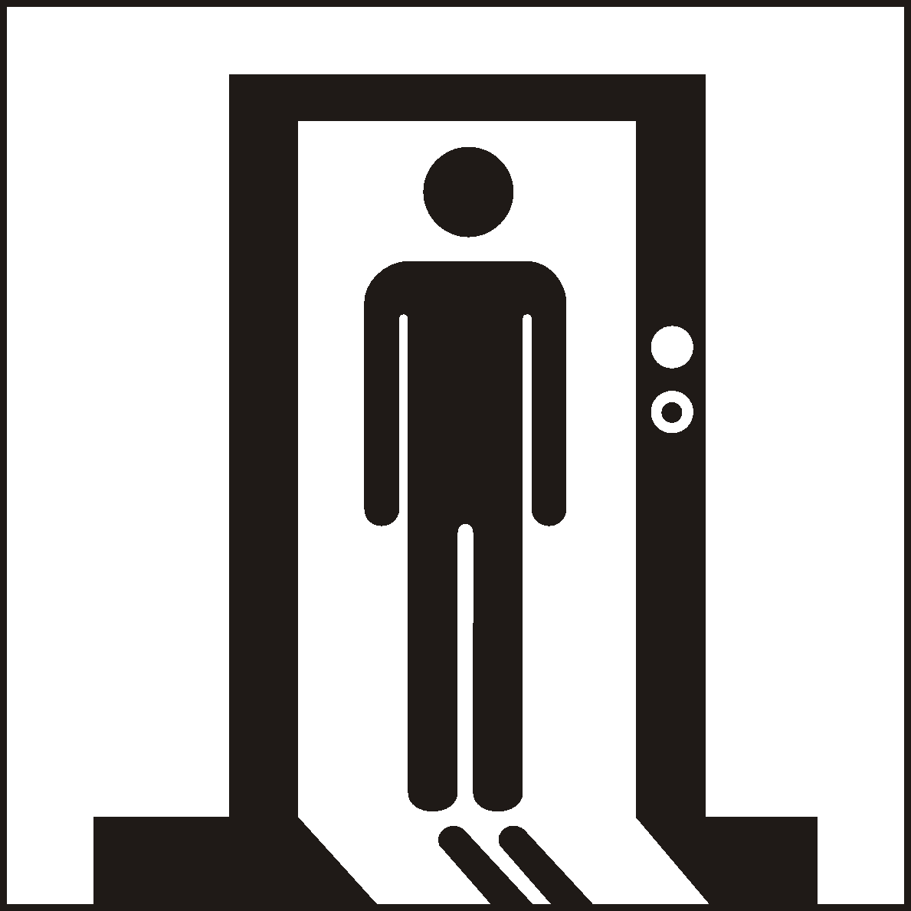](http://www.google.co.uk/url?sa=i&rct=j&q=&esrc=s&source=images&cd=&cad=rja&uact=8&ved=0ahUKEwialYnHwtPJAhUKWhoKHUKJBs4QjRwIBw&url=http://www.standard.org.cn/dgsymbol/list.aspx?sid%3D12%26stid%3D%26Page%3D5%26searchtxt%3D&bvm=bv.109395566,d.d2s&psig=AFQjCNEa1EVlPPeWeUJ-gD_trfHzICP1Hw&ust=1449913041342312)



Enquiries Counter

**Security Check**

You will enter the security lobby where trained security staff may request that you pass through a metal detector.

Wheelchair users are scanned by a paddle scanner. Your bags or briefcases may also be searched.

When you are ready, the security staff will direct you to the reception desk located to the left of the main hall, which serves as the central point of access for the rest of the building.

Please report to the Enquiries Counter and state the reason for your visit. The staff will then direct you accordingly.

Staff can assist you if you have any question about the court building or your visit.





If you have a wheelchair or a pushchair and you require specific access assistance, please telephone:

**01563 550024**

or textphone

**18001 01563 550024**

For further information on the layout of the court building please refer to the floor plan layouts on page 17.

**Facilities**







**Toilets**

Public toilets are located on the first floor. There is a fully equipped toilet for wheelchair users at this level.

**Signage**

High contrast signage is provided around all circulation areas to ensure the public zones are easily navigated.



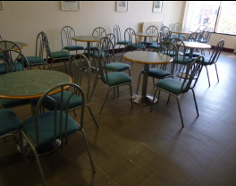

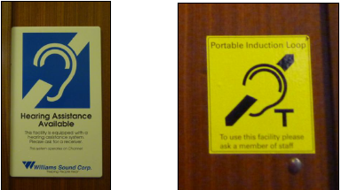



**Refreshments**

There is a cafe located on the first floor of the courthouse and available from 09:00 to 14:00. The area is free from clutter and there is sufficient room for manoeuvring. In addition, the chairs and tables are not fixed and can be moved to provide addition space. A vending machine is located on the ground floor for cold drinks.

**Hearing Loop**

For people who are hard of hearing a fixed loop induction service is available at all reception counters. Portable mobile loop induction services are available for all courtrooms.

On arrival please inform the reception desk staff if you require this facility.

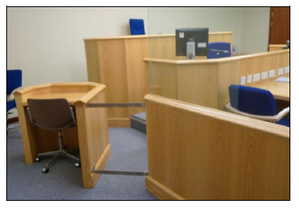

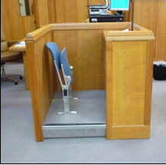

Witness box

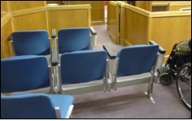

Typical court room seating

[](https://www.google.co.uk/url?sa=i&rct=j&q=&esrc=s&source=images&cd=&cad=rja&uact=8&ved=0ahUKEwijmeXk2NnJAhWFLhoKHaetCAcQjRwIBw&url=https://www.iconfinder.com/icons/41952/elevator_lift_icon&psig=AFQjCNFBzdPzzcb-7dUs7YIenjllh-kU0g&ust=1450125533140326)

**Courtrooms**

All courts are well lit, sufficiently spacious and have good acoustic qualities including full induction loop facilities. As such they provide good access to all users. While no provision is given for wheelchair users to access the seated area in the public gallery or the witness box, the space in the courtrooms is ample. Wheelchairs can be accommodated in areas just outside the witness box and the gallery. When making the journey to the court from the main reception zone or the lift lobby, some assistance may be needed in opening doors.

**Internal Access**

The ground floor public area is spacious with plenty of room for manoeuvring as shown below. The stairs between the ground floor and the first floor are located in the centre of the public area on the ground floor. In addition to the stairs there is a lift that provides access to the first floor of the courthouse.

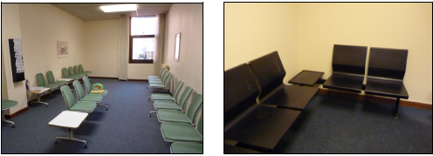

Typical witness waiting rooms

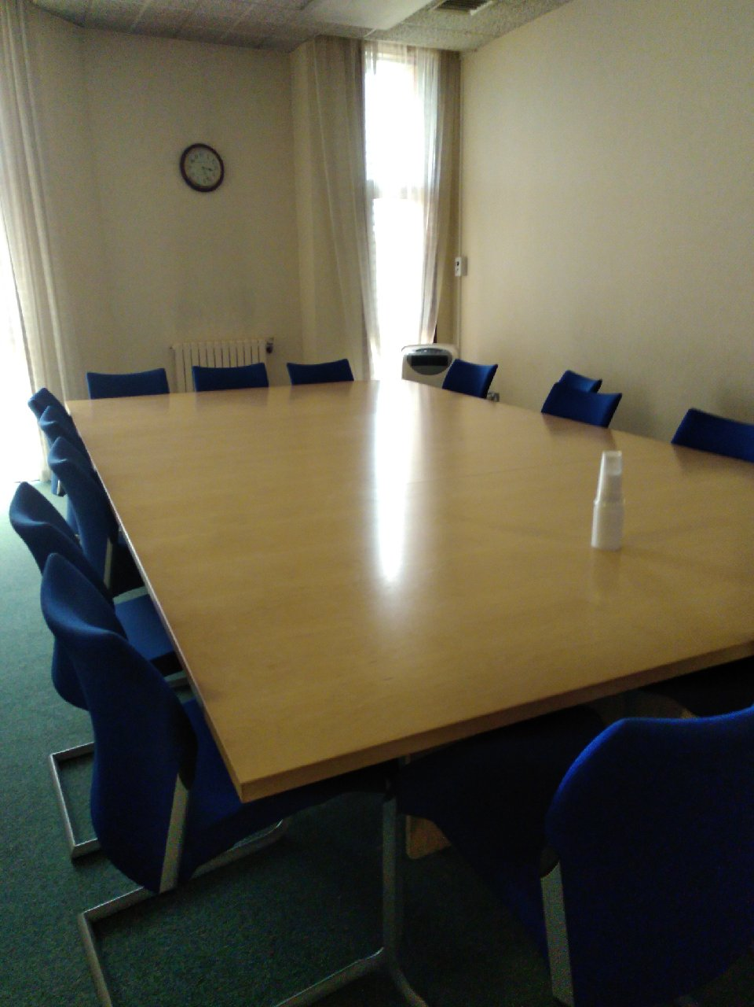

Typical Jury room

**Witness Waiting Rooms**

Waiting rooms for witnesses are located within the ground and first floors of the courthouse. Reception staff will direct witnesses to the correct waiting room upon arrival. Defence and Crown witnesses will be located in separate rooms. There is sufficient room for manoeuvring.

**Jury Rooms**

Members of the public who have been selected to serve on a jury will be accommodated in one of two jury rooms on the first floor. Lunch will be provided to jurors during the course of the trial. There is limited room for manoeuvring.

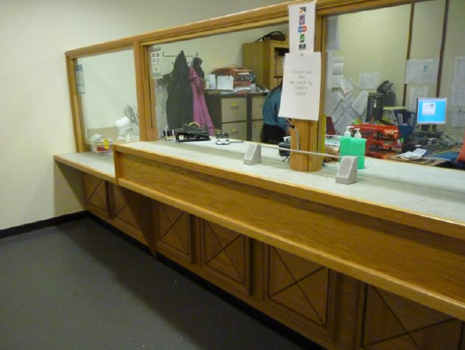

Fines and Criminal Office

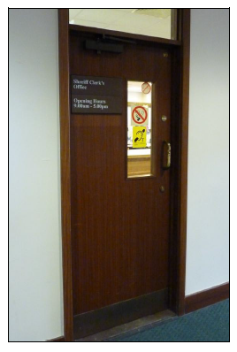

Sheriff Clerk’s Office

**Fines and Criminal Office**

The Fines Office is located opposite to the Enquiries Counter adjacent to the Sheriff Clerk’s Office. The counter has high and lowered sections and the waiting area has seats with and without arm rests.

**Sheriff Clerk’s Office**

The Sheriff Clerk’s Office is located just inside the main entrance, on the right as one enters the Courthouse, opposite the Enquiries Counter. Internally the room is small, but a lowered counter section is useful for wheelchair users. The signage used here is high contrast.

**Floor Plans**



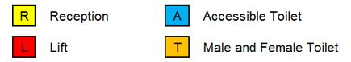

Ground Floor Layout





First Floor Layout

**Opening Times**

**Weekly**

Monday to Thursday: 9 am to 5 pm

Friday: 08:30 am to 4.30 pm

**Please note that the public and fine counters close at 1.00 pm on the first Wednesday of each month**

**Public Holidays**

### 2019

01 – January Tuesday **New Year’s Day**

02 – January Wednesday **2nd January**

19 – April Friday **Good Friday**

22 – April Monday

06 – May Monday **Early May Bank Holiday**

27 – May Monday **Spring Bank Holiday**

1 – July Monday

5 – August Monday

23 – September Monday

02 – December Monday **St Andrew’s Day**

25 – December Wednesday **Christmas Day**

26 – December Thursday **Boxing Day Contact Information**







**Postal Address**

Kilmarnock Sheriff Court

St Marnock Street

Kilmarnock

KA1 1ED

**Sheriff Clerk**

Neil Christie

**Main Telephone**

**01563 550024**

Jury Helpline - 01563 550034 (with recorded message for Jurors)

**Email**

[kilmarnock@scotcourts.gov.uk](mailto:kilmarnock@scotcourts.gov.uk)

**Additional Information**

If you require this document

in an alternative format

please contact the Property

and Services Unit at the

below address.

[enquires@scotcourts.gov.uk](mailto:enquires@scotcourts.gov.uk)

**The Scottish Courts and**

**Tribunals Service**

Saughton House

Broomhouse Drive

Edinburgh

EH11 3XD

**0131 444 3300**

or text phone

**18001 0131 444 3300**







### Accessibility contact

If you want to contact us using text relay please follow the guidance at this link -  [the Next Generation Text Service](https://www.btplc.com/inclusion/MakingCallingEasier/Textrelay/index.htm)

If you require the support of an interpreter when you contact a court (by phone or attend in person), a telephone interpretation service is available.  To access this service ask for telephone interpreting and the language required. This service is NOT available during actual court proceedings.

If you use British Sign Language (BSL) and wish to phone us using a sign language interpreter, you can use the online video relay interpreting service. For more information see the contactSCOTLAND website. [www.contactscotland-bsl.org](http://www.contactscotland-bsl.org/)

**This Report**

This report has been compiled using the Scottish Accessible Information Forum, ‘Making Information Accessible’ guidance published September 2014.

A copy of our Court Users’ Charter can be accessed [here](http://www.scotcourts.gov.uk/docs/default-source/scs-board/charter.pdf?sfvrsn=8)

Should you require this document in another language or format please contact:

Court Services Branch

Scottish Courts and Tribunals Service

Spur N1,

Saughton House

Broomhouse Drive

Edinburgh

EH11 3XD

[csbenquiries@scotcourts.gov.uk](mailto:csbenquiries@scotcourts.gov.uk)

0131 444 3455

