Our Promise
to you

Sheriff Court & Justice of the Peace Court

Users’ Charter

Easy Read version

August 2017
What this leaflet is about.

 | This leaflet is about the Sheriff Court & Justice of the Peace Court Users’ Charter.
 | The Charter was written by the Scottish Courts and Tribunals Service.
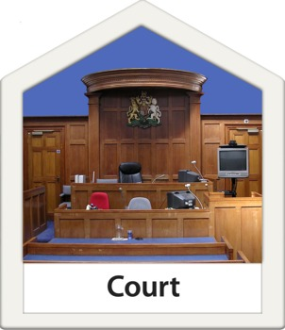 | The Charter tells what should happen if you ever have to go to court in Scotland.
 | A court is a place where people go to sort things out when they do not agree.
 | This booklet will tell you about what happens in court.
 | Big words will be written in bold.
 | Words in bold will be explained in this booklet.

What the Scottish Courts and Tribunals Service does.

The Scottish Courts and Tribunals Service is in charge of the buildings that are used for court.

They make sure that the people who work in court make it easy for the people who visit the court.

They make sure that if a person has to go to court they get any help they need.

They do not give any advice about the law.

If you have to go to court.

 | If you need someone to help you, phone before you go to arrange this.
If someone has arranged to meet you at the court they will meet you at the time they said they will.

You can tell someone who works there if you need any help during your court visit.

 | If you need help to hear they will make sure this is there for you.
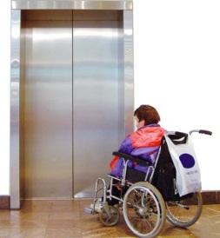 | If you need help to get around the building they will help you with this.
 | If you need information in another language they will get this for you.
 | You can get some information in braille or on a CD if you need it.

When you arrive at court.

 | There will be a sign that shows you where the reception is.
 | There will be signs that show where information desks are.
 | Any other information you need in the court will be clear and easy to find.
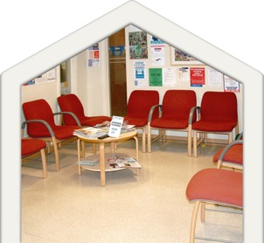 | The building will be clean and comfortable.

If you need to make a phone call to a court.

 | If you phone between 9 am and 5 pm someone will usually answer the call.
 | If no one can answer your question they will arrange to call back and talk to you another time.
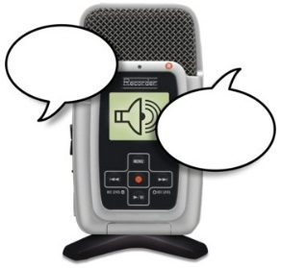 | If you are asked to go to court to be on a jury there will be a special telephone message service for information.
 | A jury is a group of people.
 | The jury listens to what is being said in the court and says what they think happened.

If you need to write to the Scottish Courts and Tribunals Service.

If you write a letter or e-mail to the Scottish Courts and Tribunals Service you will get an answer within 10 days.

The answer will be written in easy words.

If you need to go to court as a witness.

A witness is a person who knows something about what happened.

The witness answers questions about what they know.

What the witness says is called evidence.

Saying evidence in court can make you feel stressed and upset.

The Scottish Courts and Tribunals Service will try to make it as easy as they can.

In court there are two sides called prosecution and defence.

Prosecution is the side that says that the person who is accused did the crime that is being talked about in court.

Defence is the side that says that the accused didn’t do the crime that is being talked about in court.

The accused is the person who the police think did the crime.

People go to court to decide if the accused did the crime.

If you are in court as a witness you will not sit next to the accused or witnesses for the defence.

Someone will tell you what is happening during the day.

If there is a change and you do not need to talk in court someone will tell you.

If you have a complaint or idea.

If you are not happy about something or if you have an idea to make things better you should let the Scottish Courts and Tribunals Service know about it.

In some courts you can write your comment on a card and put it in the box in the court building.

You can tell someone who works in the court.

You can write a letter to
Scottish Courts and Tribunals Service,
Saughton House,
Broomhouse Drive,
Edinburgh,
EH11 3XD.

You can write an email to
enquiries@scotcourtstribunals.gov.uk

If you need more information.

You can look on the website
www.scotcourtstribunals.gov.uk

You can write a letter to
Scottish Courts and Tribunals Service,
Saughton House,
Broomhouse Drive,
Edinburgh,
EH11 3XD.

You can write an email to
enquiries@scotcourtstribunals.gov.uk

You can telephone 0131 444 3352

