**Visiting**

**Paisley Sheriff Court**

**and**

**Justice of the Peace Court**





[](http://www.bing.com/images/search?q=Phone+Symbol&view=detailv2&&id=66CED88CCFB20CC9EB9C955ABD258FACE9200A23&selectedIndex=61&ccid=NLXDtiSr&simid=608051032150313885&thid=OIP.M34b5c3b624ab2e77aecc5b51235ed993o0)

This leaflet will help you to

plan your visit to the

Paisley Sheriff Court and

Justice of the Peace Court.

If you require more information

about anything here you can

email:

[enquires@scotcourts.gov.uk](mailto:enquires@scotcourts.gov.uk)

or telephone the Property

and Services Unit on:

**0131 440 3300**

or text phone

**18001 0131 444 3300**

(Full contact details are on

page 22)

**Contents**

**Location Details**

Page 4

……………………………………………..

**Ways of getting to the Court Building**

Pages 5 to 8

………………………………………………

**On Arrival**

Pages 9 to 11

………………………………………………

**Facilities**

Pages 12 to 18

……………………………………………….

**Floor Plans**

Pages 19 and 20

………………………………………………

**Opening Times & Public Holidays**

Page 21

………………………………………………

**Contact Information**

Page 22

………………………………………………

**Additional Information**

Pages 23 and 24

**Location Details**

Paisley Sheriff Court and

Justice of the Peace Court is

located in one building on

St James Street in Paisley

town centre.

The main public entrance is

on St James Street which is

a short walk from Paisley Gilmour Street Rail Station and the main bus station.





**Ways of getting to the Court Building**

**By Bus**

Local and out of town buses

stop in the town centre at

Gilmour Street.

McGill’s 19 service stop on

St James Street and

Wilsons of Rhu service 340

stop on Caledonia Street

both of which are a short

walk from the court building.





Bus stop locations

**By Train**

The main train station is

Paisley Gilmour Street

which is a short 0.1 mile

walk from the court building.

Trains run to and from

Glasgow regularly.

Visit [www.nationalrail.co.uk](http://www.nationalrail.co.uk)

or call **03457 484 950** for

train times.





Train station location

**By Public Transport**

Contact Traveline Scotland

for all public transport

enquiries and assistance on

**0871 200 22 33** or visit

[www.travelinescotland.com](http://www.travelinescotland.com)

**By Car**

There is no public car

parking at the court building.

Public pay and display

parking facilities are

available on Glen Street,

Glen Lane and Moncrieff

Street, all of which are close

to the court building.

Two disabled parking bays

are located on Glen Street

and Glen Lane, and four

disabled bays are on

Moncrieff Street.

Travel by public transport is

recommended.





Pay and display parking

**By Taxi**

Taxis are available at

Paisley Gilmour Street train

station.

[](https://www.google.co.uk/imgres?imgurl=http://www.jonkopingairport.se/images/18.7a35645314b5170974317743/1424968594236/taxi%2Bsymbol.png&imgrefurl=http://www.jonkopingairport.se/engelska/jonkoping-airport/to-and-from-the-airport/taxi.html&h=290&w=289&tbnid=BUyITbj0zQn5_M:&docid=ONo4G9HamXNJaM&ei=PKxpVu2rIYH8UsjPsHg&tbm=isch&ved=0ahUKEwjtufuC39HJAhUBvhQKHcgnDA8QMwh7KFQwVA)

**On Arrival**

**Entrance**

Public entrance to the

court building faces on to

St James Street and is

accessed from pavement

level by nine steps, or by a

side ramp for those with

restricted mobility.

The entrance doors are

double swing access doors

which can also be opened

automatically by push pad

  
activation on the right-hand side of the doorway.



Entrance steps

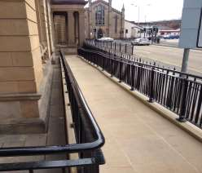

Entrance ramp

**Security Check**

You will enter the security

lobby where trained security

staff will request that you pass

through a metal detector.

Wheelchair users are scanned

by a paddle scanner.

Your bags or briefcases may

also be searched.

When you are ready, the

security staff will direct you to

the reception desk located to

the left of the main hall, which

serves as the central point of

access the rest of the building.

Please report to the reception

desk and state the reason for

your visit. Reception staff will

then direct you accordingly.

Staff can assist you if you

have any question about the

court building or your visit.

[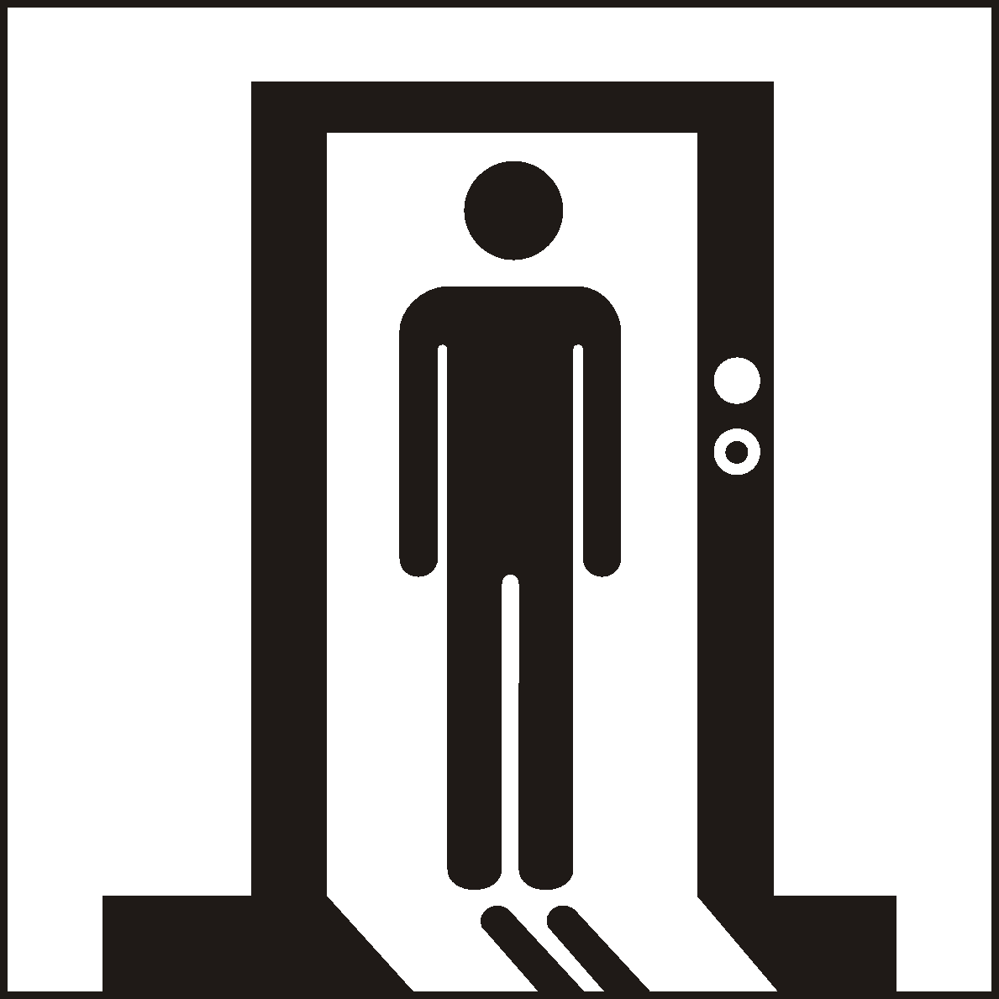](http://www.google.co.uk/url?sa=i&rct=j&q=&esrc=s&source=images&cd=&cad=rja&uact=8&ved=0ahUKEwialYnHwtPJAhUKWhoKHUKJBs4QjRwIBw&url=http://www.standard.org.cn/dgsymbol/list.aspx?sid%3D12%26stid%3D%26Page%3D5%26searchtxt%3D&bvm=bv.109395566,d.d2s&psig=AFQjCNEa1EVlPPeWeUJ-gD_trfHzICP1Hw&ust=1449913041342312)



Reception desk

If you have a wheelchair or a

pushchair and you require

specific access assistance,

please telephone:

**0141 887 5291**

or textphone

**18001 0141 887 5291**

For further information on the

layout of the court building

please refer to the floor plan

layouts on pages19 and 20.

[](http://www.google.co.uk/url?sa=i&rct=j&q=&esrc=s&source=images&cd=&cad=rja&uact=8&ved=0ahUKEwj97rvTy9PJAhUGOhoKHYi5CSAQjRwIBw&url=http://www.printmag.com/logo-design/isotype-disability-logo/&bvm=bv.109395566,d.d24&psig=AFQjCNH-8i74rInjIp3hEzGAq3oi4bC8Kg&ust=1449915488421523) [](http://www.google.co.uk/url?sa=i&rct=j&q=&esrc=s&source=images&cd=&cad=rja&uact=8&ved=0ahUKEwjGuNWIy9PJAhWHMhoKHcqUDRwQjRwIBw&url=http://www.fotosearch.de/CSP712/k21035407/&bvm=bv.109395566,d.d2s&psig=AFQjCNEldjNZO6vinOGxNRuUXaXckC1Cgw&ust=1449915589191710)

[](http://www.bing.com/images/search?q=Phone+Symbol&view=detailv2&&id=66CED88CCFB20CC9EB9C955ABD258FACE9200A23&selectedIndex=61&ccid=NLXDtiSr&simid=608051032150313885&thid=OIP.M34b5c3b624ab2e77aecc5b51235ed993o0)

**Facilities**

**Toilets**

Public male and female toilets

are located throughout the ground and first floor public areas.

At ground floor level an

accessible toilet is located to

the right hand side of Court 5

and at first floor level an

accessible toilet is located to the left hand side of Court 7.

A baby changing facility is

provided in the accessible

toilet on the ground floor.

**Signage**

High contrast signage is

provided around all circulation

areas to ensure the public

zones are easily navigated.

[](http://www.google.co.uk/url?sa=i&rct=j&q=&esrc=s&source=images&cd=&cad=rja&uact=8&ved=0ahUKEwiF96LM1NPJAhVL7RQKHTQCBZ0QjRwIBw&url=http://www.clker.com/clipart-23329.html&psig=AFQjCNHODAmfK5T3xc8P94NSEMLwh6WGLA&ust=1449918213568933)

[](http://www.google.co.uk/url?sa=i&rct=j&q=&esrc=s&source=images&cd=&cad=rja&uact=8&ved=0ahUKEwiF96LM1NPJAhVL7RQKHTQCBZ0QjRwIBw&url=http://www.soshified.com/forums/user/304780-chairman90/?tab%3Dstatus&psig=AFQjCNHODAmfK5T3xc8P94NSEMLwh6WGLA&ust=1449918213568933)

[](http://www.google.co.uk/url?sa=i&rct=j&q=&esrc=s&source=images&cd=&cad=rja&uact=8&ved=0ahUKEwjxm4K289PJAhWKfxoKHbSPCJUQjRwIBw&url=http://www.zazzle.com/toilets%2Bstickers&bvm=bv.109395566,d.d2s&psig=AFQjCNE5z456mN4ypA-cvbcUyAdIjI0yVg&ust=1449926541257654)

**Refreshments**

Hot and cold drinks and light

snacks are available at the

Tea Bar located at ground floor

level next to the reception desk.

The Tea Bar is open every

weekday until 1pm.

If you are sitting on a jury, lunch

and refreshments will be

provided for you if the court sits into the afternoon.

**Hearing Loop**

For people who are hard of

hearing a fixed loop induction

service is available at all

reception counters. Portable

mobile loop induction services

are available for all courtrooms.

On arrival please inform the

reception desk staff if you

require this facility.





**Courtrooms**

All courtrooms are accessible

to wheelchair users with

exception of Court 1 at

ground floor level and the

Justice of the Peace Court on

second floor level.

If you are due to attend either

of these Courts and you

require wheelchair

assistance, please contact

the court on **0141 887 5291**

so that prior arrangements

for reasonable adjustments

can be made.

Courts 2 to 8 which are

located on ground and first

floor levels can accommodate

wheelchair users however

assistance may be required

to open double doors that

lead into the public seating

area of the courtroom.



Typical court room

[](http://www.bing.com/images/search?q=Phone+Symbol&view=detailv2&&id=66CED88CCFB20CC9EB9C955ABD258FACE9200A23&selectedIndex=61&ccid=NLXDtiSr&simid=608051032150313885&thid=OIP.M34b5c3b624ab2e77aecc5b51235ed993o0)

The main concourse and

atrium area are barrier free

and well lit, however the

courtroom entrance lobbies

do not have automatic push

pad opening.

Some building users and

visitors may require

assistance with accessing

these areas.

Assistance will be provided if

help is required.

**Lifts**

A passenger lift located in the

ground floor main atrium

provides public access to the

ground and first floor level

court rooms. The lift is

provided with illuminated floor

level indicators, raised floor

indicator buttons, voice over

floor and door alerts.

[](https://www.google.co.uk/url?sa=i&rct=j&q=&esrc=s&source=images&cd=&cad=rja&uact=8&ved=0ahUKEwijmeXk2NnJAhWFLhoKHaetCAcQjRwIBw&url=https://www.iconfinder.com/icons/41952/elevator_lift_icon&psig=AFQjCNFBzdPzzcb-7dUs7YIenjllh-kU0g&ust=1450125533140326)

**Witness Rooms**

All Witness Rooms are spacious

and can accommodate

wheelchair users and persons

with restricted mobility.

Comfortable seating and

reading materials are also

provided.

Corridor doors serving the

witness rooms do not have

automatic push pad opening.

Some building users and visitors

may require assistance with

accessing these areas.

Assistance will be on hand if

required.

Male and female toilets are

provided and an accessible

toilet is located at ground floor

level to the right hand side of

Court 5 and at first floor level to

the left hand side of Court 7.



Witness Room

[](http://www.google.co.uk/url?sa=i&rct=j&q=&esrc=s&source=images&cd=&cad=rja&uact=8&ved=0ahUKEwiF96LM1NPJAhVL7RQKHTQCBZ0QjRwIBw&url=http://www.clker.com/clipart-23329.html&psig=AFQjCNHODAmfK5T3xc8P94NSEMLwh6WGLA&ust=1449918213568933) [](http://www.google.co.uk/url?sa=i&rct=j&q=&esrc=s&source=images&cd=&cad=rja&uact=8&ved=0ahUKEwiF96LM1NPJAhVL7RQKHTQCBZ0QjRwIBw&url=http://www.soshified.com/forums/user/304780-chairman90/?tab%3Dstatus&psig=AFQjCNHODAmfK5T3xc8P94NSEMLwh6WGLA&ust=1449918213568933)

**Jury Rooms**

Jury Rooms are furnished with

comfortable seating.

Male and female toilet facilities

are provided and an accessible

toilet is located at ground floor

level to the right hand side of

Court 5 and at first floor level to

the left hand side of Court 7.

**Fines and Criminal Office**

The Fines and Criminal Office

are located on the ground floor

level near the main entrance

to the court building.

Double doors are positioned

open to allow barrier free

access.

The reception desk is provided

with a dropped counter and a

fixed induction loop system.

[](http://www.google.co.uk/url?sa=i&rct=j&q=&esrc=s&source=images&cd=&cad=rja&uact=8&ved=0ahUKEwiF96LM1NPJAhVL7RQKHTQCBZ0QjRwIBw&url=http://www.clker.com/clipart-23329.html&psig=AFQjCNHODAmfK5T3xc8P94NSEMLwh6WGLA&ust=1449918213568933)[](http://www.google.co.uk/url?sa=i&rct=j&q=&esrc=s&source=images&cd=&cad=rja&uact=8&ved=0ahUKEwiF96LM1NPJAhVL7RQKHTQCBZ0QjRwIBw&url=http://www.soshified.com/forums/user/304780-chairman90/?tab%3Dstatus&psig=AFQjCNHODAmfK5T3xc8P94NSEMLwh6WGLA&ust=1449918213568933)



Fines and Criminal Office

**The Civil Office**

The Civil Office is located on the

ground floor level and observes

the same opening hours as the

main court building.

There is no push pad

automated door entry to this

area therefore if you require

assistance, please ask at the

main reception upon entry to

the building.

The waiting area has sufficient

space for wheelchair

manoeuvrability and is provided

with a dropped reception

counter.



Civil Office Waiting Room

**Floor Plans**

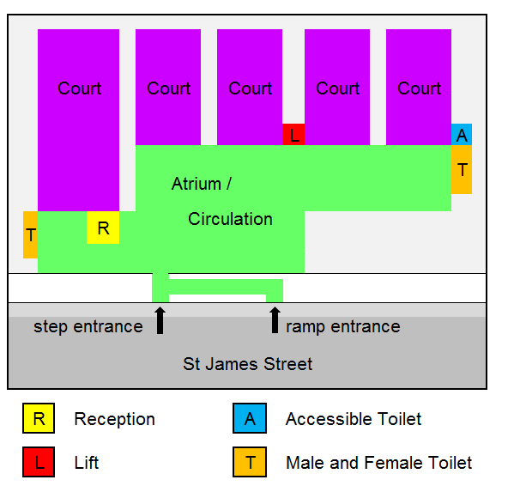

Ground Floor Layout

**Floor Plans**

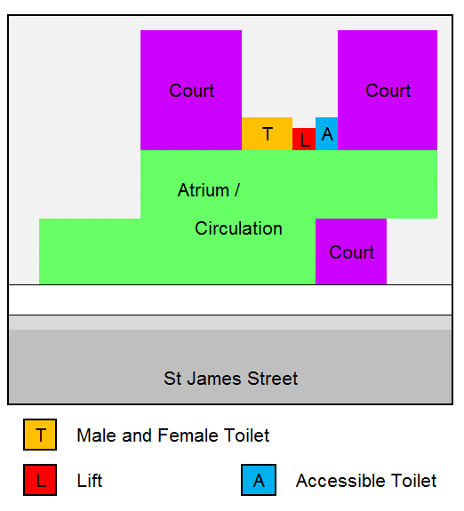

First Floor Layout

**Opening Times**

**Weekly**

Monday to Thursday: 9 am to 5 pm

Friday: 9 am to 4.30 pm

**Staff Training during 2016**

The public offices at Paisley will close one day per month at 1pm to allow for staff training. These dates can be found [here](http://www.scotcourts.gov.uk/the-courts/court-locations/paisley-sheriff-court-and-justice-of-the-peace-court)

The reception desk will remain open during this time to assist customers.

**Public Holidays**

**2016**

* 25th and 28th of March
* 2nd and 30th of May
* 1st August
* 26th September
* 28th November
* 26th and 27th December

**2017**

* 2nd and 3rd January
* 14th and 17th April

**Contact Information**

**Postal Address**

Paisley Sheriff Court and

Justice of the Peace Court

Sheriff Court House

St James Street

Paisley PA3 2HW

**Sheriff Clerk**

Allister Wilson

**Main Telephone**

**0141 887 5291**

**Civil Department contact**

**0141 887 5291** ext 436804

**Criminal department contact**

**0141 887 5291**

ext 436823, 436829 or 436834

**Jury helpline**

**0800 731 9088**

**Email**

[paisley@scotcourts.gov.uk](mailto:paisley@scotcourts.gov.uk)

[](http://www.google.co.uk/url?sa=i&rct=j&q=&esrc=s&source=images&cd=&cad=rja&uact=8&ved=0ahUKEwiA3oHW_NPJAhVM6xoKHaBaDVEQjRwIBw&url=http://www.freepik.com/free-photos-vectors/mail&bvm=bv.109395566,d.d2s&psig=AFQjCNGohM1LTDS1zSLoUXGKe3h-FiD1Dw&ust=1449929013085619)

[](http://www.bing.com/images/search?q=Phone+Symbol&view=detailv2&&id=66CED88CCFB20CC9EB9C955ABD258FACE9200A23&selectedIndex=61&ccid=NLXDtiSr&simid=608051032150313885&thid=OIP.M34b5c3b624ab2e77aecc5b51235ed993o0)



**Additional Information**

If you require this document

in an alternative format

please contact the Property

and Services Unit at the

below address.

[enquires@scotcourts.gov.uk](mailto:enquires@scotcourts.gov.uk)

**The Scottish Courts and**

**Tribunals Service**

Saughton House

Broomhouse Drive

Edinburgh

EH11 3XD

**0131 444 3300**

or text phone

**18001 0131 444 3300**



[](http://www.google.co.uk/url?sa=i&rct=j&q=&esrc=s&source=images&cd=&cad=rja&uact=8&ved=0ahUKEwiA3oHW_NPJAhVM6xoKHaBaDVEQjRwIBw&url=http://www.freepik.com/free-photos-vectors/mail&bvm=bv.109395566,d.d2s&psig=AFQjCNGohM1LTDS1zSLoUXGKe3h-FiD1Dw&ust=1449929013085619)

[](http://www.bing.com/images/search?q=Phone+Symbol&view=detailv2&&id=66CED88CCFB20CC9EB9C955ABD258FACE9200A23&selectedIndex=61&ccid=NLXDtiSr&simid=608051032150313885&thid=OIP.M34b5c3b624ab2e77aecc5b51235ed993o0)

**This Report**

This report has been compiled

using the Scottish Accessible

Information Forum, ‘Making

Information Accessible’ guidance

published September 2014.

A copy of our Court Users’ Charter can be accessed [here](http://www.scotcourts.gov.uk/docs/default-source/scs-board/charter.pdf?sfvrsn=8)

Should you require this document in another language or format please contact:

Court Services Branch

Scottish Courts and Tribunals Service

Spur N1, Saughton House

Broomhouse Drive

Edinburgh

EH11 3XD

[csbenquiries@scotcourts.gov.uk](mailto:csbenquiries@scotcourts.gov.uk)

0131 444 3455